



TECHNICKÁ UNIVERZITA V LIBERCI
Hálkova 6, 461 17 Liberec 1, CZ

Fakulta mechatroniky a mezioborových inženýrských studií

Control Systems in Mechatronics

INTRODUCTION
TO PARAMETER ESTIMATION
(Working version)
Student text

Doc. Ing. Osvald Modrlák, CSc.

March, 2009

Institute of Systems Control and Reliability Management (RSS)

1 Introduction 2
2 Fundamental concepts 3
2.1 Mathematic model for experimental identification 3
2.2 Model of the controlled process 4
3 Parameter estimation of a transfer function with given structure 6
3.1 Identified process, input and output signals 6
3.1.1 Identified process 6
3.1.2 Output signal 7
3.2 Identification measuring and data acquisition 8
3.2.1 Input test signals 8
3.3 Structure of parameter estimation 10
3.4 Parametric estimation of the transfer function by given structure 11
3.4.1 Structure of an ON-line parameter estimation with LTI model 11
3.4.2 Structure of an Off-Line parameter estimation with LTI model 12
3.4.3 Model structure 12
3.4.4 Criterion 14
3.4.5 Optimization strategy 15
3.5 Searching for the optimal mode 16
3.5.1 Searching for the optimal structure of the transfer function 16
3.5.2 Experimental identification procedure 18
3.6 Movement to the working point 19
3.7 Model Reduction 20
3.8 Standardization of input and output signals 21
4 Program for parametr estimation in MATLAB 22
4.1 Flow-process diagram 22
4.2 Program and function in MATLAB 23
5 Introduction to using MATLAB 24
5.1 Desktop Tools and Development Environment 25
5.2 Workspace, Editor, Search path and File Operations 26
5.2.1 Workspace operations 26
5.2.2 Editor and Command Window operation 27
5.2.3 Search part and File operation 27
5.2.4 Select function size, length, roots, conv, disp, pause 28
5.3 LTI models 28
5.3.1 Creating of Some Linear Models 28
5.3.2 Data Extraction 31
5.4 Time Domain Analysis 32
5.5 Some basic plotting function 36
5.6 Opening, loading, saving files 42
5.7 Programming-flow control 47
Literatura 50

This student text offers a comprehensive overview of parameter estimation for linear dynamic systems with accent on an appropriate balance between theoretical essentials and engineering practice in identification. The student’s text presents special part of empirical identification that is referred to parameter estimation.

- Introduction
Week 1: Parametric and non parametric identification, model of the controlled process, identified process, input and output signals, design of identification measure, measuring noise signals.

Analyses, syntheses and modeling of dynamic systems and every optimization need mathematical models. For our use we will accept the definition of mathematical model by Eykhoff
A mathematical model is a representation of the essentials aspects of an existing
(or system to be constructed) which presents knowledge of that system in usable form.

Each mathematical model represents always inevitable simplification and uncertainty of the modeled real process. On principle it is yet caused by choosing the mathematical model. The models can be classified in:

- Model with lumped or distributed parameters. When the real dynamic system is described by ordinary differential equations, this is referred to as model with lumped parameters. Model that describes the modeled system with partial differential equations is the model with distributed parameters.
- Linear or nonlinear models are describing the dynamic system with linear or nonlinear equation.
- Deterministic or stochastic models. Deterministic model is one in which every set of variables states is uniquely determined by parameters in the model and by sets of these variables. Therefore the deterministic model has the same outputs for a given set of initial conditions. In a stochastic model randomness is present, and variable states are not described by unique values, but rather by probability distributions.
- Linear time invariant model are describing the dynamic system with linear differential equations with constant parameters.

Let us suppose a real system to be modeled with an input and output shown in the Fig.1a. Mathematical modeling of a real system generally depends on a priori information about the modeled system. What shell we consider as a priori information?

Input
Output

Black-box model
Input
System
no a priory information
available
Output
Fig.1a Modeled system Fig. 1b) Mathematical model

Generally a priori information contains knowledge, facts or principles about the process that are known.
A posteriori information contains knowledge after analysing, thinking sth by starting from known facts with “a priori information”and making experiments.

They may come in forms of knowing the type of functions relating different variables, the model structure, types of non-linearity, order of the systems. The operating experience provides a priori information about operating plant condition, limitation on the input perturbation, level of measured noise and so on. Usually it is preferable to use as much a priori information as possible to make the model more accurate. From this point of view the experimental modeling is classified into black-box or white- box model. A black-box model is related to a system of which there is no a priori information available.
A white-box model is related to a system where all necessary information is available. Practically all systems are somewhere between the black-box and white-box models.
- Fundamental concepts
  - Mathematic model for experimental identification
Engineers can obtain the mathematical model by applying fundamental physical principles (theoretical modeling) or by an empirical identification (experimental modeling).
By applying fundamental physical principles the structure as well as parameters of the models is obtained.
The empirical identification is based on data processing of measured signals. This approach usually necessitates a priori information about the structure of the model. The identification is using parametric and non-parametric models.
Parametric models have the model structure a priori specified. The model structure is considered to be the order and the type of differential or difference equation, (linear, non-linear differential or difference equation, type of the non-linearity and so on), or system equations, transfer function with chosen powers of numerator and denominator, or by chosen transfer matrix with m row and n columns.
Parametric models represent from the mathematic point of view equation, equations systems and algebraic equations, which comprise explicitly the coefficients of the equations and formulas. These coefficients are generally referred to as parameters of mathematical models. The parameters are to be determined.

Parametric models
Example 1

a) $y^{''}+α⋅(y^{'})^{2}+β⋅\sqrt{y}=u$, nonlinear differential equation, parameters $α,β$

b) $T⋅\overset{˙}{y}+y=K⋅u$, linear differential equation, parameters $T,K$

c) $\begin{aligned}{\overset{˙}{x}}_{1}=x_{2} \\ {\overset{˙}{x}}_{2}=g−\frac{1}{M}{\frac{(x_{3})}{x_{1}}}^{2} \\ {\overset{˙}{x}}_{3}=−\frac{R}{L}x_{3}+\frac{1}{L}u\end{aligned}$
Nonlinear state equation, parameters
$g,M,R,L$
Input $u$
Non-parametric models differ from models in that the model structure is not specified a priori but is instead determined from data.
The non-parametric models represent a functional relation between selected input and output. This relation is interpreted geometrically as plotted curves or it is printed as summary sheet (table).
Non-parametric models describe usually transient and impulse response or frequency responses as a plot or in the table form. The parameters are contained implicitly in function relations.

  - Model of the controlled process

A structure of controlled process with its elements is shown in Fig.2.2
y_{f}(t)
AC
A
TP
S
A … Amplifier
AC… Actuator
TP… Technological Process
S … Sensors
Controlled Plant /( Process)
$$u_{f}(t)$$

u ... Input/Actuating or
Manipulated variable
y_{f} .. Controlled variable
/output
y ... Measured control variable
d … Disturbance
v … Noise signal on
Measuring device

Measuring devices
Fig. 2.2 Scheme of a controlled plant/process with measuring devices

Actuating/Manipulated variable u(t) – is a single input variable that can be adjusted by controller or available for manual experiments.

Controlled variable y_{S}(t) – is the process selected output variable to be controlled.

Measured control variable y(t) – is the measured control variable.

Disturbances d(t): In addition to actuating variable the controlled plant has inputs, which change the measured control variable. These inputs are called disturbances.

Disturbance - Noise signal on measuring devices n(t) – is a stochastic signal.

Extended controlled plant/process consists of plant/process and measuring devices (see Fig 2.3.) The plant contains transducers, transmitters, amplifiers and actuator. The measuring device embodies sensing elements, transducers, transmitters or sensors.
n
Plant
(Process)
Measuring devices
Fig. 2.3 Extended controlled plant

Extended Plant/process
Fig 2.4a,c Model structures of
extended plant/process
Fig 2.4b Model structure of controlled process approximated by P(s), H(s) transfer functions.

According to the Norm DIN 19221 two linear time invariant models can be defined for controlled plant proposing that the disturbances$n(t),d(t)=0$:
- An extended controlled plant model determined by the transfer function (Fig. 2.4a). The transfer function notation is simplified by lumping all instrumentation and process dynamic into one term F_{U}(s). It can be written
$F_{U}(s)=Y_{U}(s)/U(s)=\frac{B(s)}{A(s)}$ (2 – 1)

Where, $Y_{U}(s)=L\left\{y_{U}(t)\right\}$,$U(s)=L\left\{u(t)\right\}$,$A(s),B(s)$ are polynomials,
$y_{U}(t)$… is the relating output to input $u(t)$ .

- A linear model that approximates the controlled plant by two transfer functions $P(s),H(s)$is shown in the Fig.2.4b. The transfer function $P(s)$ approximates the dynamic behaviors of the plant (without the measuring devices) and $H(s)$ approximates the dynamic behaviors of the measuring devices.
$$b)$$

Extended Plant/process
Fig 2.4a,c Model structures of
extended plant/process
Fig 2.4b Model structure of controlled process approximated by P(s), H(s) transfer functions.

$$U(s)$$

$$y_{U}(t)$$

The relationship between the disturbance $d(t)$and the measured control variable supposing that $n(t),u(t)=0$ (shown in Fig.2.4c) can be described by the transfer function (C(s) is polynomial)
$F_{D}(s)=Y_{D}(s)/D(s)=\frac{C(s)}{A(s)}$ (2 – 2)
Under these conditions the model structure of an extended controlled plant with modeled disturbance $d$ is shown in the Fig.2.5. The output
Fig. 2.5 Model structure of an extended
plant with modeled disturbance
of the model is
$y(t)=y_{U}(t)+y_{D}(t)$.

The output of the system for joint action of
manipulated variable and of the disturbance
is equal to

$$\begin{aligned}Y(s)=F_{U(\text{2 3}) }(s)⋅U(s)+F_{D}(s)⋅D(s)= \\ =\frac{B(s)}{A(s)}U(s)+\frac{C(s)}{A(s)}D(s) (2−3)\text{.}\end{aligned}$$
- Parameter estimation of a transfer function with given structure
It is known that the modern methods of analysis, syntheses and modeling of linear dynamic systems use very often as mathematical model transfer functions. The accent is laid on the approach that yields the parameters transfer function of linear continuous plant. This approach is referred to as model reference or model matching method.

  - Identified process, input and output signals

Identified process
The identified process is a controlled plant shown in the Fig.3.1.The process has three inputs: manipulated variable u(t), disturbance d(t) and noise on measuring devices n(t). The output is the measured control variable.
n
Plant
(Process)
Measuring devices
Fig. 3.1 Identified process

It is supposed that the effect of manipulated variable u(t) and disturbance d(t) can be shown by the scheme in the Fig.3.2a,b.
n(t)
Identified
process
u(t)
y_{U}(t)
Fig.3.2a The effect of manipulated
variable
y(t)
y(t)
Identified
process
d(t)
y_{D}(t)
Fig.3.2b The effect of disturbance
variable
y(t)

The measured output signal y(t) contains the dynamic effects of manipulated variable u(t), disturbance d(t) and the added noise signal on measuring devices n(t) that is shown in the Fig.3.3a.
In the Fig.3.3b is shown the approximation of the identified process by two transfer functions
Figure 2. Model of a feedback control system
F_{U}(s) and F_{D}(s). The parameter and the structure of the transfer functions F_{U}(s), F_{D}(s) must be found by the parameter estimation from the measured input and output signals.

u(t)
y(t)
Identified
process

n(t)
y_{D}(t)
Fu(s)
Fd(s)
u(t)
d(t)
n(t)
y(t)
y_{D}(t)
y_{u}(t)
Fig. 3.3b Model of the identified process
Fig. 3.3a Identified process

    - Output signal

Output signal in the Fig.3.3b can be expressed

$y(t)=y_{U}(t)+y_{D}(t)+n(t)$, (3.1 – 1)

The measured noise $n(t)$ consists of three components: $v,χ,λ$

$n(t)=v(t)+χ(t)+λ(t)$ (3.1 – 2)
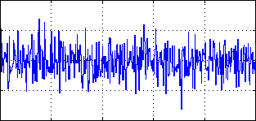
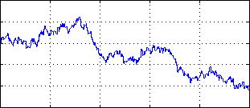
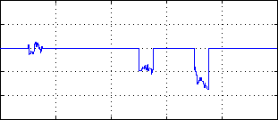
0
ν(t)
High frequency – quasi stationary stochastic signal- component ν(t)
0
t
χ(t)
Low frequency – non stationary stochastic signal-
component χ(t)
λ(t)
t
Component of the noise signal with unknown source
λ(t)
0
t
Fig.3.5 A realization of the components ν(t), χ(t), λ(t) of the measured noise n(t)

For parameter estimation is supposed that the output signal contain only the high frequency signal v(t). This means the non stationary signal χ(t) must be zero and the additive signal λ(t) must be zero or must be removed.

  - Identification measuring and data acquisition

    - Input test signals
For an identification measure the static characteristic has to be measured that give the information about static behavior of the system and about the linearity of the system.
As an input test signal we are using N step signals-measuring cycles that have constant time of measuring cycles TC. During each measured cycles their amplitudes are constant. It is recommended that the time period TC is so long that the steady state of the measured variable is reached. Each measuring cycle has constant number M of measured samples u(t),y(t) (see Fig.3.4a). The first step u₁ must excite the system to the working point.

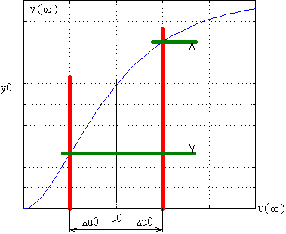
NON LINEAR STATIC
CHARAKTERISTIC
u_{h}=1,3
u_{d}=0,7
u₀=1
Working point
(u₀,y₀ )=(1,10)
LINEAR STATIC
CHARAKTERISTIC
y(∞)

0,5

1,0

1,5

-0,5

-1,0

u(∞)

u₀=0

y₀

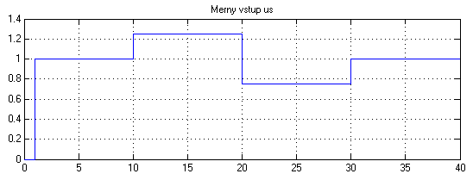
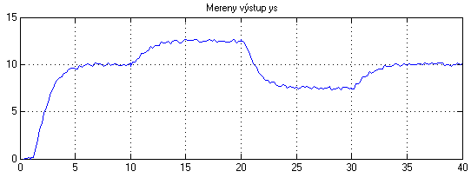
Starting point and identification time
u0
u1
u2
u3
INPUT STEP SIGNAL

u(t)
Time of
measuring
cycle TC
y1k
y0
y2k
y3k

Fig.3.4a Choosing of working point at the static characteristic, input step signal and its response

Linear time-invariant (LTI) systems have the static characteristic as a straight line which goes through the system of coordinates. Therefore for a LTI model this requirement must be fulfilled and so, that data for identification data processing of measured input and output must be transformed to the working point. The transform equations are

${Δu}_{\text{ID}}(t)=u(t)−u_{0}$, ${Δy}_{\text{ID}}(t)=y(t)−y_{0}$, (3.2 – 1,2)
where
${Δu}_{\text{ID}}(t)$, ${Δy}_{\text{ID}}(t)$= Ordinates that are input to identification processing,
$u(t)$, $y(t)$ = Measured input and outputs,
$u_{0}$, $y_{0}$ = Coordinates of input working point.

After the transform the transformed data have the working point y₀ = u₀ = 0. Practically on the basis of the measured static characteristic the working point must be selected. The chosen working point shall lie in the linear region of the static characteristic. The variation of input is to be carried out around the linear part of the working point as shown in the Fig. 3.4b.
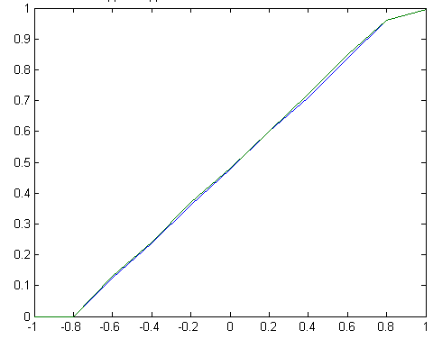
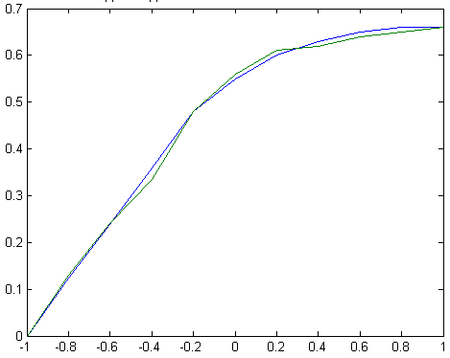
Fig. 3.4b Choice of working points on a measured static characteristic
u₀
u₀
y₀
y₀
Linear part around the working point
Linear part around the working point

The transfer function can be determined as

$F_{U}(s)=\frac{∇Y_{\text{ID}}(s)}{∇U_{\text{ID}}(s)}=\frac{B(s)}{A(s)}$, (3.2 – 3)

Where the $B(s), A(s)$ are the polynomials, which have degrees $m,n$and $m$<$n$ respectively.
  - Structure of parameter estimation
Week 2: Model structure, parameter estimation of the transfer functions with least squares method and chosen structure based on the input/output measuring of the real plant, chosen criterion and appropriate optimization strategy. ON - line and OFF - line parameter estimation. Types of model structures, criterion, optimization and flow process diagram of identification MATLAB program. Model order reduction, model verification.

The parameter estimation can be performed direct on the controlled plant so, that the measuring and data processing are carried out immediately. Such parameter estimation is called ON-line.
In the case if the identification measure is separated from the data processing then is referred to as OFF-line.

Structure of an ON-line parameter estimation

The basic idea of parameter estimation is based on the parallel model that has adjustable parameters, what is depicted in the Fig.3.6.
It is supposed that by the identification measure the input signal u(t) is a determined input test signal and all other inputs as disturbance d(t) is constant or zero.

u(t)
Fig.3.6 Structure of parameter estimation

Change of model parameters X

Adjustable
parameter
model

Criterion
J(x)

Identified
Plant/Process
Optimization
strategy of
Parameter
Estimation

The identified plant and the parallel model have the same input - the manipulated variable u(t). The model has adjustable parameters that are comprised in the parameter vector X. By starting the parameter estimation the vector X must contain the initial parameters that guarantee the stability of the parameter model X=X₀.
Of course the plant output y(t) depends only on the input in the working point. But the model output depends not only on the input signal but as well on the vector parameters X.
Outputs of the plant and model are compared and the outputs error Δy(t,X) is the input to the criterion block.
The criterion value J(x) is evaluated in the criterion block, which creates the input to the optimization strategy block. The optimization block calculates the new parameter vector X that is transferred to the model.
Now the parameter estimation process is repeating until the criterions for the stop are not achieved.

  - Parametric estimation of the transfer function by given structure

The identification methods for parametric models are based on the assumption that a priory information about the model structure is known or can be chosen. If the assumed model structure matches the process structure, higher model accuracy can be achieved by using statistical regression method.
;
    - Structure of an ON-line parameter estimation with LTI model

An identification measure for an LTI model must be performed around the chosen working point on the static characteristic. The working point is defined by the pair [u₀,y₀]. The estimation process is working with
$∇u(t)=u(t)−u_{0}$ (3.4-1)

$∇y(t)=y(t)−y_{0}$ (3.4-2)
The structure an ON-line parameter estimation is depicted in the Fig.3.7

$$y_{0}$$
$$u(t)$$
$$y(t)$$
Identified
Plant/Process
$$∇y(t)$$

$$Δ=∇y−∇y_{M}$$

Adjustable
LTI
model

$$u_{0}$$
$$∇u(t)$$
$$∇y_{M}(t,X)$$

Change of model parameters X

$$J(x)$$
Optimization
strategy of
Parameter
Estimation
Criterion
J(x)

Fig.3.7 Structure of an ON-line parameter estimation with LTI model

The adjustable LTI model has the input$∇u=u(t)−u_{0}$ and the output $∇y_{M}(t,X)$. The output error is determined
$Δ=∇y−∇y_{M}=∇y(t)−∇y_{M}(t,X)=Δ(t,X)$. (3.4-3)

    - Structure of an Off-Line parameter estimation with LTI model

By ON-line parameter estimation the input and output from the measure are saved in files. The structure is shown in the Fig.3.8.

Adjustable
LTI
model

Criterion
J(x)

Change of model parameters X

Optimization
strategy of
Parameter
Estimation

Data from file u(t)
Data from file y(t)
Fig.3.8 Structure of an OFF-line parameter estimation with LTI model

The adjustable LTI model has the input$∇u=u(t)−u_{0}$ and the output $∇y_{M}(t,X)$. The output error is determined $Δ=∇y−∇y_{M}=∇y(t)−∇y_{M}(t,X)=Δ(t,X)$.

    - Model structure
Suppose that the dynamic of the controlled plant is approximated by a linear time invariant mathematical model in the form of a transfer function. The transfer function is defined as the Laplace transform of the output variable y(t), divided by the Laplace transform of the input variable u(t), with all initial condition equal zero.

$F_{U}(s)=\frac{Y_{U}(s)}{U(s)}=\frac{∇Y(s)}{∇U(s)}=\frac{b_{m}s^{m}+⋯b_{1}s+b_{0}}{s^{n}+a_{n−1}s^{n−1}+⋯a_{1}s+a_{0}}=\frac{B(s)}{A(s)}$,
(3.4-4)

where B(s) and A(s) describe the numerator and denominator polynomials,
n>m, the system is called an n - th order system.

Transfer function with dead time has the form

$F_{U}(s)=\frac{Y_{U}(s)}{U(s)}=\frac{∇Y(s)}{∇U(s)}=\frac{b_{m}s^{m}+⋯b_{1}s+b_{0}}{s^{n}+a_{n−1}s^{n−1}+⋯a_{1}s+a_{0}}e^{−s⋅\text{Td}}\text{.}$ (3.4-5)

Generally the structure of the transfer function is defined by the powers n,m of the polynomials A(s), B(s) and by the dead time T_{d} .

The coefficients of the transfer function depend only on the structure - powers n,m and the dead time T_{d} and on the dynamic behavior of the system.

It is known that the transfer function with real roots of the polynomials A(s), B(s) can be written using its time constants in the form

$\begin{aligned}F_{U}(s)=\frac{Y_{U}(s)}{U(s)}=\frac{∇Y}{∇U}=\frac{b_{m}s^{m}+⋯b_{1}s+b_{0}}{s^{n}+a_{n−1}s^{n−1}+⋯a_{1}s+a_{0}}⋅e^{−s⋅\text{Td}}= \\ =K\frac{(1+T_{B1}s)⋯(1+T_{\text{Bm}}s)}{(1+T_{1}s)(1+T_{2}s)⋯(1+T_{n}s)}⋅e^{−s⋅\text{Td}}\end{aligned}$(3.4-6)

Some examples of available transfer function structures are described below.

$1) F_{0}\left(s\right)=\frac{{\text{Ke}}^{−T_{D}s}}{τs+1}$,
… 1th order system with time delay
$2) F_{1}\left(s\right)=\frac{K}{\left(τ_{1}s+1\right)\left(τ_{2}s+1\right)}$,
… 2th order system overdamped
$3) F_{2}\left(s\right)=\frac{K}{{\left(τs+1\right)}^{n}}$,
… n-th order system critically damped
$$4) F_{3}\left(s\right)=\frac{K}{\left(τ_{1}s+1\right)\left[{\left(τs\right)}^{2}+2\text{ξτ}s+1\right]}$$
…underdamped (oscillating)
$$5) F_{4}\left(s\right)=\frac{K}{\left(τ_{1}s+1\right)\left(τ_{2}s+1\right)\left(τ_{3}s+1\right)}$$
…3th order overdamped
$6) F_{5}\left(s\right)=\frac{b_{0}}{s^{4}+a_{3}s^{3}+a_{2}s^{2}+a_{1}s+a_{0}}$,
X = [b₀, a₀, a₁, a_{2,} a₃] parameters vector

$7) F_{6}\left(s\right)=\frac{b_{0}+b_{1}s}{s^{4}+a_{3}s^{3}+a_{2}s^{2}+a_{1}s+a_{0}}$,
X = [b₀, b₁, a₀, a₁, a_{2,} a₃],
parameters vector

For example we chose 2nd order transfer function in the form with time constants and gain.

$F_{1}(s)=\frac{K}{(T_{1}s+1)(T_{2}s+1)}=\frac{x(1)}{[x(2)s+1][x(3)s+1]}=\frac{B(s)}{A(s)}$(3.4-7)

where $x(1),x(2),x(3)$ are the unknown parameters.

    - Criterion

As criterion is used the integral of square of the outputs error Δy(t,X) in the form

$J_{2}=J_{2}\left(x\right)=\int_{0}^{\text{TM}}{Δ(t,X)^{2}\text{dt}=}\int_{0}^{\text{TM}}{{\left[y\left(t\right)−y_{M}\left(t,X\right)\right]}^{2}\text{dt}}$, (3.4-8)

where y(t), y_{M}(t,X) denote the plant and model outputs,
X = parameter vector,
TM =Time of measure.

The integral of square of the outputs error can be approximated by the sum of outputs error squared Δy(i,X)

$J_{2}(X)\overset{˙}{=}\sum_{i=1}^{N}{Δ(i,X)^{2}=}\sum_{i=1}^{N}{[y(i)−y_{M}(i,X)]^{2}}$ (3.4-9)

Where y(i), y_{M}(i,X) denote the discrete plant and model outputs,
N= number of the measured samples.

The task is to find the minimum of the unconstrained multivariable functions

$$\underset{X}{\text{min}}J_{2}\left(x\right)=\int_{0}^{\text{TM}}{Δ(t,X)^{2}\text{dt}=}\int_{0}^{\text{TM}}{{\left[y\left(t\right)−y_{M}\left(t,X\right)\right]}^{2}\text{dt}}$$

$\underset{X}{\text{min}}J_{2}(X)=\sum_{i=1}^{N}{Δ(i,X)^{2}=}\sum_{i=1}^{N}{[y(i)−y_{M}(i,X)]^{2}}$

    - Optimization strategy

For the optimization task to find minimum of unconstrained multivariable function is using derivative-free Nelder-Mead Simplex method [4].
The method uses the concept of a simplex, which is a polytope of n+1 vertices in n dimensional space. On the vertices are calculated the value of the criterion and the vertices are called as test point. For example it is a triangle on a plane, a tetrahedron in three-dimensional space and so forth. The polytop is defined by the matrix D [n x (n+1)]

1 2 3 . . . n+1
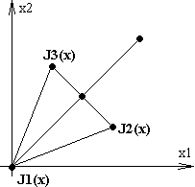
Fig.3.9 Polytop (2x3)
₁x
₂x
₃x
$D=\left[x,…,x\right]=\left(\begin{matrix}0 & d_{1} & d_{2} & ⋯ & d_{2} \\ 0 & d_{2} & d_{1} & ⋯ & d_{2} \\ ⋮ & & & & \\ 0 & d_{2} & d_{2} & ⋯ & d_{2} \\ 0 & d_{2} & d_{2} & ⋯ & d_{1}\end{matrix}\right)$

$d_{1}=\frac{t}{\sqrt[n]{2}}\left(\sqrt{n+1}+n−1\right)$ $d_{2}=\frac{t}{\sqrt[n]{2}}\left(\sqrt{n+1}−1\right)$

For example: the matrix D for two variables has dimension 2 x 3 and is equal

$\begin{aligned}\begin{matrix}D=\left(\begin{matrix}0 & 0,\text{965} & 0,\text{259} \\ 0 & 0,\text{259} & 0,\text{965}\end{matrix}\right) \\ \end{matrix} \end{aligned}$.
1 2 3

By start the method calculates in all vertex points (1, 2, 3) the value of the criterion J1(₁x), J2(₂x), J3(₃x). Melder-Mead method then generates a new test position by extrapolating the behaviour of the objective function measured at each test point arranged as a simplex.
The algorithm then chooses to replace one of these test points with the new test point and so the algorithm progresses. For this optimization we are using the function “fminsearch” from optimization Toolbox. The function is complete described in the help but for our quick use we give some basic remarks

Find local minimum of unconstrained
Function fminsearch
multivariable function using derivative-free method

x = fminsearch ('fun',x0)
x = fminsearch ('fun',x0,options)

Syntax
fmins('fun',x0)

'fun' the function to be minimized. It is a function that accepts a vector x and return
a scalar f . It can be an M-file function or an anonymous function
x0 a starting vector of initial parameter estimate
x is the result vector
options is a structure that provides control of optimization with specific conditions
defined by “options” structure. Use the “optimset” to set the options the values
of these fields in the options structure “OPTIONS”.

String
‘MaxFunEvals’ Maximum number of function evaluations allowed
‘MaxIter’ Maximum number of iterartions allowed
‘TolFun’ Termination tolerance on the function value
‘TolX’ Termination tolerance on x

Example of “optimset’:
OPTIONS=optimset(‘MaxIter’,1000, ‘TolX’, 1e-2)

Searching for the optimal mode
    - Searching for the optimal structure of the transfer function

Searching for the optimal structure of the transfer function is supposed as finding such a structure of the model, which gives us the best agreement between output from model $y_{M}(t)$ and the measured output from the plant.

Verification of the model is supposed as the act of proving the correctness of model output $y_{M}(t)$ to the measured plant output$y(t)$ with respect to the identification input signal $u(t)$.

For needs in this lecture we are limiting the verification to comparison of the model $y_{M}(t)$ .

By the practical parameter estimation the structure of transfer function is changed and the 7
judgment of agreement is passed between model and identified plant. The judgment is subjective and the following change of the model structure depends on experience of the engineer. We can give follow advices for model structure optimization:

- Check the steady states of model and identified plant.

- Check the transient parts of the responses that depend on order of the systems. By non minimum systems depend as well as on the degree of the numerator of the transfer function. The numerator degree shell bee small as possible.

- You must ensure that by a oscillating system the denominator of the transfer function contains at least one term $[(τs)^{2}+2\text{ξτ}⋅s+1];$
$$τ=1/{ω_{n}}; s_{\text{12}}=α±iω={\text{ξω}}_{n}±{iω}_{n}\sqrt{1−ξ^{2}};ξ∈(0,1)$$
- Chose degree of nominator zero and by changing step by step the degree of the denominator (1, 2, 3, 4) you shall prove how matches the responses of the model with the identified plant. It is possible to improve the model by choosing the degree of nominator 1 or maximal 2.

- Chose the time delay, when the identification measure of the plant matches with a time delay or you will make the order of the model smaller.

- Check the performance criterion. Attention! The value of the criterion cannot be taken absolutely and separately. We are always searching for a compromise solution between the complexity and the measure of approximation.

- An other parameter is the maximum number of function evaluations in the optimization function “fminsearch”. By begin is advised to choose 20-50 steps with follow-up increasing when the model structure is satisfactory.

- For model verification is necessary to move the model output to the working point.

    - Experimental identification procedure
The procedure of experimental identification of a system by searching the best model can be described by a flow-process diagram as it is shown in Fig. 3.10. Result from diagnostic evaluation and verification can optimize the model structure and the design of identification measure in feedback.

Completion
Model Verification
Plant Experiment
Determine Model Structure
Data Processing-Parameter Estimation
Design of Identification Measure
Diagnostic Evaluation
A priory
knowledge
Alternative
data
Feedback Model
Optimization
Fig. 3.10 Experimental identification procedure

  - Movement to the working point
By the model verification of congruence the outputs between the model $y_{M}(t)$ and plant$y(t)$are checked. Therefore it is suitable to move the linear model output $∇y_{M}(t)$ to the working point$y_{0},u_{0}\text{.}$The parameter estimation in the fig.3.8 has inputs $∇u(t)=u(t)−u_{0}$ and $∇y(t)=y(t)−y_{0}$. The output from the parameter estimation (identification) as a model is the transfer function $F(s)$. The linear (LTI) model input is $∇u_{M}(t)=∇u(t)=u(t)−u_{0}$ and
a)
b)
Obr.3.9 Variants of movement to the working point
d)
c)

Σ
Σ

the output is $∇y_{M}(t)$(see Fig. 3.9a). From the transfer function $F(s)$ the gain of the model $K_{M}$can be evaluated. There are some variants how the movement can be done to the working point.
  - According the definition of the transfer function
  - When we will carry out the moving in the working point, the input to the LTI model must be $∇u_{M}(t)=∇u(t)=u(t)−u_{0}$ and the output will be $∇y_{M}(t)$. In working point the output from model will be $y_{M}(t)=∇y_{M}(t)+y_{0}$ as shown in the Fig. 3.9b.
  - An other possibility how to carry out the moving to the working point is shown in Fig. 3.9c. By this structure the addition of $y_{0}$ to output will be replaced by the term $u_{\text{KOR}}={y_{0}}/{K_{M}}$ on input. The LTI model input can be calculated as
$u_{M}(t)=u(t)−u_{0}+u_{\text{KOR}}=u(t)−u_{0}+{y_{0}}/{K_{M}}=∇u_{M}(t)+{y_{0}}/{K_{M}}$
  - In the Fig. 3.9.d is shown the variant, which has the input to the LTI model $u(t)$ . It means that the influence of $u_{0}$ must be replaced on LTI output as the term $y_{\text{KOR}}=−u_{0}\text{.}K_{M}$ . The model output can be calculated as
$y_{M}(t)=∇y_{M}(t)+y_{0}−y_{\text{KOR}}=∇y_{M}(t)+y_{0}−u_{0}\text{.}K_{M}$

Model Reduction

By the experimental identification the order of the mathematical model and the structure of the transfer function (order of the polynomials in numerator and denominator) must be estimated. It can happen that the order of the model was chosen higher as than required to fulfill a control purpose. In this case is recommended order reduction.
Generally the base for the reduction is to find modes that are unreachable and unobservable that can be pruned. You can see there are modes with small influence. By the order reduction this modes are cancelled. This will cause that the approximating dynamic behavior have to keep the static gain or magnitude in given range of frequencies.
How can we pick out such a case? First we must check poles and zeros and decided if a pair of a pole and a zero can be reduced. Second we must analyze contribution of each pole to the input-output relationship.
Basic steps and the procedure will be shown by the following example. Here's shown how to reduce the model "by hand" without the use of MATLAB software resources.
Example 3.8-1

Let us consider a SISO system, which dynamic is approximated by the transfer function: $F(s)=\frac{1}{\left(s+0,\text{01}\right)\left(s+0,2\right)\left(s+5\right)}$.

Reducing the model order can be performing by residualisation or truncation of the model poles.

a) Residualisation

The transfer function can be written in the form
$$\frac{1}{\left(s+0,\text{01}\right)\left(s+0,2\right)\left(s+5\right)}=\frac{0,1}{\left(s+0,\text{01}\right)}⋅\frac{2}{\left(s+0,2\right)}⋅\frac{5}{\left(s+5\right)}$$
You can see that the factor $\frac{5}{\left(s+5\right)}$ has the mode (root) that represents a mode, which in comparison with the remaining modes is very fast, so that its dynamic can be neglected.
We therefore consider only steady state for which the factor is equal to $\frac{5}{\left(s+5\right)}≈1$. Reduced transfer function (model) is equal to $F_{R}(s)=\frac{0,1}{\left(s+0,\text{01}\right)}⋅\frac{2}{\left(s+0,2\right)}$.
b) Truncation

Consider we write F(s) in terms of partial-fraction expansion:
$$\frac{1}{\left(s+0,\text{01}\right)\left(s+0,2\right)\left(s+5\right)}=\frac{1,\text{0547}}{\left(s+0,\text{01}\right)}−\frac{1,\text{0547}}{\left(s+0,2\right)}+\frac{0,\text{0418}}{\left(s+5\right)}$$

You can seen that the gain of the third member in comparison with other is small, so that we can consider: $\frac{0,\text{0418}}{\left(s+5\right)}≈0\text{.}$ Reduced transfer function is than equal
$$F_{R}(s)=\frac{1,\text{0547}}{\left(s+0,\text{01}\right)}−\frac{1,\text{0547}}{\left(s+0,2\right)}=\frac{0,\text{200394}}{\left(s+0,\text{01}\right)\left(s+0,2\right)}\text{.}$$
End of example 3.8-1

Standardization of input and output signals

By analyzing and simulation of the model properties of real systems it is usually necessary to carry out a standardization of input and output signals. The aim of standardization is that the inputs/outputs were approximately equal, and lay in the interval (-1, +1). Standard output is equal to
$y∗(t)=S_{0}⋅y(t)→Y∗(s)=S_{0}⋅Y(s)$,
where $S_{0}$ … is a diagonal matrix of conversion factors (coefficients) of output signals .
In a similar way for standardized output can be written
$u∗(t)=S_{ι}⋅u(t)→U∗(s)=S_{i}⋅U(s)$,
where $S_{i}$…. is a diagonal matrix of conversion factors (coefficients) of input signals.
Since the Laplace transform of output Y(s) can be calculated from the transfer function and L transform from input, the standardized output is equal to

$Y(s)=F(s)U(s)→Y∗(s)=S_{0}F(s)U(s)$.

In a similar way the standardized input can be calculated and than the normalized output is equal to

$$U(s)=S{}_{i}^{−1}{}⋅U∗(s)→Y∗(s)=S_{0}F(s)S{}_{i}^{−1}{}⋅U∗(s)=F∗(s)⋅U∗(s)$$
Normalized transfer matrix (transfer function) matrix is calculated from the equation

$\text{F*}(s)=S_{0}F(s)S{}_{i}^{−1}{}$.

- Program for parametr estimation in MATLAB
  - Flow-process diagram
Data Enter (File name, measured data,
data variable, working point)
Start
Evaluation of the criterion
’critT’
Creating u, y, tG and
increments uG, yG
Plot Graph
Displaying the transfer
function structure
Creating of the vector x and a LTI object.

Settings OPTIONS value.

Invoke „fminsearch (‘crit‘, x, OPTIONS)

OUTPUTS

End

  - Program and function in MATLAB

%A_idT
%F=K/(Ts+1)^n, n=3, measure with sample time=0,1sec
close all
clear all
global tG uG yG N A
load ('SU02') %Data Enter,Datei name, measured data,
%data variable
u=W(:,1);y=W(:,2); %Creating of the vector u, y
tG=0:0.1:(length(u)-1)*0.1; %Creating of the time vector tG
figure (1)
plot(tG,y,tG,u) %Plot graph - measured data
title ('Graph of mesurenment')
%working point
y0=2.5;u0=2; %working point
yG=y-y0; %increment yG
uG=u-u0; %increment uG

figure (2)
plot(tG,yG,tG,uG) %Plot graph - increments yG, uG
title ('Graph of increments yG,uG')
pause
%Displaying the transfer function structure

disp('Approximation by the transfer funcion')
disp(' x(1) K ')
disp('F(s)=------------------ = -----------')
disp(' (x(2).s + 1)^3 (Ts + 1)^3')

%Creating of the vector x and a LTI object
N=2 %N=n-1
T=0.5 %start at the Time constant=0,5
K=1 %start at the gain=1
A1=[T 1]; %polynomial A1=(Ts+1)
A=A1;
for i=1:N; %evaluation of (Ts+1)^3
A=conv(A,A1);
end
s=tf(K,A) %LTI object s
roots(A)
x=[K T] %start point x0:x(1)=K…gain, x(2)=T… time constant
critT(x) %evaluation of the function to be minimzed
disp('running...')

%setting the values of the field in the "options" structure
OPTIONS=optimset('MaxIter',50,'TolX',1e-1);
%start of the finding a minimum by the "fminsearch"
x=fminsearch('critT',x,OPTIONS);
%outputs
disp('Optimalized vector x')
x
disp('Function/criterion value J')
critT(x)
roots(A)
tf(x(1),A)
sys=tf(x(1),A);
[yi,ti]=lsim(sys,uG,tG);

figure(3) %Plot graph outpu of the LTI model and measured increments
plot(tG,yG,tG,uG,ti,yi)

The criterion as an M-file “criT”

%criT(x)
function f=critT(x) %the function to be minimzed
global tG yG uG N A
A1=[x(2) 1];
A=A1;
for i=1:N; %evaluation of the polynomial [x(2)+1]^3=(Ts+1)^3
A=conv(A,A1);
end
sys=tf(x(1),A); %creating of a LTI object
[yi,ti]=lsim(sys,uG,tG);%evaluation of yi=yM(i)
%plot(ti,yi,ti,yG)
%pause (0.1)
f=sum((yG-yi).*(yG-yi));%function evaluation

- Introduction to using MATLAB

Subject specifications consider that utilizations of MATLAB software tools are involved in practical lessons. As you know MATLAB is a technical computing language for high-performance mathematical computation and visualization. MATLAB integrates numerical analysis, matrix computation, signal processing, and graphics in easy to use environment.
The MATLAB R2006a involves products of the MATLAB Product Family. The structure can be depicted as shown in the Fig.5-1. You see the MATLAB consists of MATLAB Extension, MATLAB Toolboxes, SIMULINK, SIMULINK Extension and SIMULINK Blocksets.
- MATLAB Extension are optional tools that supports the implementation of systems developed in MATLAB.
- MATLAB Toolboxes are libraries of MATLAB functions and tools.
- SIMULINK is a system for nonlinear simulation that combines a block diagram interface and simulation with numeric, graphics, and language functionality of MATLAB.
- SIMULINK Extensions are optional tools that support the implementation of systems developed in SIMULINK.
- SIMULINK Blocksets are collections of SIMULINK Blocks designed for use in specific application areas.

The software product is very good described in user’s manuals [1,2,3,4,5] and offers help functions by implementation of this software.
In spite of that it is not easy for students to use it because of the software is very large.
Students must apply this software for solving theoretical and practical tasks. To help them to find quickly orientation in MATLAB software we prepared in chapter 5 an introduction to MATLAB. Of course in this chapter we explain only the most important functions that are necessary to understand explained identification program and carry out necessary changes.
We hope that shall help students to be able as soon as possible to solve their tasks.

SIMULINK
MATLAB
MATLAB Extension
MATLAB Compiler
MATLAB C Math Library

MATLAB Toolboxes
Control Systems
Financial
Fuzzy Logic
Frequency Domain System
Financial
Model Predictive Control
System Identification
Model Predictive Control
μ-Analysis and Synthesis
Neural Network
Optimisation
Robust Control
Signal Processing
Spline
Statistic
Symbolic Mat

SIMULINK Extensions

Real Time Workshop

SIMULINK Block sets

Fig.5-1. The MATLAB Product Family

Command
Windows
WORKSPACE

Variables
Files
Objects

  - Desktop Tools and Development Environment

- Starting MATLAB

On Windows platforms, start MATLAB by double-clicking the MATLAB shortcut icon on your Windows desktop.
You can customize MATLAB startup. For example, you can change the directory in which MATLAB starts or automatically execute MATLAB statements in a script file named startup.m. For More Information See Starting MATLAB in the Desktop Tools and Development Environment documentation.

- Quitting MATLAB

To terminate your MATLAB session, select File -> Exit MATLAB in the desktop, or type quit in the Command Window. You can run a script file named finish.m each time MATLAB quits that, for example, executes functions to save the workspace, or displays a quit confirmation dialog box. For More Information See Quitting MATLAB in the Desktop Tools and Development Environment documentation.

- MATLAB Desktop

When you start MATLAB, the MATLAB desktop appears (see Fig.5.1-1), containing tools (graphical user interfaces) for managing files, variables, and applications associated with MATLAB. The illustration in Fig. 5.1-1 shows the default desktop. The MATLAB desktop consists of Command Window, Current Directory and Command History window.
You can customize the arrangement of tools and documents to suit your needs. For more information about the desktop tools, see Desktop Tools and Development Environment.

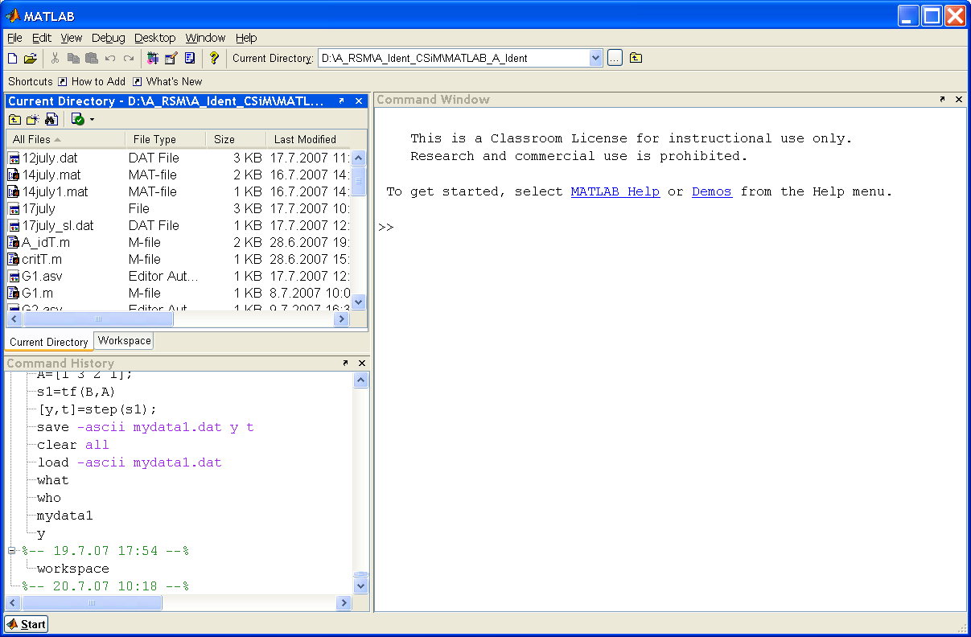
Fig. 5.1-1 MATLAB desktop

  - Workspace, Editor, Search path and File Operations
The workspace is the set of variables maintained in memory during a MATLAB session. Use the Workspace browser or equivalent functions to view the workspace.

Workspace operations

- This function displays Workspace browser, the graphical user interface that allows you to view and manage the contents of the workspace.
workspace
who, whos
- This functions list all variables in the currently active workspace.

clear all
3) This function removes all variables from the workspace.

clear name
4) This function removes just the M-file or MEX-file function or
    - variable name from the workspace.

clear global name
5) This function removes the global variable name.

Editor and Command Window operation
clc
1) This function clears the screen.

edit

2) This function opens a new editor window.

- This function opens the M-file fun in the default editor.
edit fun.m

edit fun1 fun2 … …

- This function opens fun1.m fun2.m, and so on, in the
default editor.

You can use an alternative to the “edit” function, select New or Open from the File menu in the MATLAB desktop or any desktop tool.

Search part and File operation
search

- This function displays the current MATLAB search path.

cd

- This function changes working directory.

- This function lists the directory.
dir

exist name
- This function checks existence of variable, function,
or directory.
what
- This function lists the M, MAT, MEX, MDL, and P-files and the class directories that reside in the current working directory.
which fun
- This function displays the full pathname for the argument fun.

type ('filename')

type filename
- This function displays the contents of the specified file in the MATLAB Command Window.

Select function size, length, roots, conv, disp, pause

d=size (X)
- This function returns the sizes of each dimension of array X in
a vector d with ndims(X) elements. If X is a scalar, which
MATLAB.
[m n]=size (X)
- This function returns the size of matrix X in separate variables m
and n.

- This function returns the size of the longest dimension of X. If X is
n = length(X)
a vector, this is the same as its length.

- This function returns a column vector whose elements are the
r = roots(c)
roots of the polynomial c.
w = conv(u,v)
- This function convolves vectors u and v. Algebraically, convolu
tion is the same operation as multiplying the polynomials whose
coefficients are the elements of u and v.
disp (X)
6) This function displays an array, without printing the array name.
If X contains a text string, the string is displayed.
pause
- This function by itself, causes M-files to stop and wait for you to
any key before continuing.

8) This function pauses execution for n seconds before continuing,
pause(n)
where n can be any nonnegative real number. The resolution of
the clock is platform specific. A fractional pause of 0.01 seconds
should be supported on most platforms.

  - LTI models
    - Creating of Some Linear Models
1) Creation of transfer function models

Specify transfer function by given coefficient of nominator or denominator, or converts state-space or zero-pole-gain
Function tf
models to the transfer function form.

Syntax function
sys = tf(num, den)

tfsys = tf(sys)

Creates a continuous-time transfer function with numerator(s)
and denominator(s)
Converts an arbitrary SS or ZPK LTI model sys to transfer
function form

where
sys is a TF object storing the transfer function data,
num, den are the real- or complex-valued row vectors of numerator and
denominator coefficients ordered in descending powers of.
These two vectors need not have equal length and the transfer
function need not be proper. For example, s1=tf([1],[1 0] speci
fies the integrator 1/s.

2) Creation of zeros-pole-gain model
Function zpk
Specify zero-pole-gain model or convert LTI model to zero-pole.
Syntax function
sys = zpk(z,p,k)

zsys = zpk(sys)

creates a continuous-time zero-pole-gain model with ze-
ros z, poles p, and gain(s) k.
converts an arbitrary LTI model sys to zero-pole-gain
form

where
sys is a ZPK object storing the model data
z and p are cell arrays of vectors with as many rows as outputs and as
many columns as inputs, and k is a matrix with as many rows
as outputs and as many columns as inputs.

In the SISO case, z and p are the vectors of real- or complex-valued zeros and poles, and k is the real- or complex-valued scalar gain.

$\text{sys}=k\frac{(s−z(1))(s−z(2))\text{.}\text{.}\text{.}(s−z(m))}{(s−p(1))(s−p(2))\text{.}\text{.}\text{.}(s−p(n))}$

Set z or p to [] for systems without zeros or poles. These two vectors need not have equal length and the model need not be proper (that is, have an excess of poles).

3) Creation of State-Space Models
Function ss
specify state-space models or convert LTI model to state
space

Syntax function
sys = ss(A,B,C,D)

sys_ss = ss(sys)

creates the continuous-time state-space model,

converts an arbitrary TF or ZPK model sys to state space.

In the SISO case, for a model with Nx states $x$, one output $y$and one input $u$ , the continuous state space model can be described by equations

$\begin{aligned}\overset{˙}{x}=\text{Ax}+Bu \\ y=Cx+\text{Du}\end{aligned}$

where
A is an [Nx,Nx] real- or complex-valued matrix
B is an [Nx,1] real - or complex-valued vector
C is an [1,Nx] real - or complex-valued matrix
D is an [1,1] real- or complex-valued scalar. If you can simply set d to zero.
sys is an SS model that stores the model data

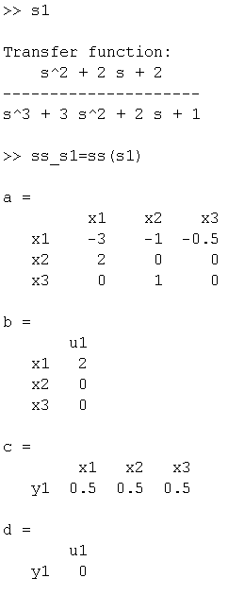
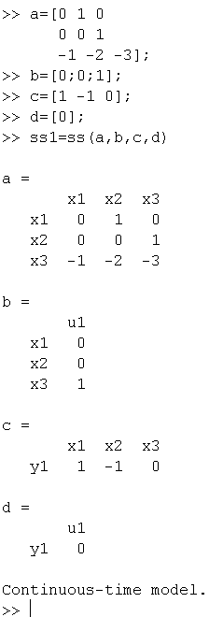
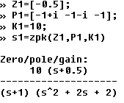
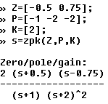
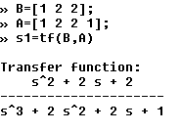
Example 5.3-1
Example 5.1-3

Example 5.1-2

Example 5. 3- 4

Example 5. 3-5

    - Data Extraction
Function tfdata
1) Access transfer function data

Syntax function
[num,den] = tfdata (sys)

[num,den] = tfdata (sys,‘v‘)

returns the numerator(s) and denominator(s) of the transfer function as a LTI array of , SS or ZPK models,

For SISO transfer function, the syntax forces tfdata to
return the numerator and denominator directly as row
vectors rather than as cell arrays.
Example 5. 3-7

Example 5. 3- 6

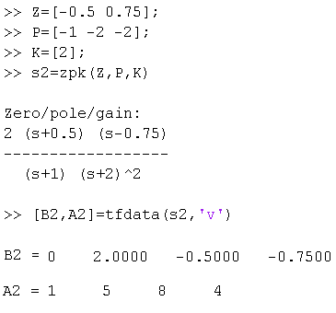
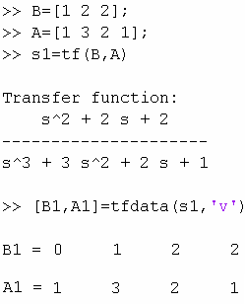

Function zpkdata
2) Access zero-pole-gain data

Syntax function
[z,p,k] = zpkdata (sys)

[z,p,k] = zpkdata (sys,‘v‘)

The syntax returns zeros z, poles p, and gain(s) k of the zero- pole-gain model sys.

For SISO transfer function, the syntax forces zpkdata to
return the zeros and poles directly as column vectors
rather than as cell arrays (see example below).
Example 5. 3- 8

Example 5. 3- 9

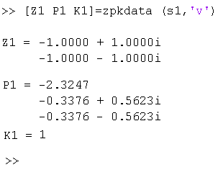
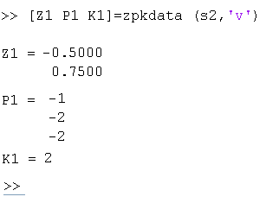

Function ssdata
3) sss Access state-space data

Syntax function
[a,b,c,d] = ssdata (sys)

The syntax extracts the matrix (or multidimensional array) data from the state-space model (LTI array) sy
Example 5. 3-10

Example 5. 3- 11

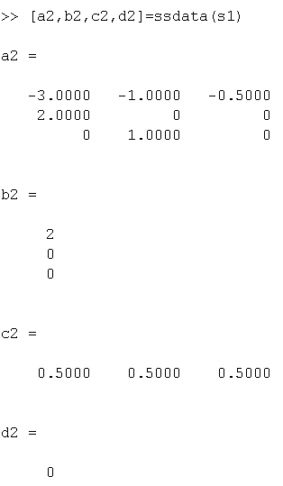
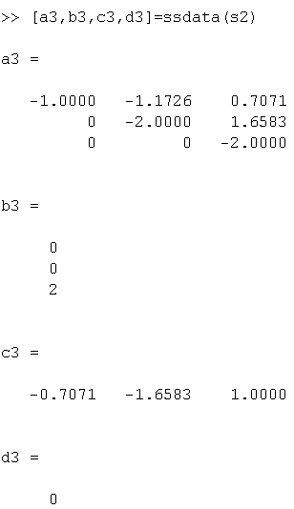

  - Time Domain Analysis

Function step
1) Step response of LTI systems

Syntax function
This step function calculates the unit step response of a
step (sys)

step (sys,t)

step (sys1,sys2,…,sysN)

[y,t,x] = step (sys)

linear system.
When invoked with no output arguments, this function
plots the step response on the screen.
This function sets the simulation horizon explicitly. You
can specify either a final time t = Tfinal or a vector of
evenly spaced time samples of the form t = 0:dt:Tfinal
This function plots the step responses of several LTI mod-
els.
This syntax returns the output step response y, the time
vector t used for simulation, and the state trajectories x
(for state-space models only).

Example 5.4- 1

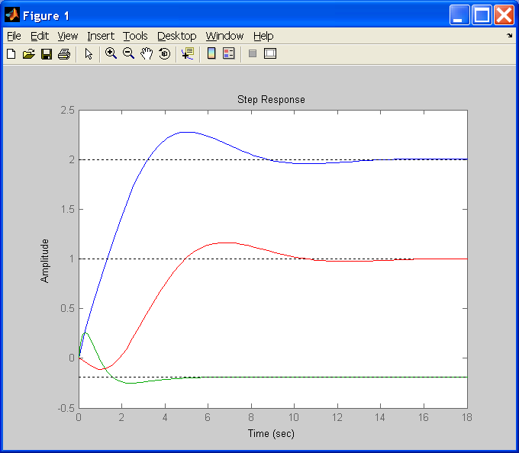
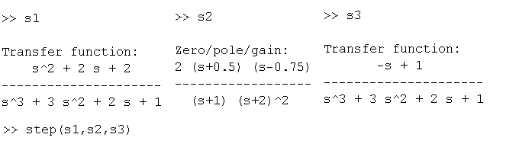

Function impulse
2) Impulse response of LTI systems

Syntax function
This impulse function calculates the unit step response
impulse (sys)

impulse (sys,t)

impulse (sys1,sys2,…,sysN)

[y,t,x] = impulse (sys)

of a linear system. When invoked with no output arguments, this function plots the impulse responses on the screen.
This function sets the simulation horizon explicitly. You
can specify either a final time t = Tfinal or a vector of
evenly spaced time samples of the form t = 0:dt:Tfinal
This function plots the impulse responses of several LTI
models.
This syntax returns the output impulse response y, the time vector t used for simulation, and the state trajectories x (for state-space models only).
Example 5. 4- 2

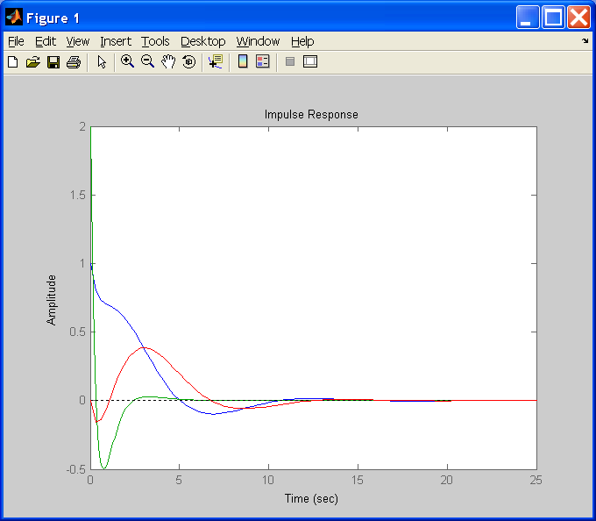

Function lsim
3) Simulate LTI model responses to arbitrary inputs

Syntax function
This function simulates the (time) response of continuous or discrete linear systems to inputs u and time history t. The vector t specifies the time samples for the simulation and consists of regularly spaced time samples: t = 0:dt:Tfinal.
lsim (sys,u,t)

lsim (sys,u,t,x0)

[y,t] = lsim (sys,u,t)

[y,t,x] = lsim (sys,u,t)

When invoked without left-hand arguments, lsim plots the response on the screen.
This function further specifies an initial condition x0 for the system states.

This syntax returns the output response y, the time vector t used for simulation. No plot is drawn on the screen.

This syntax returns the output response y, the time vec-
tor t used for simulation, and the state trajectories x for
state-space models only.

lsim(sys) opens the Linear Simulation Tool GUI. For more information about working with this GUI, see Working with the Linear Simulation Tool in

Function gensig
4) Generate test input signals for lsim

Syntax function

[u,t]=gensig (type,tau)

[u,t]=gensig (type,tau,Tf,Ts)

This function generates a scalar signal u of class type
with period tau (in seconds) and returns a vector t of
time samples. The vector u of signal is defined values
at these samples. All generated signals have unit ampli
tude.The following types of signals are available:

'sin' Sine wave
'square' Square wave
'pulse' Periodic pulse.

This function also specifies the time duration Tf of the
signal and the spacing Ts between the time samples t.

You can feed the outputs u and t directly to lsim and simulate the response of a single-input linear system to the specified signal.

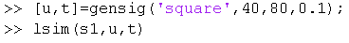
Example 5. 4- 3

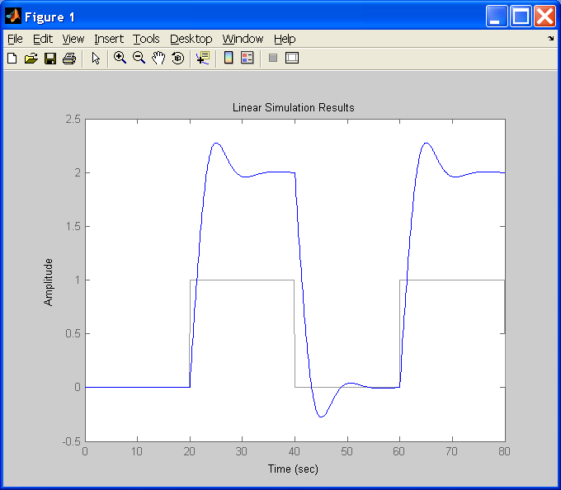

  - Some basic plotting function

MATLAB provides a variety of functions for displaying vector data as line plots, as well as functions for annotating and printing these graphs. We will explain the function “plot” that produces 2-D line plots with linear scales for both axes

Function plot
1) 2-D line plot

Syntax function
This function plots the columns of Y versus their index if Y is a real number.
plot (Y)

plot (X1,Y1,…)

This function plots all lines defined by Xn versus Yn pairs

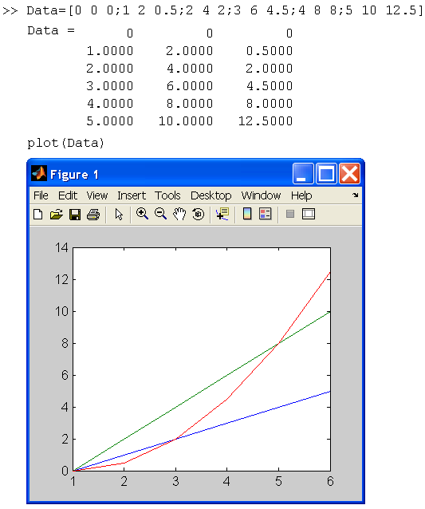
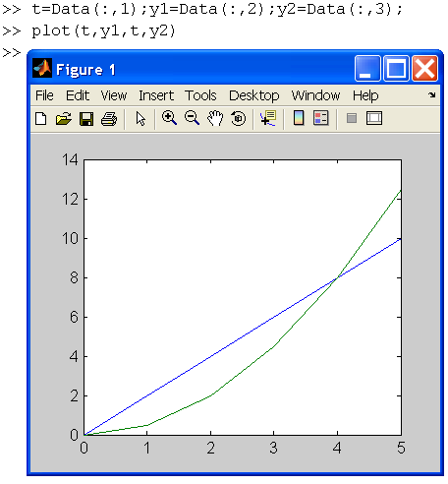

Example 5.5-1

Function title
2) adds title at the top of the Figure

Syntax function
title (‘string‘)

This function adds the string at the top of the figure

Function xlabel, ylabel, zlabel
3)

Syntax function
xlabel (‘string‘)

ylabel (‘string‘)

zlabel (‘string‘)

This function labels the x-axis of the current axis

This function labels the y-axis of the current axis

This function labels the z-axis of the current axis

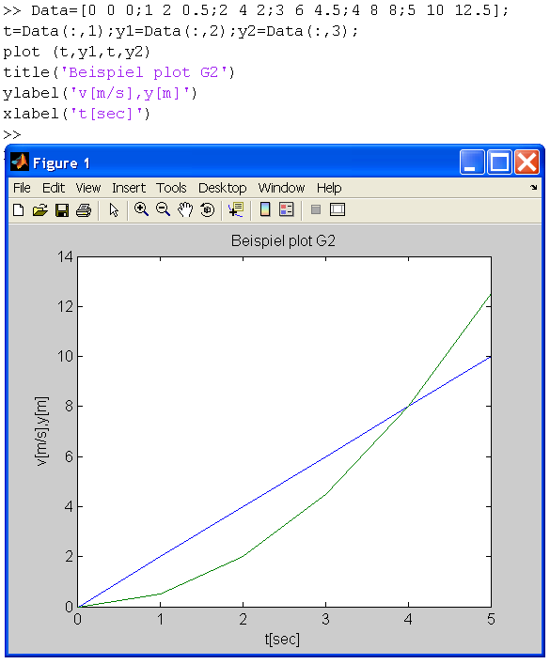
Example 5. 5-2

Function LineSpec
- determines line type, marker, symbol and color
of the plotted lines.

MATLAB enables to define Line style, Marker type, Color, Line width, Marker size, Marker face and edge coloring. MATLAB uses string specifiers for Line style, Marker type and Color that are listed in Tab.1,2 and 3:

Tab.1 Line Style specifiers Tab.2 Marker Specifier

Line style | Specifier
solid line | -
dashed line | --
dotted line | :
Dashed-dot line | -.
Marker Type | Specifier
Plus sign | +
Circle | o
Asterisk | *
Point | .
Cross | X
Square | s
Diamond | d
Upward-pointing triangle | ^
Downward-pointing triangle | V
Right-pointing triangle | >
Left-pointing triangle | <
Five-pointed star | p
Six-pointed star | h

Tab.3 Color Specifiers
Color | Specifier
Red | r
Green | g
Blue | B
Cyan | c
Magenta | m
Yellow | y
Black | k
White | w

Function figure
4) Create figure graphic object

Syntax function
figure

figure (h)

This function creates a new figure objects - the individual windows on the screen
Suppose h is an integer and is not a number of existing figure, then this
function creates a figure and assigns it the number h.

Function hold
5) Retain current graph in figure

Syntax function
hold

hold on

hold off

hold all

This function determines whether new graphics object are added to the graph or replace objects in the graph.
This function retains the current plot and certain axes properties so that subsequent graphing commands add to the existing graph.
This function resets axes properties to their defaults before drawing
new plots
This function holds the plot and the current line color and line style so
that subsequent plotting commands do not reset the ColorOrder and
LineStyleOrder property.

Applying of the function “figure” and “string specifiers” for line style and color is presented in the example 5.3-3. In the Figure 1 only the color is specified. The first string defines a red color ‘r’, the second string the blue color ‘b’.
In the Figure 2 is added the specification of the Line style. The first string defines a dashed line of red color ‘--r’, the second string the dashed-dot line of blue color. The first string defines a dashed line of red color ‘--r’, the second string the dashed-dot line of blue color ‘-.b’.
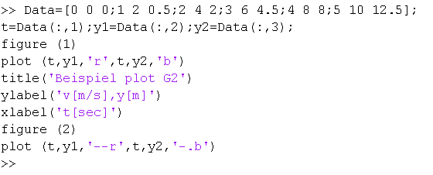
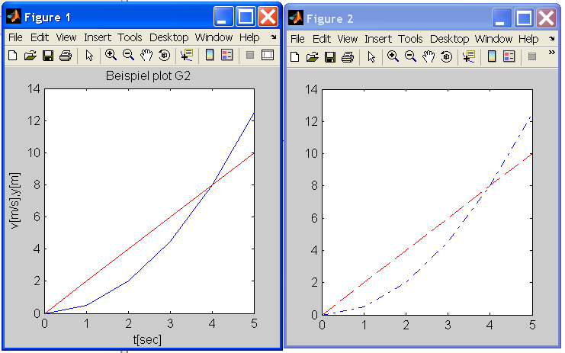
Example 5. 5-3

Use of the string specifiers for marker, line and color is shown in the example 5.3-4. In the figure 3 the first string defines a dashed line of red color with marker type of square ‘--rs’, the second string the dashed-dot line of blue color with marker type of circle ‘-.bo’.
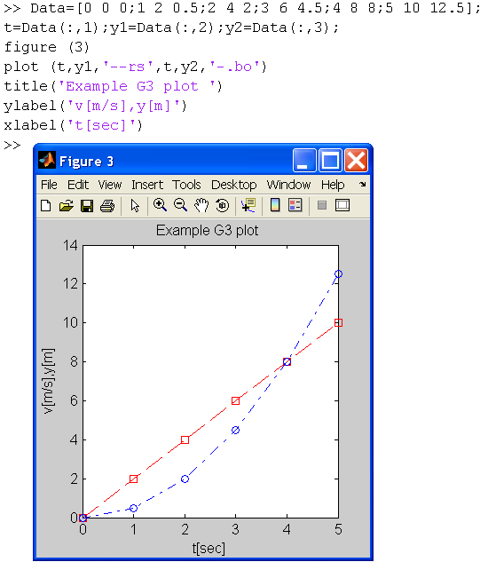
Example 5. 5-4

The other line characteristic can be specified as Related Properties by follow strings:

‘LineWidth’ … the width in points of the line,
‘MarkerEdgeColor’ … the color of the marker or the edge color for filled marker,
‘MarkerFaceColor’ … the color of the face of filled marker
‘MarkerSize’ … the size of the marker,

Use of the function “hold” and strings ‘LineWidth’, ‘MarkerEdgeColor’, ‘MarkerFaceColor’,‘MarkerSize’ is demonstrated in the example 5.3-5.
In the figure 1 is first prepared for plot the line 1. We added to the line specification the specification of the line width 'LineWidth',2,, color of the marker 'MarkerEdgeColor','k',color of the face of the of filled marker 'MarkerFaceColor','g', and the size of the marker 'MarkerSize',10. The marker size of the square is 10 points.
After setting the command “hold on” is added the line 2. The line width is now 4 points, the marker size of the circle is 20 points

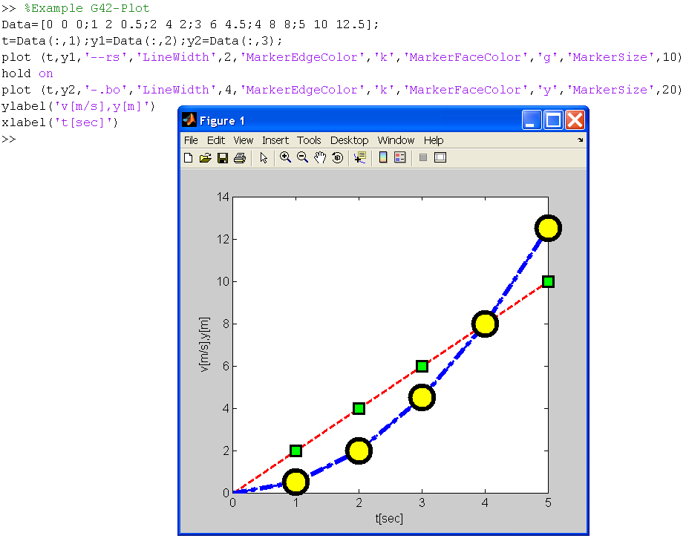
Example 5.5-5

  - Opening, loading, saving files
Function save
1) Save workspace variable to disk

Syntax function

This function stores all workspace variable in a binary
save

save filename

save filename var1 var2…

save (filename)

save (’stringfilename’)
save (‘filename’,’var1’,…)

format in the current directory in a file named
“matlab.mat”. Retrieve the data with “load”.
This function stores all workspace variables in the current directory in the “filename.mat”.
This function stores only specified workspace variables var1,var2,… in the given filename.mat”.
This functions store all workspace variables in the
current directory in the “filename” that is a string.
You must specified: filename=’stringfilename’
You can use direct the string ’stringfilename’
This function stores only specified workspace variables described as string ‘var1’,… in the given ‘filename’.

Save all variables from workspace in binary MAT-file
Example 5.6-1

named matlab.mat. List variables in workspace applying function whos. Check files in current directory using functions what.
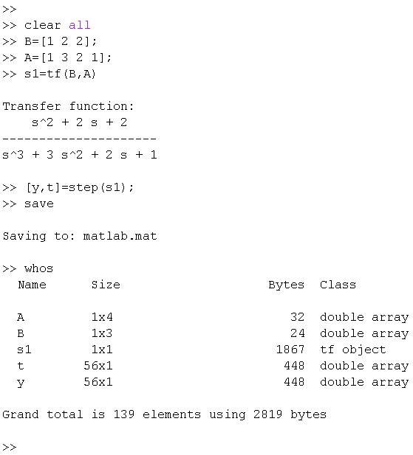
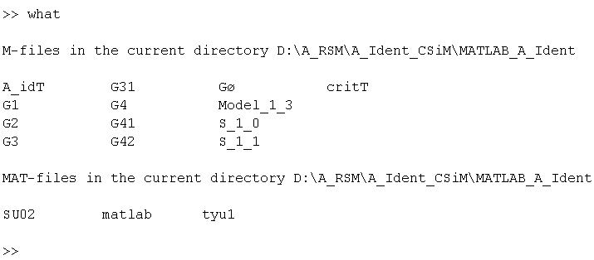

Save all variables from the workspace in binary MAT-file
Example 5. 6-2

named 14july.mat. List files in current directory using functions
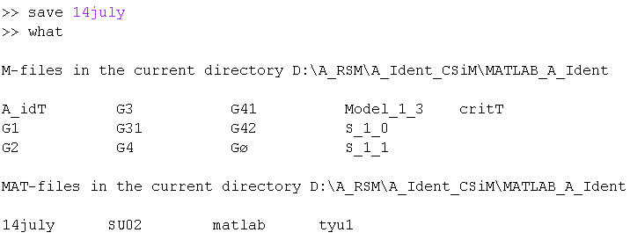
what.

Example 5. 6-3

a) Save the y, t variables from the workspace in binary MAT-file
named 14july1.mat.
- Assign the string ‘test14_july2’to the variable – filename savefile. Save all variable in file specified by string ‘test14_july2’
- Save the variable A, B specified by strings ‘A’, ‘B’ in the file specified by the string ‘test14_july1’.
- Save all variables from the workspace to the binary MAT-file
named by the string ‘test14_ july3’.
- Save the variables specified by strings ‘y’, ‘t’ from the workspace in the MAT file named by the string ‘test14_july4’. List files in current directory the using function what.

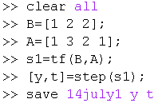
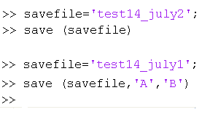
a)
b)
c)

Example 5.4-1

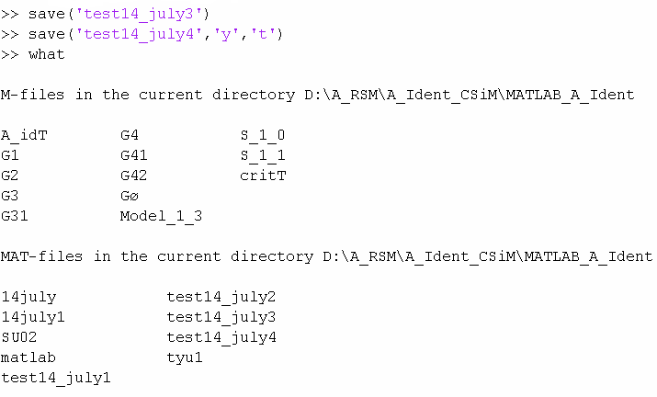
d)
e)

d)
e)

Function load
2) Load to workspace variable from disk

Syntax function

This function loads all the variables from the MAT-file mat in “matlab.mat” to the workspace.
load

load filename

load filename X Y Z …

load filename –regexp expr1 expr2 …

load –asci filename

load –mat filename

This function loads all variables from the file specified by the “filename.mat” to the workspace. The filename is a string specifying by a file name.

This function loads just the specified variables X, Y, Z, etc. from the MAT-file.

This function loads just those variables that match any of the regular expressions given by expr1, expr2, etc.

This function forces load to treat the file as an ASCI- file, regadless of file extension. If the file is not numeric text, load returns an error.

This function forces load to treat the file as an MAT- file, regadless of file extension. If the file is not numeric text, load returns an error.

Example 5. 6-4

Loading from a binary MAT-file.
      - Use function who to see which variables are in the work space.
      - Clear workspace and load a binary MAT-file specified by its string. Check the variables in the Workspace.

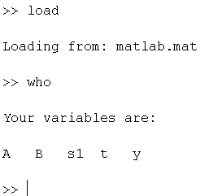
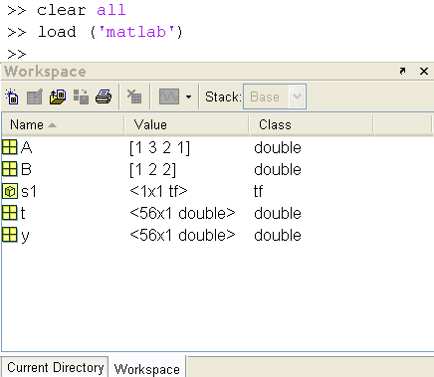

Example 5.4-4

- Clear the workspace and load the variables from the MAT-file 14july. Check the variables in the Workspace.
Example 5. 6-5

- Clear the workspace and load the variables from the MAT-file 14july1. Use the function who to see which variables are in the work space.

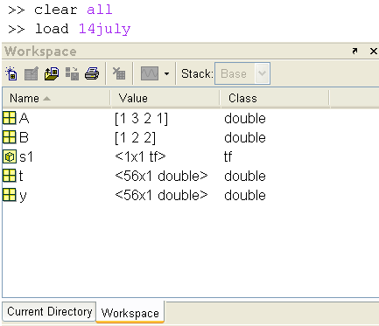
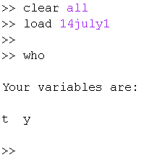

Example 5. 6-6

Loading a list of variables.
- Clear the workspace and load the variables y t from the MAT-file 14july. Use the function who to see which variables are in the work space.
- Clear the workspace and load the variable y from the MAT-file 14july. The file and variable y are specified as a string. Use the function who to see which variables are in the work space.

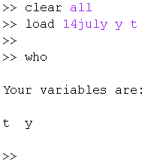
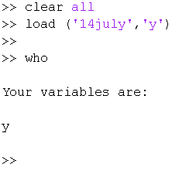

  - Programming-flow control

Function If, else, and elseif

1.

The if statement evaluates a logical expression and executes a group of statements when the expression is true. The optional elseif and else keywords provide for the execution of alternate groups of statements. An end keyword, which matches the if, terminates the last group of statements. The groups of statements are delineated by the four keywords -- no braces or brackets are involved.
Example 5.7-1

Syntax function

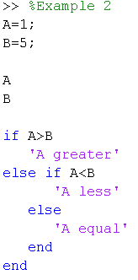
if expression1
statements1
else if expression2
statements2
else
statements3
end

Expression is a MATLAB expression, usually consisting of variables or smaller expressions joined by relational operators (e.g., count < limit), or logical functions (e.g., isreal(A)).

Simple expressions can be combined by logical operators (&&, ||, ~) into compound expressions such as the following. MATLAB evaluates compound expressions from left to right, adhering to operator precedence rules.
(count < limit) && ((height - offset) >= 0)

Statements is one or more MATLAB statements to be executed only if the expression is true or nonzero.

Function switch and case
2.

The switch statement executes groups of statements based on the value of a variable or expression. The keywords case and otherwise delineate the groups. Only the first matching case is executed. There must always be an end to match the switch

Switch statements syntax
switch switch_expr
case case_expr
statement, ..., statement
case {case_expr1, case_expr2, case_expr3, ...}
statement, ..., statement
otherwise
statement, ..., statement
end

The switch statement syntax is a means of conditionally executing code. In particular, switch executes one set of statements selected from an arbitrary number of alternatives. Each alternative is called a case, and consists of The case statement One or more case expressions One or more statements

In its basic syntax, switch executes the statements associated with the first case where switch_expr == case_expr. When the case expression is a cell array (as in the second case above), the case_expr matches if any of the elements of the cell array matches the switch expression. If no case expression matches the switch expression, then control passes to the otherwise case (if it exists). After the case is executed, program execution resumes with the statement after the end.

Example 5.7-2

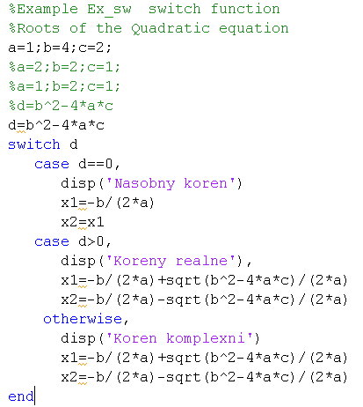

Function for
3.

The for loop repeats a group of statements a fixed, predetermined number of times. A matching end delineates the statements.
The columns of the expression are stored one at a time in the variable while the following statements, up to the end, are executed. In practice, the expression is almost always of the form scalar : scalar, in which case its columns are simply scalars. The scope of the for statement is always terminated with a matching end:
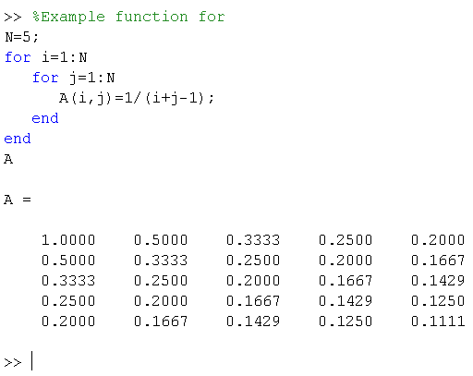
Example 5.7-3

Syntax
for variable1 = expression1
statements
...
for variable2 = expression2
...
statements
...
end2
...
statements
...
end1

4.
Function while

The while loop repeats a group of statements an indefinite number of times under control of a logical condition. A matching end delineates the statements.

while expression
statements
end

while repeats statements an indefinite number of times. The statements are executed while the real part of expression has all nonzero elements. expression is usually of the form
expression rel_op expression

where rel_op is ==, <, >, <=, >=, or ~=.

The scope of a while statement is always terminated with a matching end.

Function continue
5.

The continue statement passes control to the next iteration of the for loop or while loop in which it appears, skipping any remaining statements in the body of the loop. In nested loops, continue passes control to the next iteration of the for loop or while loop enclosing it.

Function break
6.

The break statement lets you exit early from a for loop or while loop. In nested loops, break exits from the innermost loop only

Function return
7.

The return terminates the current sequence of commands and returns control to the invoking function or to the keyboard. return is also used to terminate keyboard mode. A called function normally transfers control to the function that invoked it when it reaches the end of the function. You can insert a return statement within the called function to force an early termination and to transfer control to the invoking function.

Literatura

[ 1] NOSKIEVIČ,P.: Modelování a identifikace systémů. MONTANEX a.s.,
1999, Ostrava.
[ 2] GRACE, A.-LAUB, J.A-LITTLE, J.N.-THOMPSON, C.M.: Control System Tool-
box. For Use with MATLAB. User's Guide. The Math Works, Inc.1995.
[ 3] HANUŠ, B.- ALEXÍK, M.- BÍLA, J.- KROC, L.- KRUPKA, Z.: Teorie automatického
řízení II. Skripta Liberec,1985.
[ 4] NELDER, J.A.-MEAD, R.: A Simplex Method for Function Minimization. Cmputer
Journal, Vol.7, p.308-313.

QUESTIONS - IDENTIFICATION SYSTEM
1) What is mathematical model, type of models, parametric and non-parametric models
and their identification, input and output signals?
2) What do you know about types of noise signals and their effect on the estimation of
the parameters?
3) What is the working point, how must be chosen, design of the excitation functions for
the identification of measurement.
4) What are the necessary conditions for the realization of Off-Line Identification with LTI
model?
5) Structure Off-line identification for a LTI model
6) Describe the structure of the model, criteria, strategies for model parameters
optimization!
7) What do you know about simple models for identification of an underdamped
systems?
8) Draw the structure for parametrization process of a LTI system dynamics model. How
to use a priori information?
9) Write a simple flow chart of the experimental identification of the selected model
structure.
10) What is the "fminsearch". Describe it!
11) Explain the Rules of Procedure of model reduction on a simple example!
12) Describe the standardization of input and output signals!

