Technical University of Liberec,
Faculty of Mechatronics, Informatics and Interdisciplinary Studies

and

HS Zittau/Görlitz,
Faculty Electrical Engineering and Computer Science

Master Study Program Guide
“Mechatronics”

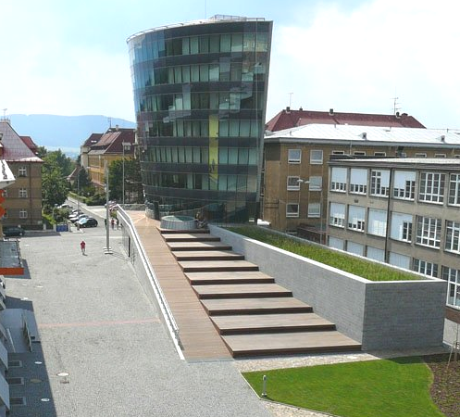

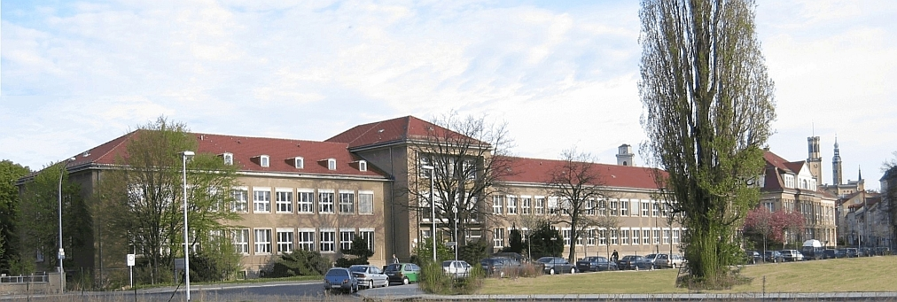

August 2009

Technical University of Liberec,
Faculty of Mechatronics, Informatics and Interdisciplinary Studies

and

HS Zittau/Görlitz,
Faculty Electrical Engineering and Computer Science

Master Study Program Guide
“Mechatronics”

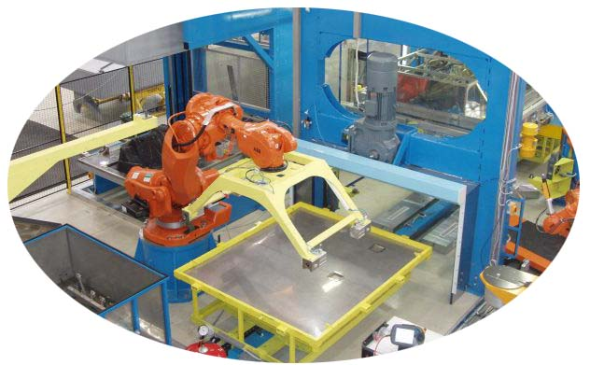

Mechatronics systems

Liberec 2009

Contents

1 Preface 4
2 Master Course Structure and Modules 4
2.1 First semester 4
2.1.1 Winter Term, Study load, Credits 4
2.1.2 Modules annotation 5
2.2 Second Semester 6
2.2.1 Summer semester, Study load, Credits 6
2.2.2 Modules annotation 7
2.3 Third Semester 9
2.3.1 Winter semester, Study load, Credits, Form of Examination 9
2.3.2 Modules annotation 9
2.4 Fourth Semester 12
2.4.1 Summer semester, Study load, Credits 12
2.4.2 Modules annotation 12
3 Policy and Legal Procedures 14
3.1 Common boards 14
3.2 Students 14
3.3 Study structure 15
3.3.1 Place of Hosting University 15
3.3.2 Thesis Work 15
3.4 Study and Examination guidelines 15
3.4.1 Study guidelines 15
3.4.2 Examination guidelines 15
3.5 Admission and Application procedure 16
3.5.1 Admission requirements 16
3.5.2 Application procedure 16
3.5.3 Required documents 17
3.6 Administration, Examination results, Diploma 17
3.6.1 Student administration by Home University 17
3.6.2 Student Administration by the Hosting University 17
3.6.3 Diploma 18
3.6.4 Enter to the PhD study 18
3.7 Fees 18
3.8 Funding 18
3.9 Finding accommodation 18
3.10 Execution of the study programs 18
3.11 Administrative Formalities 19
3.11.1 Czech Administrative Formalities 19
3.11.2 German Administrative Formalities 19
Attachments 19
Attachement 1 20
Attachement 2 21
Attachement 3 23
Attachement 4 25
Attachement 5 27

Preface
The study program “Mechatronics” is based on joint cooperation of Technical University of Liberec, Faculty of Mechatronics, Informatics and Interdisciplinary Studies (TU Liberec FM) and HS Zittau/Görlitz, Faculty Electrical Engineering and Computer Science (HS Zittau/Görlitz F-EI).
These are the Partner Universities. Applicants for this study program were matriculated at HS Zittau/Görlitz or TU Liberec. The university, where a student got his first Matriculation, is called “Home University”. The respectively other Partner University is called “Host University”. During his stay at the Host University, the student is registered at the TU Liberec and matriculated at HS Zittau/Görlitz.
The main objective of this new joint study program “Mechatronics” is to connect the great diversity of mechatronics expertise at the TU Liberec and HS Zittau/Görlitz to a common higher education platform in the European Region Nisa according the Bologna Declaration. European and TU Liberec and HS Zittau/Görlitz students with bachelor’s degree will in the framework of master study “Mechatronics” have the possibility to study mechatronics science. They will be fully integrated into research projects and cooperation with the regional industry at both higher education institutions. Students will take part in design and development of new engineering products and processes by integration of electronic and electrical engineering, computer technology and control engineering
Another objective is to given the students cross-disciplinary extension from the laboratories and computer environment to industrial and research projects and gaining international experience, acquiring the English language and picking up a new culture lifestyle along with their qualification of course.
Study master in “Mechatronics” will bring benefits to European Region Nisa and European industry because of the graduates will be familiar with the specific features of region and host countries.

Master Course Structure and Modules
The Fig.1 determines the pattern of the semesters for the master study in Mechatronics.
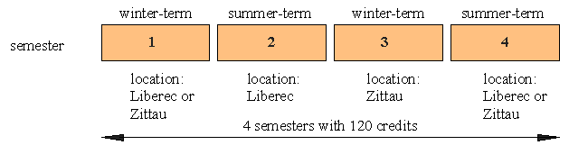
Fig.1 Pattern of the semesters for the Master in Mechatronics.

First semester

Winter Term, Study load, Credits
The first semester is a preparatory one and is valued at minimum of 30 ECTS (see 3.4.2). The bachelor’s degrees valued in 210 ECTS are recognized as the preparatory first semester and students with such one can enter direct the second semester of master study in Mechatronics [see 3.5.1 (3.)]. The modules to be taken by students registered at TU Liberec are given in the Table 1

Table 1. Semester: 1. (winter)
TU Liberec
Nr. | Subject names | Study load/ ECTS | Exami-  nation
Obligatory Subjects
1 | Applied Mathematics Maryška J. jiri.maryska@tul.cz  Volf P. petr.volf@tul.cz | 6+2 / 10 | WO
2 | Selected parts of Physics Richter A. ales.richter@tul.cz  Kopecký V. vasek.kopecky@tul.cz  Hokr M. milan.hokr@tul.cz | 4+4 / 10 | W
3 | Electric drives Kubín.J jiri.kubin@tul.cz  Richter A. ales.richter@tul.cz | 3+2 / 5 | WO
4 | Laboratory I Potěšil A. antonin.potesil@tul.cz | 0+4 / 5 | PL
Type of Examination: W – written exam, O – oral exam, WO – written and oral exam, PL - laboratory

Modules annotation
Applied Mathematics
The objective of the subject is to inform students on advanced mathematical methods of solution of ordinary and partial differential equations and statistical methods with use of computers. The core subject topics are
- Analytical solution of ordinary differential equations, basics of functional analysis
- Metric spaces, Hilbert and Banach spaces, spaces of smooth and integrable functions, Sobolev spaces, classification of partial differential equations and Finite Difference Method.
- The basic models and characteristics of probability distributions are recalled briefly.
- Selected methods of statistical data analysis and modeling, the maximum likelihood and Bayes principles,

Selected parts of Physics
This module provides understanding of the basic principles of physics and of their applications to typical engineering problems. After completion on this module a student should know:
- Continuum mechanics–Hooke’s law, stress and strain tensors, torsion and bending, boundary value problems, virtual work, minimum energy, Castigliano’s principle.
- Electromagnetism–electric and magnetic field, Maxwell’s equations, electromagnetic waves.
- Optics– electromagnetic theory of light, wave equation in homogeneous and inhomogeneous medium, monochromatic electromagnetic waves, Helmholtz equation, interference a multiple interference.

Electric drives
The aim of the subject is to give to students, theoretic and practical knowledge about overall arrangement, function and characteristic properties of basic parts of electric drives in the technologic systems:
- Electrical drives – configuration, requirements on electric and working machines
- Kinematics of electric drives, losses and dimensioning
- Analyze of regulating systems, control algorithms, optimization of systems
- DC motors - properties, mathematical models, control of velocity and simulation
- AC motors – properties, mathematical modeling, control of velocity and simulation
- Power semiconductor converters, properties and characteristic
- Components of control circuits
- Electric drives in the distributed control system.

Laboratory I
Objective of the course is to introduce laboratory technology planning used for characteristics identification and electromagnetic systems responses to students. The laboratory topics are
- The theory and practical solutions of variety of experimental work and functional telemetry
- The demonstration of measuring chains used in experimental and developing units of industrial subjects and engineering companies.

Second Semester

Summer semester, Study load, Credits
The modules to be taken by students in the summer term are given in the Table 2. Minimal one subject of obligatory elective subjects has to be chosen! Minimum number of students in an obligatory elective subject has to be 6.
Table 2. Semester: 2. (summer)
TU Liberec
Nr. | Subject names | Study load/ ECTS | Exami-  nation
Obligatory Subjects
1 | Robotics Záda V. vaclav.zada@tul.cz | 2+2 / 5 | WO
2 | Programmable Controllers Tůma P. petr.tuma@tul.cz  Diblík M. martin.diblik@tul.cz | 2+2 / 5 | WO
3 | Drives and Servomechanisms Rydlo P. pavel.rydlo@tul.cz  Černohorský J. josef.cernohorsky@tul.cz | 2+2 / 5 | WO
4 | Semester (Term) project | 0+4 / 5 | PB
5 | Control Systems in Mechatronics Modrlák O. osvald.modrlak@tul.cz | 2+2 / 5 | WO
Obligatory elective Subjects
1 | Digital Signal Processing Nouza, J. jan.nouza@tul.cz  Žd´árský J. jan.zdarsky@tul.cz | 2+2/5 | WO
2 | Dynamics of the Machines Pešík L. lubomir.pesik@tul.cz | 2+2/5
3 | Laboratory II Potěšil A. antonin.potesil@tul.cz  Koprnický J. jan.koprnicky@tul.cz | 0+4 / 5 | PL
4 | Design of the electrotechnic systems Novák M miroslav.novak@tul.cz  Plíva Z. zdenek.pliva@tul.cz | 2+2 / 5 | WO
5 | Hardware software codesing Novák O. ondrej.novak@tul.cz  Plíva Z. zdenek.pliva@tul.cz | 2+2 / 5 | W
6 | Electrical Transducers of the Nosek J. jaroslav.nosek@tul.cz  Physical Quantities Mokrý P. pavel.mokry@tul.cz | 2+2 / 5 | WO
Type of Examination: W – written exam, O – oral exam, WO – written and oral exam, PL – laboratory, PB-Student Work

Modules annotation
Robotics
The subject Robotics is oriented to deep student knowledge in the problems of analysis and control of robot manipulators with using sensors.
- Matrix methods of kinematics of robot manipulators, quaternion methods.
- Direct and inverse kinematics, using analytical and numerical methods.
- Dynamics of robots, differential equations of motion, matrix methods.
- Using kinematics and dynamical equations for robots control from point to point.
- Robot motion control on defined trajectories or surfaces, classical trajectory robot planning.
- Adaptive and adaptive-learning iterative control in robotics.
- Numerical solutions of robots dynamics and simulations of robot motions.

Laboratory II
The objective of the advanced course is to introduce laboratory technology planning used for characteristics identification and electromagnetic systems responses to students. Through suitably chosen laboratory topics the theory and practical solutions of a variety of experimental work and functional telemetry is introduced to students. Practice:
- Laboratory of car electronic systems
- Research Laboratory of VUTSl

Semester (Term) project
- Semester projects are announced by institutes at the TU Liberec or HS Zittau/Görlitz from begin to the end of summer term.
- Students have to pick one.
- The last date for project assigning is given by notice of the dean.
- Project will be assigned by the chief of the project in writing.
- Project has to be closed by project defense. The date of project defenses is given by notice of the dean.

Dynamics of Machines
The aim of the course is to apply skills gained especially from theoretical mechanics and other disciplines of the theoretical basis. The course is divided into theory and laboratory part.
The focus of the module is
- The identification of dynamic parameters of a real dynamic system by means of measurement methods of modal analysis or operational deflection shapes.
- The analysis of balancing of rotating parts and moving mechanisms.

Control systems in Mechatronics
The module provides a comprehensive overview of control systems with accent on an appropriate balance between theoretical concepts and engineering practice in analysis, synthesis and identification of dynamic systems. After completion the students should
- Acquire good knowledge of practical parameter estimation for determined model structure
- Apply design methods of single loop PID control and it’s enhancements
- Understand fundamental approach to robust control
- Be familiar with description of multi input multi output systems
- Be familiar with the modern software tools MATLAB for analysis and synthesis.

Photonics
The subject Photonics is focused on selected topics in optics, quantum electronics and optoelectronics:
- Interaction photons and atoms - spontaneous, stimulated emission and absorption
- Coherent optical amplifier, gain coefficient, saturated gain, pumping
- Lasers, theory of laser oscillation and characteristics of laser radiation
- Photons in semiconductors - interaction photons, electrons and holes
- Light-emitting diodes, laser diodes, injection laser diodes
- External and internal photo effect, quantum efficiency, sensitivity, response time, gain
- Semiconductor photo detectors – photoconductors, photodiodes, avalanche photodiodes, photo detector noise.
Programmable Controllers
The module provides a comprehensive overview of programmable control systems with accent on Programmable Logical Controllers and communication in networks.
After completion the students should
- Acquire good knowledge and overview of implemented hardware and systems
- Be familiar with the modern languages and software (STEP 7)
- Good knowledge about communication in network
- Be familiar with fundamental approach to industrial implementation
- Implementation of hybrid control

Design of the electrotechnics systems
This subject teaches students necessary theory of electrotechnics needed for design of distribution boards and electrical equipment of machines and buildings.
- CAD/CAE/CAM systems at electrotechnics
- Electrotechnics legislative and standards
- Conductor and cable design
- Protection devices, design, selectivity of protection
- Over voltage protections
- Switchboard parts, control parts, measuring devices over supplies, properties of low voltage power net
- Switch board cooling, thermal behavior

Electronic Circuits and Components
The subject deals with selected, more complex analog and mixed circuits for instrumentation, control, electro acoustics, communication and radio electronics. The focus is
- Basic principles of some electronic systems (TV, FM stereo, GSM, GPS …)
- Progressive design methodology of electronic equipments.
- VHDL language and its application
- Laboratory works

Electrical Transducers of the Physical Quantities
In this subject, there will be given the both theoretical overview and practical experience in the area of selected electric transducers of physical quantities. After completion of this module the students should know about:
- Smart materials and their fabrication
- Piezoelectric wide band (aperiodic) and resonant transducers
- Piezoelectric resonators and their applications
- Piezoresistive transducers,
- Smart sensors and actuators, and an overview of modern trends in the design of electrical transducers based on the application of ferroelectric thin films including processing of micro-electro-mechanical systems (MEMS),
- Design of complex mechatronics systems.

Third Semester

Winter semester, Study load, Credits, Form of Examination
The modules to be taken by students in the third term at HS Zittau/Görlitz are given in the Table 3. Minimal one subject of obligatory elective subjects and the mechatronical Project has to be chosen! Minimum number of students in an obligatory elective subject has to be 6.

Table 3. Semester: 3. (winter)
HS Zittau/Görlitz
Nr. | Subject names |  | Study load / ECTS |  | Exami-  nation
Obligatory Subjects
1 | Automatic Control Theory Proske D. d.proske@hs-zigr.de |  | 2+2 / 5 |  | PL/PK 180
2 | Fuzzy - Control Kästner W. w.kaestner@hs-zigr.de |  | 2+2 / 5 |  | PK 150
3 | Image Processing Bischoff S. s.bischoff@hs-zigr.de |  | 2+2 / 5 |  | PK 150
4 | Digital Communication Technologie Vogt J. j.vogt@hs-zigr.de |  | 2+2 / 5 |  | PK 120
5 | Digital Signal Processing II Thiele R.. r.thiele@hszigr.de |  | 2+3 / 5 |  | PK 120
Obligatory elective Subjects and Mechatronical Project
1 | Magnetic Bearings Worlitz F. f.worlitz@hs-zigr.de | 2+2 / 5 |  |  |  | 2 x PB
2 | Hardware Programming Kühne S. st.kuhne@hs-zigr.de | 2+2 / 5 |  |  |  | PB
3 | Wind and Water Power Weise V. v.weise@hs-zigr.de | 2+2 / 5 |  |  |  | PB
Type of Examination: PK-Test, PB-Student Work, PL-Laboratory

Modules annotation
Automatic Control Theory
In the course students learn about modern methods of Automatic Control. Accent will be put on practical use and implementation of these methods. Students will acquire knowledge of
- Analysis of controlled systems by state space description
- State Estimation
- Synthesis of state space controller
- Multi loop control design
- Digital control

Fuzzy – Control
The aim of this course is to give consolidated knowledge about fuzzy set theory, fuzzy systems and their application in control theory. Main topics are:
- Foundations of fuzzy set theory
- Fuzzy systems and their components, Fuzzy system of Mamdani type (structure, example of demonstration, practical realization, software tool DynStar)
- Fuzzy system of Takagi-Sugeno-Kang type (structure, example of demonstration, practical realization, analogy to Artificial Neural Networks)
- requirements for application in control theory (consideration of dynamic components)
- development of fuzzy controller
- application of fuzzy controller and comparison to classical controller

Image Processing
This course provides a general introduction to the fundamental techniques of computer vision and image processing and illustrates their practical application. The main topics are:
- Image acquisition and representation
- Preprocessing methods: transformations of pixel brightness and geometry, camera calibration, local operators
- Video and audio compression
- Image segmentation
- Feature extraction: color, texture and shape descriptors; Principal Component Analysis
- Classification: prototypes, cluster analysis, statistical methods, classifiers
- Teachable image evaluation: supervised and non-supervised learning, neural networks, Support-Vector-Machine (SVM)
- Multi-sensor technology, Fusion
- Current practical application areas

Digital Communication Technology
Digital communications systems have seen tremendous developments throughout the past decade.
Particularly improvements in signal processing, source and channel coding have lead to high data rates via cable and wireless.
In this course the basics of modern communication systems are highlighted, especially source coding, channel coding, cryptography and adaptive filters.
Source coding is the optimal representation of information. Channel coding means generation of signals which are robust against channel distortions.
Cryptography is the theory of hiding information. In this course modern principles as symmetric and asymmetric methods are shown.
Adaptive filters are widely used in digital communication and control systems.
In the course the basics of analysis and synthesis of adaptive systems as
transversal filters or lattice structures are developed. The students get
information about the mathematically description of least mean squares- and
recursive least squares algorithms. The convergence and stability analysis
with design rules are also shown.

Digital Signal Processing
In this course, the basics of digital signal processing are developed.
This is time-based signals and systems, a mathematical description of signals and systems in the time, frequency and screen domain, including
totals and integral transformations. The main emphasis here is the discrete and Fast Fourier transform for signal and system analysis. Another subject of Education is the design of recursive and non-recursive digital filters also wave digital filters. For this purpose both the Impulse-Invariance and Bilinear method, the Fourier approximation and the wave description to the design of digital filters conveys.

Magnetic Bearings
The aim of the subject is to provide knowledge and requirements for design and application of magnetic bearings. The main topics of lectures are:
- Kinds of magnetic bearings
- Design and engineering
- Control theory
- Diagnosis possibilities
- Applications

Hardware Programming
This subject provides a study of modern hardware programming. The focus is led on
- Hardware of 8-Bit Microcontrollers (architecture, special function registers, bus-system, reset-logic, pin-layout, timers,
- ANSI standard C language programming, Program development in ANSI C with µVISON2
- Interrupt-controlling, interrupt-priorities, mask cable Interrupts
- Hardware description of the real time clock DS12887
- Integration of hardware expansions
- Using of the printed board software EAGLEe from the German company CADSOFT
- Routing and board-design of printed-circuit boards
- Assembling and fitting of the printed board
- Soldering and commissioning of the printed board
- Test of the developed board with software routines

PLC – programming
The aim of the module is to provide study of modern methods for programming of PLC. Students will acquire knowledge for programming of logic control and digital control and about the use of PLC to realize these methods for industrial control.

Wind and Water Power
The aim of the course is to provide knowledge of utilization the wind and water power. The module contains follow parts:
- Wind energy and conversion, system components of wind energy converters, power control of wind energy converters
- Economical aspects and Environmental of wind energy utilization
- Principles of water turbines and their properties, System components of water power stations, Electricity generation and grid linkage for water power stations
- Economical aspects and Environmental of water power

Fourth Semester

Summer semester, Study load, Credits
The students will do their Master Thesis work at chosen higher education institution, which are TU Liberec or HS Zittau/Görlitz [Details see 3.3.2].

Students registered at HS Zittau/Görlitz have their Diploma Thesis work valued at 30 ECTS during the fourth semester. They are working on their Diploma Thesis in the Industry without any subjects (see Table 4.) [Details see 3.3.2 (2.)].

Students registered in the fourth semester at TU Liberec have their Diploma Thesis work valued at 12 ECTS and Diploma Colloquium at 3 ECTS. Further they have to take 3 obligatory elective subjects valued altogether at 15 ECTS that are shown in the Table 4.
During the fourth semester they will have 30 ECTS [Details see 3.3.2 (2.)].

Type of Examination: W – written exam, O – oral exam, WO – written and oral exam, PL – laboratory, PB-Student Work
Table 4 Semester: 4. (summer)
TU Liberec |  |  |  | HS Zittau/Görlitz
Nr. | Subject names | Study load / ECTS | Exami-  nation | Subject names | Study load / ECTS
Obligatory Subjects |  |  |  | Obligatory Subjects
1 | Diploma Seminar  Richter A. ales.richter@tul.cz | 0+3 / 3 | PB | Diploma thesis |  | 0+15/30
2 | Diploma Thesis Supervisor | 0+12 / 12 | PB
Obligatory elective Subjects |  |  |  | Obligatory elective Subjects
1 | Technical Diagnostics  Jaksch I. ivan.jaksch@tul.cz  Matela L. lukas.matela@tul.cz | 2+2 / 5 | WO
2 | Intelligent Robots  Záda V. vaclav.zada@tul.cz | 2+2 / 5 | WO
3 | Digital Image Processing  Chaloupka J. josef.chaloupka@tul.cz  Matela L. lukáš.matela@tul.cz | 2+2 / 5 | W
4 | Control systems of Vehicles  Malý M. miroslav.maly@tul.cz | 2+2 / 5 | WO
5 | Human-computer Interaction  Drábková J. jindra.drabkova@tul.cz | 2+2 / 5 | WO
6 | Control Methods in Applications  Hlava J. jaroslav.hlava@tul.cz | 2+2/5 | WO

Modules annotation
Diploma thesis
- Working out of Diploma thesis
- Consulting with Supervisor and Experts from Industry and Research Institution

Diploma Colloquium
- Communication skills at diploma thesis work
- Preparation: six key points
- Objectives, Audience, Content, Organization, Visual information, Practice
- Giving talks and presentations
- Presentation, Signposting language, Delivery

Technical Diagnostics
The subject deals with industrial technical diagnostics methods including advanced method of signal processing
- Diagnostics models. System reliability. Statistics methods. Expert systems
- Analysis of diagnostic signals in time and frequency domain.
- Cyclical machine and sound diagnostics.
- Hilbert transform and its use in diagnostics. Modulation and demodulation.
- Vibro-diagnostics systems. Accelerometers. Spectral analysis.
Intelligent Robots
The subject Intelligent Robots is focused to the using of some methods of artificial intelligence in the area of robotics, firstly in the trajectory planning and task planning.
- Task-level programming
- Gross-motion and Fine motion planning
- Predicate logic
- Task solving in robotics and heuristics
- Task-planning, source and global scene, scene analysis, task planner simulation.

Digital Image processing
The subject Digital Image processing is focused on student’s ability to understand basic principles of computer image processing and recognition. The main content of this subject is:
- Digital cameras, lenses, digitized image, sampling, quantization.
- Image pre-processing and transformation
- Local preprocessing: image smoothing, edge detectors.
- Mathematical morphology
- Skeletons and object marking, segmentation
- Region identification and object recognition.

Measurement and Diagnostic of Machines
The subject Measurement and Diagnostic of Machines compiles knowledge obtained in other courses in order to offer insight into theory and praxis behind automated measurement and diagnostics in technical plant.
- Measuring chain and its role in control a diagnostics.
- Signal theory, transformation, sampling
- Integral transformations, Fourier transformation, Laplace transformation, Z-transformation and wavelet transformation.
- Machine diagnostics - vibration diagnostics, modal analysis, multiple criterion based diagnostic.
- Design of weighting sensor with digital output.
Control systems of vehicles
The subject is focused to fundamental properties of driving system elements and its parts. The module contains follow parts:
- Drive train, function, design, diverting elements, transmissions

- Hydrostatic transmission of mobile machines
- Vehicle systems: Steering, Braking, Stabilization, Antilock and Control systems
- Safety systems, information and communication.

Human-computer Interaction
The subject /Human-Computer Interaction/ offers the overview of design of virtual environments (3D objects) with interactive components.
- Introduction of VRML, Navigation, Shapes, Appearance
- Special nodes, Variable types, Prototypes
- Sensors
- Animations
- Scripts

Control methods in applications
This course is focused on practical applications of automatic control methods. Particular emphasis is put on those features present in controlled plants and systems that complicate or even exclude the application of classical linear finite dimensional control theory. Such features include
- time delay systems including systems with internal delays
- non-linear behavior and interaction of continuous and logical controls
- hybrid control

Policy and Legal Procedures

Common boards
- The Faculty of Mechatronics, Informatics and Interdisciplinary Studies of TU Liberec and the Faculty Electrical Engineering and Computer Science of HS Zittau/Gorlitz created common “Board Master of Mechatronics“ in Liberec, January 28. 2008. This board authorizes organization structure and administration rules of the study program “Master in Mechatronics” at both faculties.
- “Board Master in Mechatronics“ is governed by deans of both faculties: Faculty of Mechatronics, Informatics and Interdisciplinary Studies and the Faculty Electrical Engineering and Computer Science and includes two members of each faculty that are appointed by Vice rector of study at HS Zittau/Görlitz and at TU Liberec by the dean of Faculty of Mechatronics, Informatics and Interdisciplinary Studies.
- The both dean of Home Universities will create the “State Final Examination Boards of Mechatronics” and “Admission Board of Mechatronics” and they have the right to appoint the members of both boards from both faculties.

Students
- The study program master in “Mechatronics” is determined for students TU Liberec and HS Zittau/Görlitz, European and Third-country students.
- The number of students is supposed to be about 25 Master’s students (10 TU Liberec, 10 HS Zittau/Görlitz and 5 European).
- Possibly there will be an increase in the amount of European and Third-country students.

Study structure

Place of Hosting University
- In each semester all students of the study program master in “Mechatronics” have jointly defined the Hosting University by the pattern of the semester (see Fig.1). The exception makes the first and fourth semester.
  - The students of TU Liberec and HS Zittau/ Görlitz will pass the first semester at the university, where they got their Bachelor’s degree. Euro and Third-country students with less than 210 CP passing the first semester at the TU Liberec and HS Zittau/ Görlitz. Euro and Third-country students with 210 CP can start at the second semester. They can choose the home university TU Liberec as well as HS Zittau/Görlitz
  - In the beginning of the third semester students have to choose one of the Home Universities, where they will do their Diploma Thesis in the fourth semester.
- Thesis Work will be assigned at
- HS Zittau/ Görlitz in the end of the third semester.
- TU Liberec in the beginning of the third semester. The students have to begin working on their Thesis Work.

Thesis Work
    - Diploma thesis are announced by
  - Partner Universities that appointed a Supervisors (Thesis leader).
  - Corporations and companies
      - Research institutions
    - Students have to pick one.
- If the thesis is from the industry, than it is necessary to find a supervisor with the State Final Examination Boards of Mechatronics.
- Thesis Work will be assigned by dean at:
- HS Zittau/ Görlitz in the end of the third semester
- TU Liberec in the beginning of the third semester. The students have to begin working on their Thesis Work immediately.

Study and Examination guidelines

Study guidelines
- The study and examination guidelines in semester satisfy the local law, standards and rules of the Hosting University.
- Courses, including course material, instruction, examination, and study counseling are English at both universities.
- Lecturers and educational personal, time table, the form of examination in given semester will determine the Hosting University.
- Thesis Work will be made up in accordance with the local rules and laws at chosen university.
- Diploma Thesis is written and defended in English. In a special case it can be in German, the State Rigorous Examination must be in English [Details see 3.3.2 (3.)].

Examination guidelines

- Modules and examination will be credited by “European Credit Transfer System ECTS”. Semester project, Semester work, Labor protocol and papers have to be determined in examination and study rules.
- The master study program “Mechatronics” is valued during two years at a minimum of 120 ECTS. The sum have to be valued :
  - minimum of 30ECTS at the TU Liberec FM in the first preparatory semester
  - minimum of 30ECTS at the TU Liberec FM in the second semester
  - minimum of 30ECTS at the HS Zittau/Görlitz F-EI in the third semester
  - 30ECTS by making up of their Thesis Work at one of the universities TU Liberec or HS Zittau/Görlitz.
    - Students registered in the fourth at HS Zittau/Görlitz have their Diploma Thesis work valued at 30 ECTS. They are only working on their Diploma Thesis in the Industry (see Table 4).
    - Students registered in the fourth semester at TU Liberec have their Diploma Thesis work valued at 12 ECTS and Diploma Colloquium at 3 ECTS. Further they have to take 3 obligatory elective subjects valued altogether at 15 ECTS that are shown in the Table 4. So during the fourth semester they will have 30 ECTS too.

- This program has to bee completed by the “State Final Examination of Mechatronics” involving the “Defense of a thesis” and “State Rigorous Examination” of four thematic domain appointed by the “State Final Examination Board of Mechatronics¨ as “Topic of Master degree state examination Mechatronics”.

This program has to bee completed by the “State Final Examination of Mechatronics”
involving the “Defense of a thesis” and “State Rigorous Examination” of three subjects
appointed by the “State Final Examination Board of Mechatronics¨.

- Students, who complete successfully the Master in Mechatronics program, will receive Double Master’s Degree.

Admission and Application procedure

Admission requirements
- The selection process will be carried out by Admission Board of Mechatronics. An Admission requires:
- An appropriate Bachelor’s degree at HS Zittau/Görlitz, at TU Liberec (home universities) or a Diploma (D), Diploma (F), First Degree (E) valued in 180 ECTS (min. 6 Semesters) with a certificate of successful completion.
- Passing the requirements entrance condition of
  - Consecutive two-level study master program mechatronics at HS Zittau/Görlitz
  - Consecutive two-level study program Electrical Engineering and Informatics in the academic discipline “Mechatronics” at the TU Liberec.
- Passing the entrance exam by the examining board of Master in Mechatronics at TU Liberec.

- Students enrolled by their home university have to register by the host university according the pattern of semesters.

- The bachelor’s degrees at HS Zittau/Görlitz valued in 210 ECTS are recognized as the preparatory first semester. It enables students to enter direct the second semester of Master in Mechatronics.

Application procedure
- The Home and European students follow the local routines for enrolment at TU Liberec and HS Zittau/Görlitz.
- The Third-land students have the deadline on April the 28th.

Required documents

The follow documents requested must be in English.
- Application Form
- Official transcript of the university records and the official Bachelor degree certificate. All documents must be officially true attested copies. All translations must be officially certified and accompanied by the copy of the original.
- Letter of motivation
- Language test report
- A Curriculum Vitae in English.
- A copy of the passport
- Name, address and kind of relation to nearest relative.

European students and Third-country students send their Application to:
Technická univerzita v Liberci
Děkanát fakulty mechatroniky, informatiky a mezioborových studií
Studentská 2
CZ – 461 17 Liberec 1
Master „Mechatronics“
E-mail: dagmar.militka@tul.cz (Secretary of Faculty)
or
Hochschule Zittau/Görlitz (FH)
Akademische Verwaltung
D-02763 Zittau
Theodor-Körner-Allee 16
Master „Mechatronics“
E-Mail: s.kuehne@hs-zigr.de
German

Administration, Examination results, Diploma

Student administration by Home University

- Administration of information about student’s semester thesis and examination results at both universities as the study and student documentation will run at the home university using ECTS.
- The home university runs the documentation of registered student of Hosting University too.

Student Administration by the Hosting University

- The Hosting University is the primary point of contact for all students affair.
- The Hosting University runs the documentation of registered student of Home University.
- Regulations for the exchange of information about the students especially their examination results have been established within the applicable local law.
- The Hosting University is responsible for delivering of examination results and other information to the Home University.

Diploma

- Students who complete this program successfully will receive Certificate of successful completion from the Home University
- TU Liberec see attachment 1
- University Zittau/Görlitz see attachment 2
- The Home University awards the Double Degrees with Diploma Supplements.
  - Diploma degree “Master of Engineering” from the consecutive two-level study program “Master in Mechatronics” at the HS Zittau/Görlitz attachment 3 and
  - Diploma degree “Inženýr”, (Master of Engineering) briefly “Ing.” from the consecutive master study program Electrical Engineering and Informatics in the academic discipline/field “Mechatronics” at the TU Liberec attachment 4.
- The universities TU Liberec and HS Zittau/Görlitz make out the Diploma-Supplement attachment 5.

Enter to the PhD study
- Admission to the doctoral study in German for graduates from HS Zittau/Görlitz is given by promotion rules at the University Faculties.
- Graduates at the TU Liberec enter the doctoral courses without the admission examination, when the graduate has an appropriate thesis topics and a professor gave him a good recommendation.

Fees
- The universities TU Liberec and HS Zittau/Gorlitz will charge tuition fees according to their national legislation. In this time there are any.
- A student has to pay the administrative fees as required by local law at the Hosting University.
- All fees will be collected and owned by the Hosting University and managed according the local rules and regulations.

Funding
- The students will bee support by Socrates/Erasmus Program according its structure and rules.
- The both Partner University will endeavor the finding the financial funding.

Finding accommodation
- The both Partner University operate their own halls of residence.
- The cost of such accommodation varies depending on its quality from 5O€–90€.
- There is a possibility to find their accommodation within the private sector.

Execution of the study programs
- The students, registered in this study program at the Hosting University, have the same rights and duties as the other matriculated university students in other programs.
- All students of the Partner University have to obey the rules and regulations of the Hosting University.
- The State Final Examination Board of Master in Mechatronics, matriculation department and other institutions of the Hosting University are responsible for the execution of the jointly developed regulations for this study program.
- It is the responsibility of the Hosting University that the modules are provided by sufficiently qualified persons in accordance with the local laws and regulations.
- The Hosting University is responsible for ensuring local laws about safety rooms, laboratory equipment etc.

Administrative Formalities

Czech Administrative Formalities
Generally
- Students who are EU and EEA Member States citizen with respect to the health insurance and visa have the same rights as in their home country.
- Before departure, citizens from non-EU countries coming to the Czech Republic for the purpose of study need can contact the Czech embassy to consulate for information on the health insurance and visas

German Administrative Formalities
Generally
- Students have to register with the local authority (Einwohnermeldung) when they arrive in Germany.
- The student must prove if his health insurance (from own country) is recognized in Germany or he have to have German health insurance.
- Apart from the visa, which is not necessary for EU citizens, every student from abroad needs a proof of solvency, certifying the grant of scholarship or an affidavit of support.

Attachments
Attachement 1

CZECH REPUBLIC
Josef Novák
(First name and Surname)
2. July 1971 – Czech republic
(Date and Place of Birth)

completed university education in master study programme
Electrotechnics and informatics code: M 2301

Study direction: Mechatronics
at the Faculty of Mechatronics
In compliance with the article 46, paragraph 4 on Higher Education Act No. 111/1998 Collection
and on modifications and amendments of further acts he is awarded

the degree of Inženýr, abbreviated as Ing. used in front of the name.

In Liberec 17. June 2004

with speciality in Mechatronics code (KKOV): 2303T002

Rector Dean

Technical University of Liberec

No. 00001
DIPLOMA
Attachement 2 Zeugnis Deutsch Zittau
Zeugnis Englisch

FREISTAAT SACHSEN


FACHBEREICH ELEKTRO- UND
INFORMATIONSTECHNIK

Z E U G N I S
über die Masterprüfung
Herr/Frau «vorname» «name»
geboren am .............. in .......................

hat im Studiengang
Mechatronik
(Dual-Post-Degree-Programm)
studiert
und die Masterprüfung bestanden.
Gesamturteil:
.........................
(Durchschnittsnote: .........................)
Ergebnisse der Masterprüfung

1. Masterarbeit

Thema der Masterarbeit:

Gesamtnote der Masterarbeit: «diplNote»

2. Modulprüfungen

s. Studienablaufplan(Lehrfach) (Note)
............ ............
............ ............
............ ............
............ ............

3. Module, deren Bewertung nicht in das Gesamturteil eingegangen sind
(u. U. fakultativ gewählte Wahlpflichtfächer auf Antrag der Studenten)
...................... ...........
...................... ...........

Attachement 3 Masterurkunde Deutsch Zittau
Masterurkunde Englisch

FREISTAAT SACHSEN

U R K U N D E
Herr/Frau «vorname» «name»
geboren am «gebdatum» in ..........................

hat die Masterprüfung im Studiengang
Mechatronik
(Dual-Post-Degree-Programm)
erfolgreich abgelegt.

Die Hochschule Zittau/Görlitz (FH)
- University of Applied Sciences -
verleiht durch diese Urkunde
den Hochschulgrad
Master of Engineering
- MEng -.

Zittau/Görlitz, .........................

Siegel

N.N. N.N.
Rektor Vorsitzender des Prüfungsausschusses
Fachbereich Elektro- und Informationstechnik
FREE STATE OF SAXONY

It is herewith certified that

Ms/Mr «vorname» «name»

born on ……………… in ……………………

having successfully completed the relevant Master course
has been admitted to the degree of Master following a course of study in the field of
Mechatronics

(Dual-Post-Degree-Programm)

and that the
Zittau/Görlitz University of Applied Sciences (FH)
hereby awards the degree of

Master in Ingineering
- MEng -.

Zittau/Görlitz,…………………

University Seal

N.N. N.N.
Rector Chair of the Board of Examiners
Department of Electrical Engineering
and Information Technology
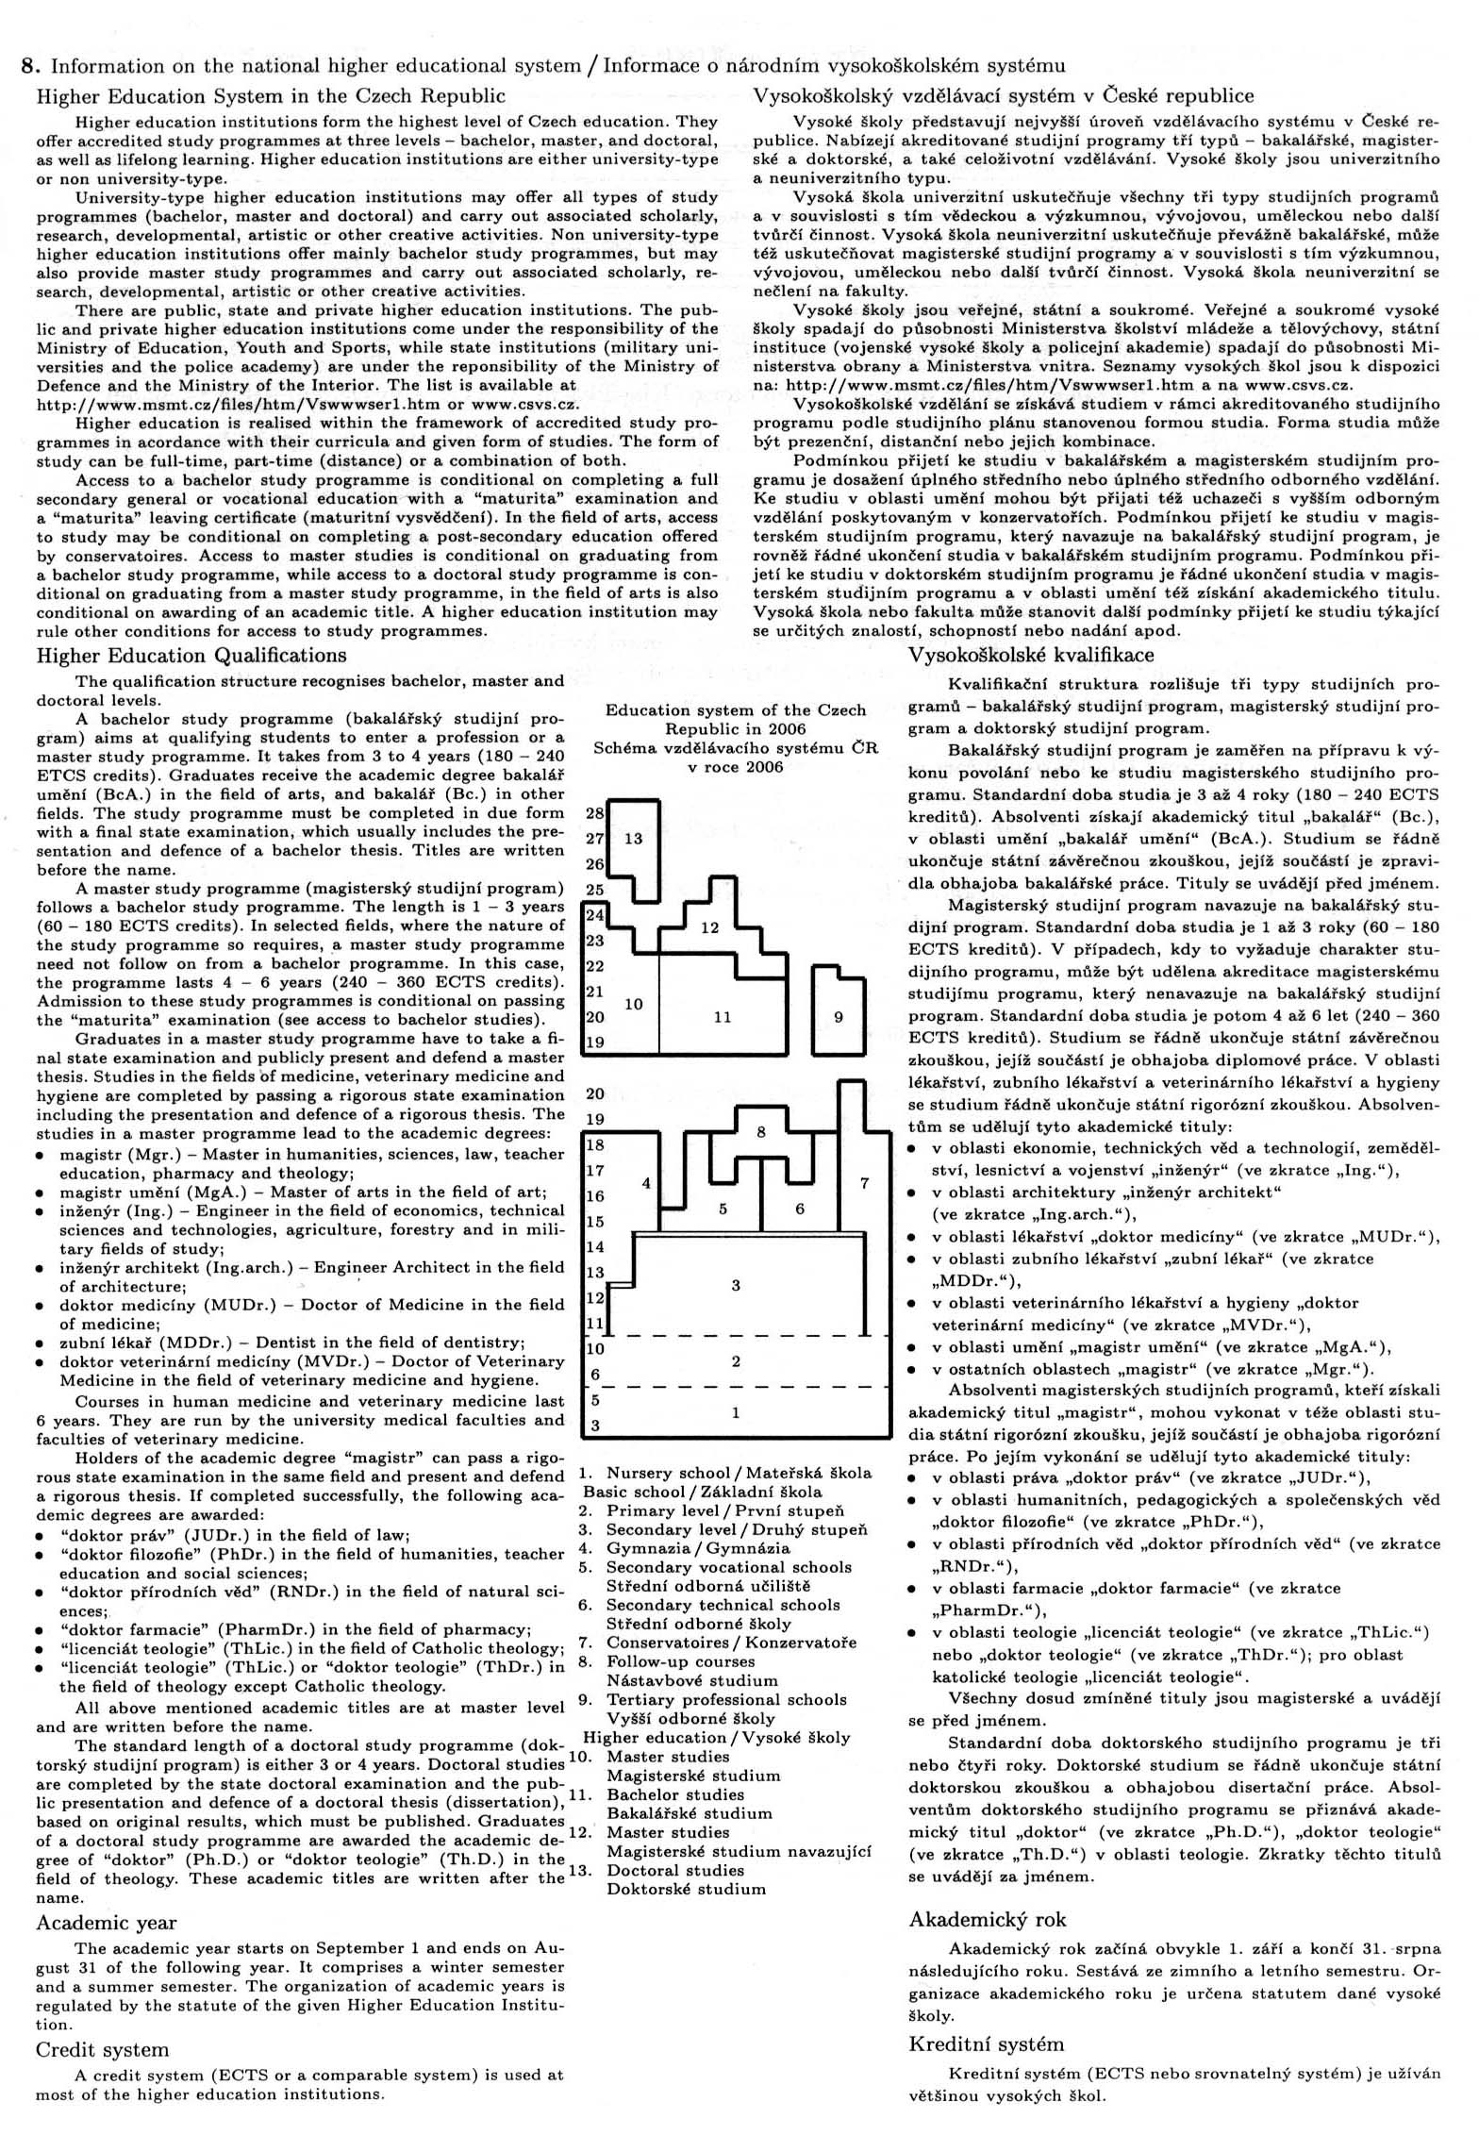
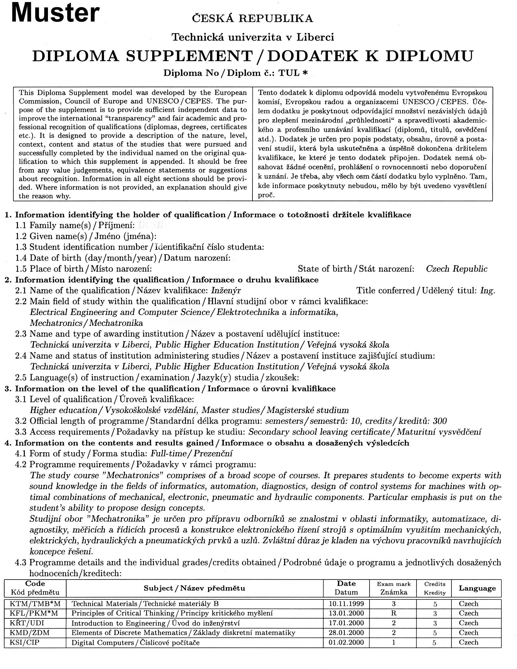
Attachement 4
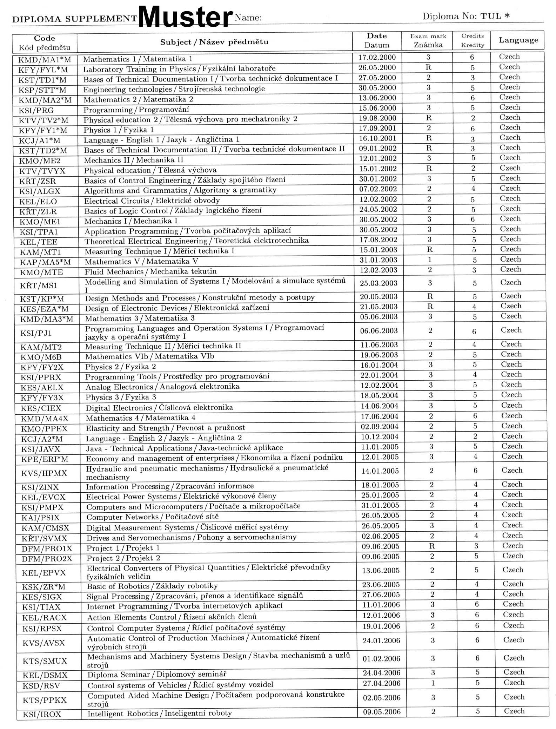
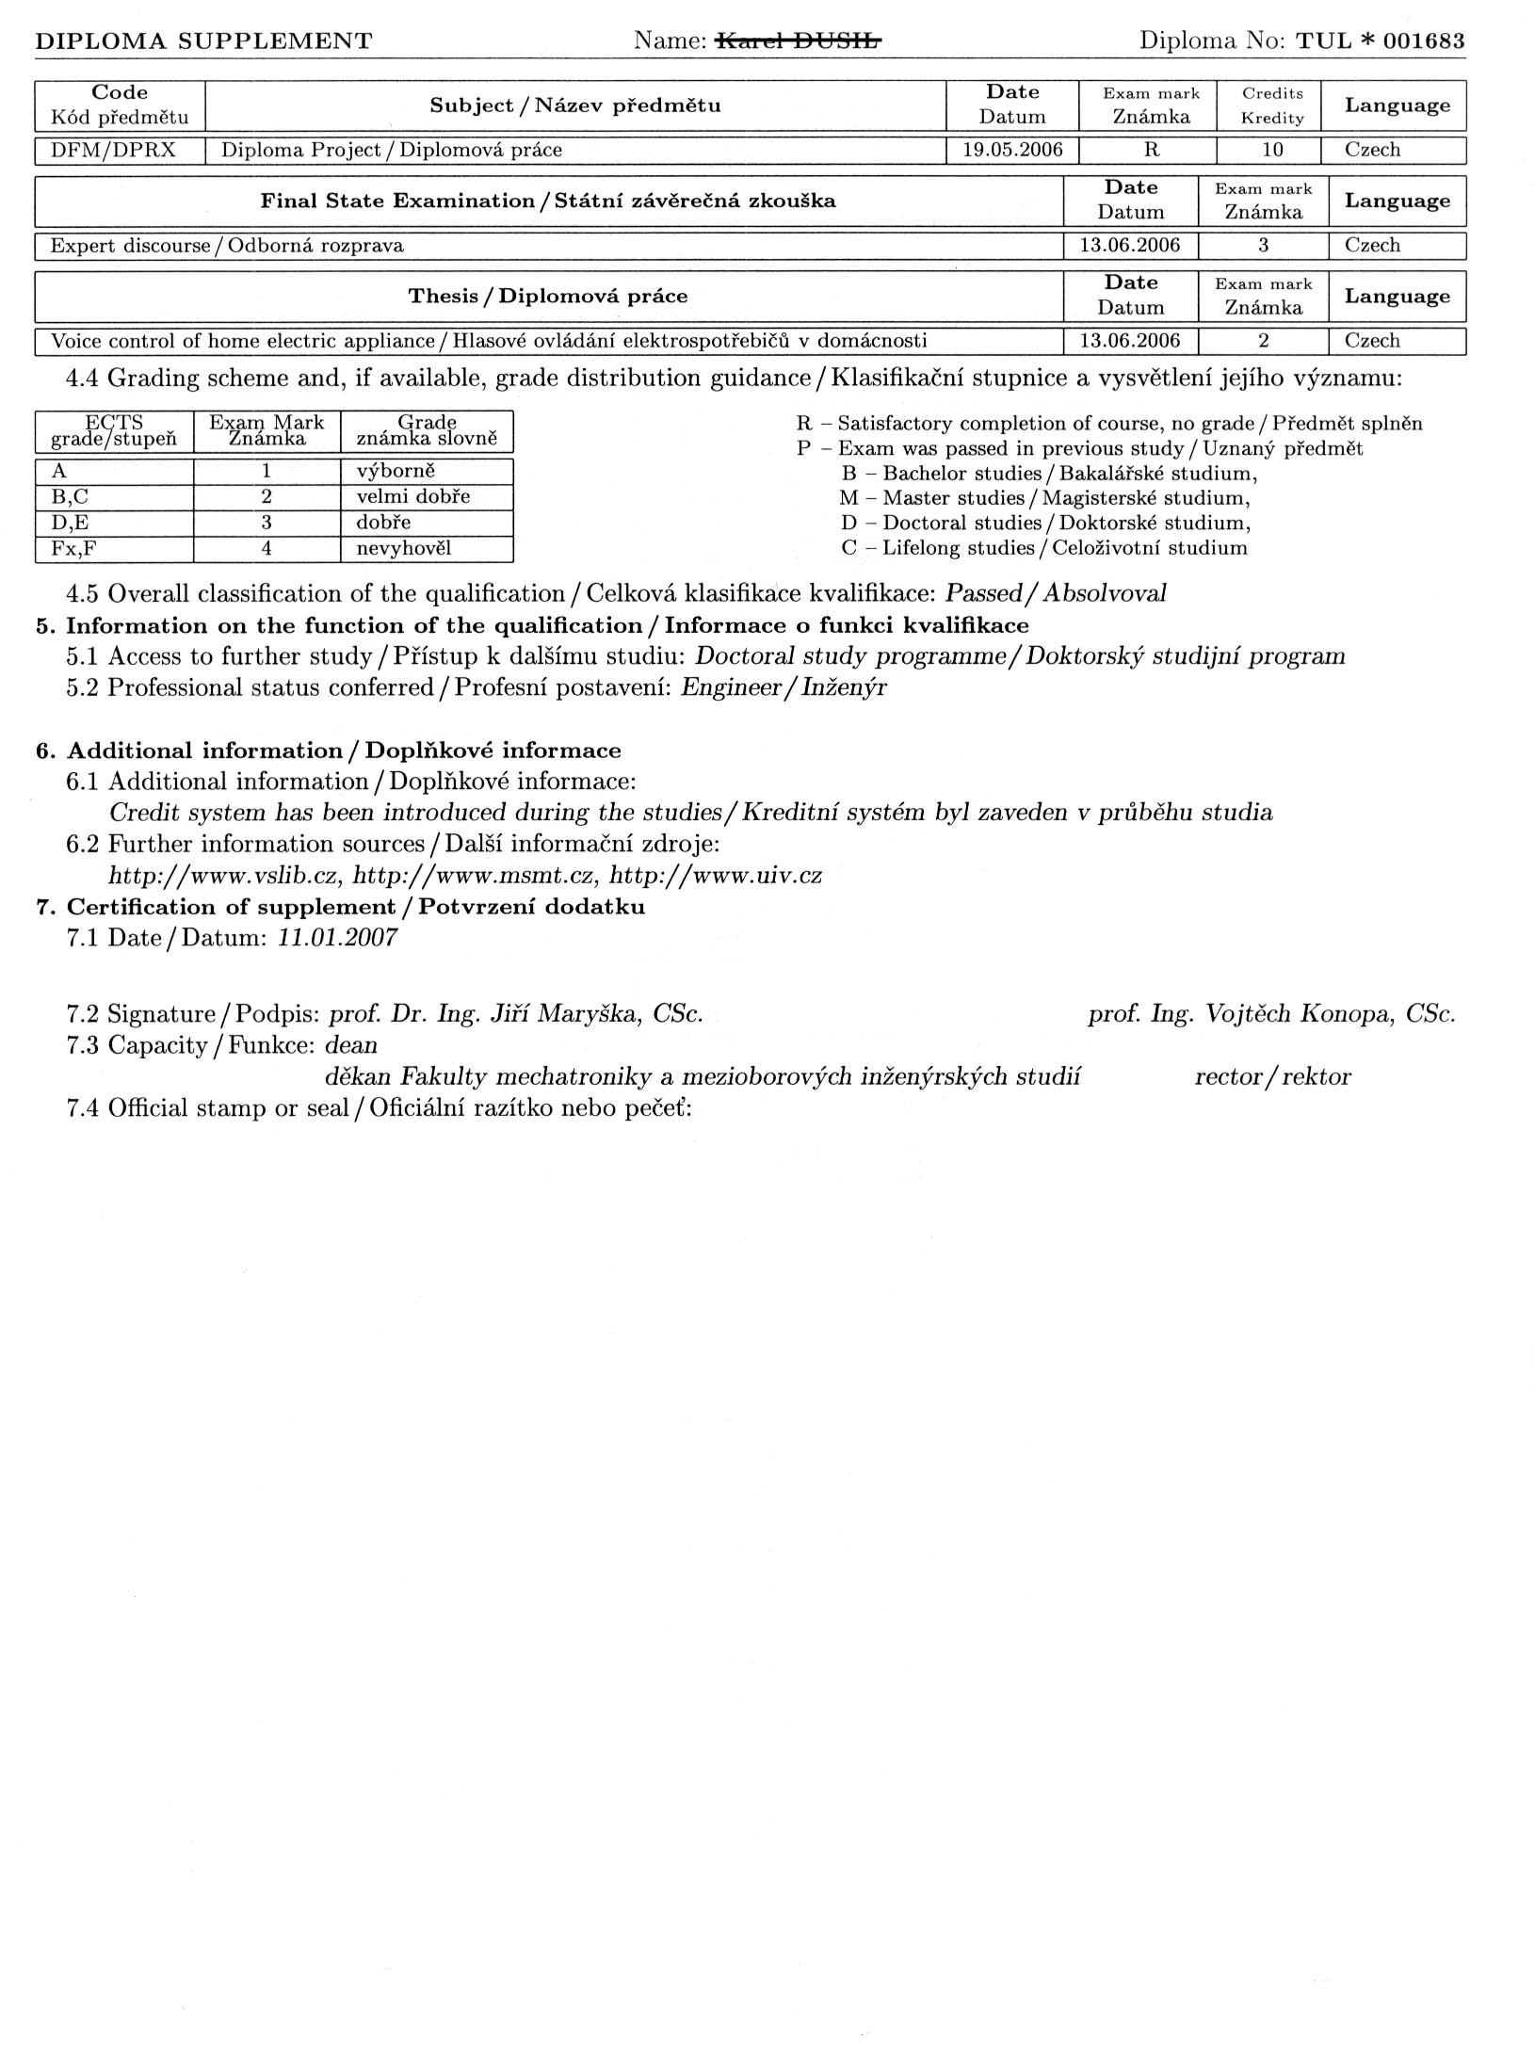
Attachement 5

Diploma Supplement

Anlage zum Diploma Supplement – Transcript of Records

Transcript of Records (Master-Mechatronik Dual-Post-Degree-Programm)
Prüfungsordnung Mechatronik vom .....

1 |  | Robotik | Robotics
2 |  | Laborpraktikum II | Laboratory II
3 |  | Antriebe und Servomaschinen | Drives and Servomechanisms
4 |  | Semester Projekt | Semestral project
5 |  | Maschinendynamik | Machine Dynamics
6 |  | Wahlpflichtfächer  Steuerungstechnik in der Mechatronik  Optische Systeme  Digitale Signalverarbeitung  Entwurf von elektrotechnischen Systemen  Elektronische Schaltungen und Komponenten  Elektrische Wandler für physikalische Größen | Obligatory elective Subjects  Control Systems in the Mechatronic  Photonics  Digital Signal Processing  Design of the electrotechnic systems  Electronics circuits and Components  Electrical Transducers of the Physical Quantities
7 | EI1-1 | Regelungstechnik II | Automatic Control II (advanced course)
8 | EI2-1 | Digitale Signalverarbeitung | Digital Signal Processing
9 | EI3-2 | Fuzzy-Control | Fuzzy Control
10 | EI4-2 | Digitale Kommunikationstechnik | Digital Communication Technology
11 | I1-2 | Image Processing | Image Processing
12 | I2-2 | Maschinennahe Programmierung Schaltungsentwurf | Hardware-oriented Programming / Circuit Design
13 | MS1-1 | Modellgestützte Messverfahren/ nichtlineare dynamische Systeme | Model-based Measuring Methods/ Nonlinear Dynamic Systems
14 | MS2-2 | Künstliche Intelligenz/ Neuronale Netze | Artificial Intelligence/Neural Networks
15 | AW1-2 | Unternehmensführung/Sprachen | Business Management/Languages
16 | WP1-2 | Wahlpflichtfach/Internationales Projekt  1. Magnetlagertechnik  2. Projekt/Projektmanagement  3. Fluidische Steuerungsmittel  4. SPS-Programmierung  5. Qualitätssicherung  6. Modellierung und Simulation  7. Lichtwellenleitertechnik  8. Wasser- und Windenergienutzung  9. Optische Sensoren  10. Photovoltaik  11. Prozessornahe Programmierung /Programmentwicklung in C | Optional Module /International Project  1. Magnetic Bearing Technology  2. Project/Project Management  3. Fluid Control Systems  4. Programmable Logic Controller (PLC)  5. Quality Control  6. Modelling and Simulation  7. Optical Transmission Systems  8. Use of Water and Wind Energy  9. Optical Sensors  10. Photovoltaics  11. Hardware Programming / Program Development in C
17 | WP2-3 | Abschlussmodul/Masterarbeit | Final Module/Master Thesis

