Contents

1 Goal of the experiment: 2
2 Basic principles of feedback control 2
2.1 Analyze of feedback control 2
2.1.1 Basic structure of control 2
2.1.2 The structure of feedback control 3
2.2 Parametric Identification-system identification tool 5
2.2.1 Data import 6
2.2.2 Process Model 8
2.2.3 Working Data and Validation Data 13
2.2.4 Using knowledge of some parameters of transfer function in the identification 16
2.3 Model of control 18
2.3.1 Open-loop control 18
2.3.2 Closed-loop control 18
2.4 PI controller 19
2.5 Control parameter optimization 20
2.5.1 Hand tuning 20
2.5.2 Root-Locus Designed method 22
3 Set-up of the experiment 24
3.1 Controlled plant 24
3.2 Controller SIPART DR 20 25
3.3 Data acquisition and control 27
4 Operating the equipment and software used in the experiment 28
4.1 Controller SIPART DR20 28
4.1.1 Parameterization 28
4.1.2 Structuring 29
4.1.3 Controller output functions of controllers are: 30
4.2 Data acquisition and control 30
5 Conducting the experiment 31
5.1 Conducting of measuring and recording on the SITRAN DR 20 31
5.2 Instruction to the identification measurement 31
5.3 Modelling 34
5.3.1 Modelling of the controlled system 34
5.3.2 Theoretical analysis of the control loop: 34
5.3.3 Studies on the model of the control loop: 34
5.4 Studies on the real feedback system (control loop) 34
6 Analysis of the experiment 36
7 Literature 36

Goal of the experiment:

- Analysis of an electric heating component
- Identification and modelling using the MATLAB modelling language
- Verification
- Controller parameter optimisation
- Handling of an industrial control unit

Basic principles of feedback control

Analyze of feedback control

Basic structure of control

In general two generic control configurations are used: open-loop and closed-loop systems.

Open-loop systems

The Generic open-loop system is shown in Fig. 2.1-1. The “Input transducer” converts the form of input to that used by the controller. The “Controller” drives the “Process” or “Plant” with the controller output u. The input w* of the controller is sometimes called the “reference” while the output of the plant y_{S} can be called “controlled variable”. The “disturbance” d is an undesirable input to the plant.
Open-loop systems do not correct for disturbances and are simply commanded by the reference signal.

Fig. 2.1-1: Open loop system
Disturbance
Input transducer
Criterion
variable

Controller
Plant
(Process)
Internal
feedback

Closed-loop systems

The generic architecture of a closed-loop system is shown in Fig. 2.1-2. The input transducer converts the form of the input w* to the form w of the controller known as desired value. The summing junction algebraically subtracts the feedback signal y, which arrives via the feedback path, from the desired value/set point signal w,. This signal is generally called “error” .

Fig.ure 2.1-2: Closed-loop control
system

y ... Ffeedback signal to the controller/
Mmeasured (controlleded) variable
u ... Mmanipulateding variable/input
y_{S} .. Ffinally controlled variable
/output
x_{A}... Ooutput quantity of the
control plant
w ... Desired value
w*... Reference input
e ... (Control) error e= w-y/
actuating variable
Controller
Plant
(Process)
Input
transducer
Generation of quantity of the task
Measuring device

The controller generates a signal u(t) known as “manipulating signal”, which is the input to plant (process).

The closed-loop system compensates for disturbances by measuring the output response y(t), feeding that measurement back through a feedback path, and comparing that response to that input w(t) at the summing junction.
If there is any difference between the two responses, the system drives the plant, via error (control error) “e”, to make a correction. If there is no difference, the system does not drive the plant, since the plant response is already the desired response.

The structure of feedback control

A block scheme of a technological process is shown in Fig. 2.1-3. We can denote as extended/generalized plant a part of the scheme that consists of plant (process) and measuring devices (see Fig. 2.1-4). We recall that a plant contains amplifiers with transducers and the technological process with actuator.
A … Amplifiers with Transducers TP… Technological Process
AC… Actuator S … Sensors with Transducers

Fig. 2.1-3: Scheme of a controlled plant/process with measuring devices
S

Controller
AC
A
TP
Feedback path
Extended controlled plant

Plant
(Process)
Measuring device
Fig. 2.1-4: Extended/generalized controlled plant

The measuring device embodies sensors with transducers or transmitters. The dynamic of the extended plant is generally approximated by three transfer functions F_{V}(s), F_{S}(s) and H(s). The transfer function F_{V}(s) approximates the dynamic of amplifiers, transmitters and actuator, the transfer function F_{P}(s) approximates the dynamic of the process and the transfer function H(s) approximates the dynamic of measuring devices (see the Fig. 2.1-5).
Transfer function of the extended controlled plant
Fig. 2.1-5 : Transfer function of the extended controlled plant

Finally, the transfer function notation is often simplified by lumping all instrumentation and process dynamic into one term F_{U}. This is equivalent to the following expression

$F_{U}(s)=\frac{Y(s)}{U(s)}=F_{V}(s)⋅F_{S}(s)⋅H(s)=F(s)=\frac{B(s)}{A(s)}$ (2.1 - 1)

The relationship between the disturbance $d(t)$and the measured controlled variable Y=Y_{D} (u=0) can be approximated by the transfer function F_{D}(s)
$F_{D}(s)=Y_{D}(s)/D(s)=\frac{C(s)}{A(s)}$ (2.1 – 2)
(C(s) is polynomial)
Under these conditions the model structure of an extended controlled plant with the modeled disturbance $d$ is shown in the Fig.2-6.
Fig. 2.1-6: Model structure of an extended
plant with modeled disturbance

The output
of the model is

$y(t)=y_{U}(t)+y_{D}(t)$.

The output of the system for joint action of
manipulating variable and of the disturbance
is equal to

$Y(s)=F_{U}(s)⋅U(s)+F_{D}(s)⋅D(s)=\frac{B(s)}{A(s)}U(s)+\frac{C(s)}{A(s)}D(s)$ (2 – 3)

The classical control uses models of control systems that are described by transfer functions. The block diagram of an open-loop control with disturbance is shown in Fig. 2.1-6. The block diagram of a closed-loop control with disturbance model is shown in the Fig. 2.31-8?.

In the chapters1- 4 we have introduced the concepts of identification of a dynamic system based on measured input/output. The typical identification process consists of stages where you iteratively select a model structure, compute the best model in the structure, and evaluate this model’s properties. This cycle can be itemized as follows:

- Design an experiment and collect input/output data from the process to be identified.
- Examine the data. Polish the data by removing trends and outliers
- Select and define a model structure (a set of candidate system descriptions)
- Compute the best model in the model structure according to the input/output data and given criterion for goodness of fit
- Examine the model properties of the obtained model
- If the model is good enough, then stop; otherwise go back to step 3 to try another model structure or go back to 1 to find better input/output data for identification.

Parametric Identification-system identification tool
The identification toolbox “ident” enables to build mathematical models of dynamic systems based on measured data. The toolbox is good described and contains vast help. The aim of this chapter is to make our students familiar with the toolbox “Ident” and to focus on practical identification. The procedure “Ident” involves three basic parts:
- The input-output data
- A set of candidate model (the model structure)
- A criterion to select a particular model in the set
The System Identification Toolbox “Ident” provides a graphical user interface (GUI).
Start the tool by typing
>>ident

in the MATLAB Command Window.
Window “Ident” is dominated by two tables: table for data and table models known as Data board and Model board (see Fig.2.2-2). A new data can be entering by importing them from the MATLAB workspace.

Data import
Imports are handled under the Import data menu as shown in the Fig. 2.2- 3. The GUI supports three kinds of data objects for parameter estimation: Time-domain input/output signal, Frequency-domain input/output signal and Frequency functions.
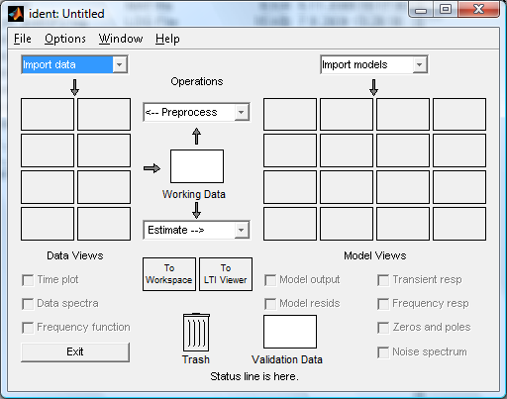
Fig. 2.2 – 2. The main ident Window
Data boardModel board

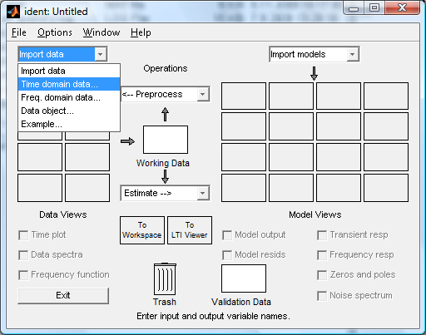
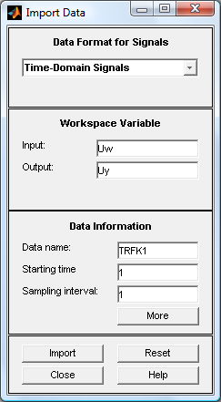
Fig. 2.2 – 3. Data import for Time-Domain input/output signals Window

The input and output are vectors that are equal

$\text{Uw}=u(t)−u_{0}, \text{Uy}=y(t)−y_{0}$, (2.2-1,2)

where $u(t),y(t)$ are vectors of measured input and output,
$u_{0},y_{0}$ are values of the working point.

You can choose the “Data name”, the “Starting time” and “Sampling interval”. Usually the parameters “Starting time” and “Sampling interval” are set to 1. After a click on “Import” the data are imported and you will see a Data icon (TRFK1) in the Data board (see Fig. 2.2 – 4). Choosing the checkbox “Time plot” you can plot the data (TRFK1: input Uw, output Ux) that are prepared for identification (see Fig. 2.2 – 4).

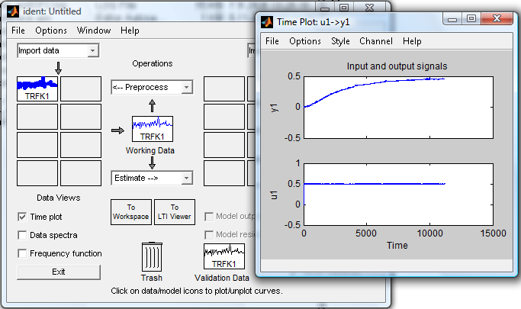
Fig. 2.2 – 4. Time plot of input/output signals

Process Model

Commands for creating estimation models based on the working data (TRFK1) you find after a click on “Estimation” menu (see Fig.2.2 – 5). You see you can choose Parametric models in form a Z-transfer function, Process model (Defined transfer function), Spectral model and Correlation models. We are interested in Process model.
By a click on the menu item “Process models…” the window “Process models” is opened (see the Fig. 2.2-6). The part of the window “Model Transfer Function” shows the structure of a continuous-time model (a transfer function) that is characterized by
K …static gain
T_{PK} … one or several time constants for k=1,2,3 or for under damped systems called T_{W} and ζ for time constant and damoing in the complex roots gcase
T_{Z} … A possible process zero
T_{D} … A possible time delay (dead time)
A possible enforced integrator.

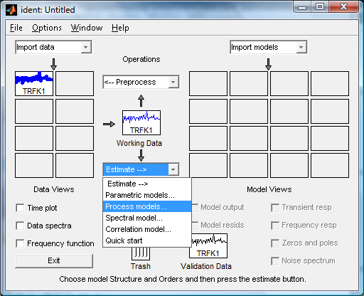
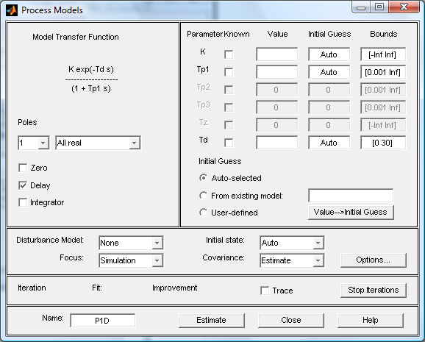
Fig. 2.2 – 5. Determination of model type
Fig. 2.2 – 6. Determination of transfer function structure
Field of transfer function structure setting

The transfer function structure with gain K is defined by number of real poles 0,1,2,3 or by choice of an underdamped system (complex poles). You can make a choice of a zero and time delay. When it is necessary you can add a pole equal zero as integrator.
Choosing a combination of above parameters a set of transfer functions can be defined.
Same of them are:

$G(s)=\frac{K}{T_{P1}s+1}e^{−\text{sTd}}$ $G(s)=\frac{K}{(T_{P1}s+1)(T_{P2}s+1)}e^{−\text{sTd}}$ $G(s)=\frac{K}{s}e^{−\text{sTd}}$

$G(s)=\frac{K}{s\left[(T_{W}s)^{2}+2{ξT}_{W}s+1\right]}$ $G(s)=\frac{K\text{.}(T_{Z}s+1)}{s(T_{P1}s+1)(T_{P2}s+1)}e^{−\text{sTd}}$

After a click on “Estimate” on the process window the estimated parameter values are shown (see Fig.2.2-7). On the main windows “Ident” the model icon is shown (see Fig.2.2-7).

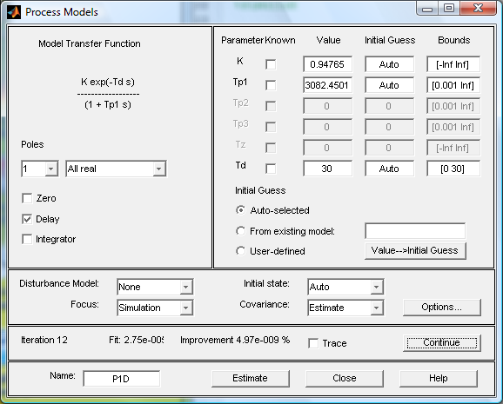

Fig. 2.2 – 7 Estimated parameters K,Tp1 and time delay Td

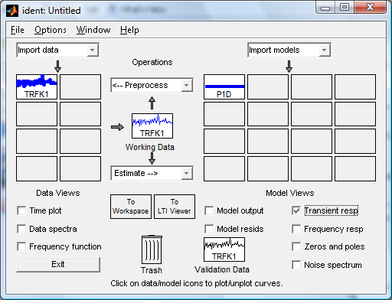
Fig. 2.2 – 8 The main window with model icon P1D

Click check point “Transient resp” (see Fig. 2.2-8) plots the transient response, Fig. 2.2-9a).
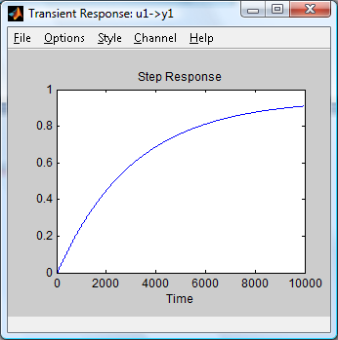
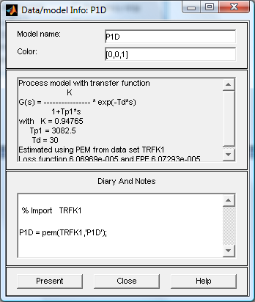

Fig. 2.2 – 9a Transient response
of the model P1D

Fig. 2.2 – 9b Data model Info: P1D.

By a click on model icon P1D is opening windoe “Data/model Info” shown in Fig.2.2-9b.
For the same data set (TRFK1) we can make parameter estimation for another transfer function structure. As an illustration example we choose the structure

$$G(s)=\frac{K\text{.}(T_{Z}s+1)}{s(T_{P1}s+1)(T_{P2}s+1)(T_{P3}s+1)}$$

On the Fig.2.2-10 you can see the determination of the model structure in the window “Process model” part “Model Transfer Function”. You can see in the field Parameter the estimated parameters. The main window “Ident” in the Fig. 2.2-11 you can see the model icon P3IZ.
The transient function is shown on the Fig.2.2-12a and the Data model Info P3IZ is sown on the fig.2.2-12b.

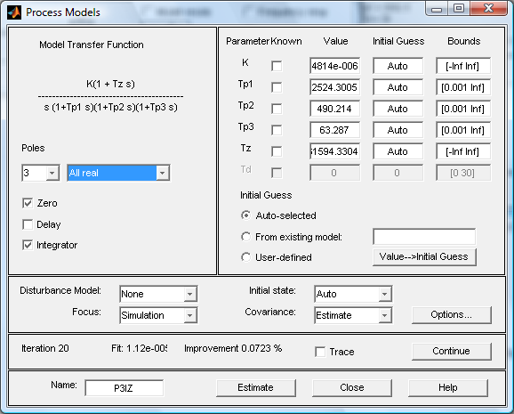
Fig. 2.2 – 10 Estimated parameters K,Tp1,Tp2,Tp3,Tz

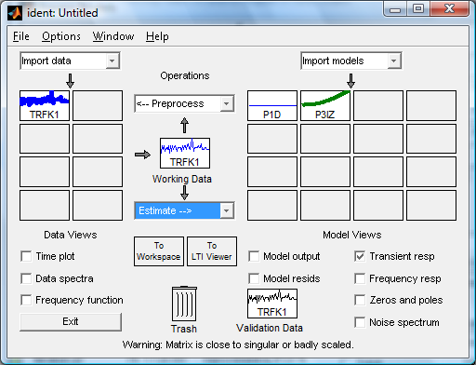
Fig. 2.2 – 11 The main window with model icons P1D, P3IZ

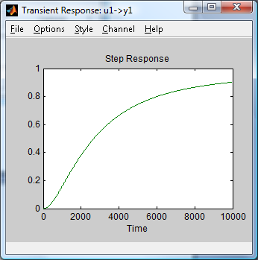
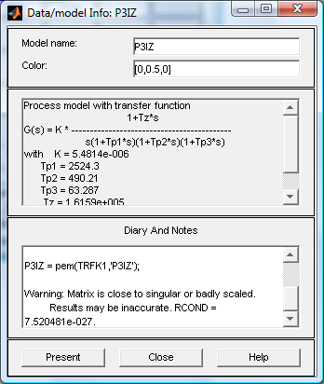
Fig. 2.2 – 12a Transient response of
the model P3IZ
Fig. 2.2 – 12b Data model Info: P1D.

Working Data and Validation Data
When we have been working with a data set and now it is necessary to create a new data set we use the function Import data. So we can have prepared in the Data Board some data sets. A data set can be processed by the tool “Ident” only than, if the data set is placed to the
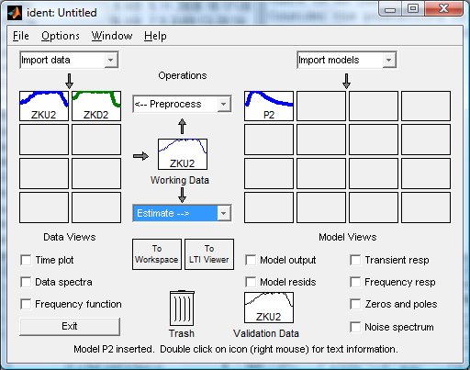
Fig. 2.2 – 13 Data Board with two data sets ZKU2,ZKD2.

placeholder (position) Working Data. So you have to drag and drop data icon from the Data Board into the position “Working Data”. You see in the Fig. 2.2-13 that in the placeholder “Working Data” is the data icon ZKU2 so the tool “Ident” is processing this data set.
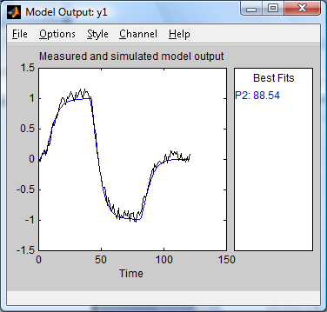
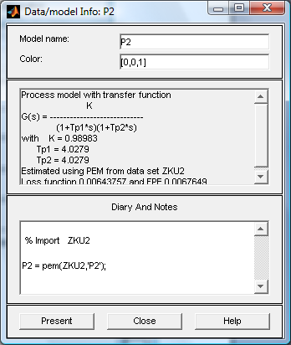

Fig. 2.2 – 14b Transient response of
the model P2

Fig. 2.2 – 14a Data model Info: P2.

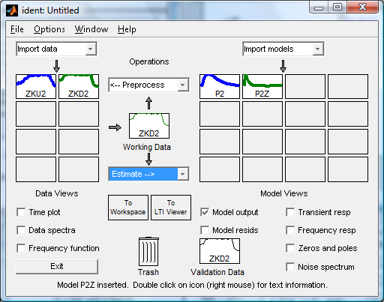
Fig. 2.2 – 15 Data Board with two data sets ZKU2,ZKD2, Working data ZKD2, two models P2,P2Z

We can estimate a model P2 (transfer function) , see results in the Fig. 2.2-14a,b. The result of drag and drop of the data set ZKD2 from the Data Board to the Working data placeholder is shown in the Fig. 2.2-15. The results of the model P2Z is shown in the Fig. 2.2 -16a,b. models P2,P2Z
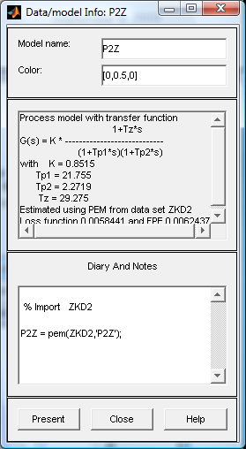
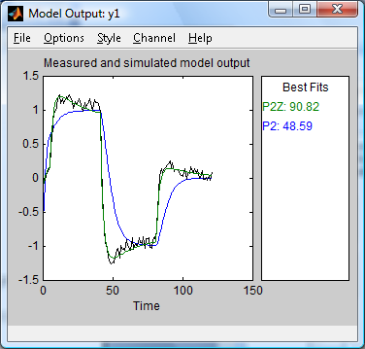

Fig. 2.2 – 16b Transient response of
the model P2Z, P2

Fig. 2.2 – 16a Data model Info: P2Z.

Using knowledge of some parameters of transfer function in the identification

In the praxis there exist situations that same of parameters of the transfer function are known. To illustrate the case we show a plant model with disturbance. By disturbance modeling of a system by an approximation of a linear model the system output can be described
$Y(s)=\frac{B(s)}{A(s)}U(s)+\frac{C(s)}{A(s)}D(s)=F_{U}(s)U(s)+F_{D}(s)D(s)$. (2.2-2)

You see that the transfer functions $F_{U}(s),F_{D}(s)$ have the same nominator$A(s)$. The polynomial $A(s)$ can be calculated by the estimation of the transfer function$F_{U}(s)$. By parameter estimation of the transfer function $F_{D}(s)$ must the polynomial $A(s)$ be the same as in the transfer function$F_{U}(s)$, so it necessary to calculate only the polynomial $C(s)$.
Using the identification tool “Ident” it is possible, the known values of some parameters write direct in the table in the field “Value” see Fig.2.2-17. You must not forget to check the parameters as known in the checkbox “Known”. The results of estimated parameters K,T_{Z} are shown in the Fig. 2.2-17 too.

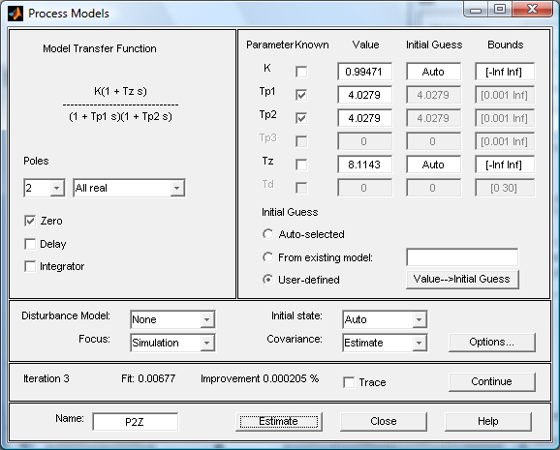
Fig. 2.2 – 17 Estimated parameters K, Tz, parameters Tp1,Tp2 are known

Data Board with two data sets ZKU2, ZKD2, Working data ZKD2, models P2,P2Zand P2Z red are shown in the Fig. 2.2-18. The window “Data/model Info” P2Z , which is processed with known parameters Tp1,Tp2 is shown in the Fig. 2.2-19a. The plot of the measure and model output P2Z is shown in the Fig. 2.2-19b.

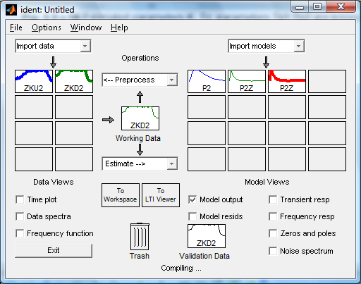
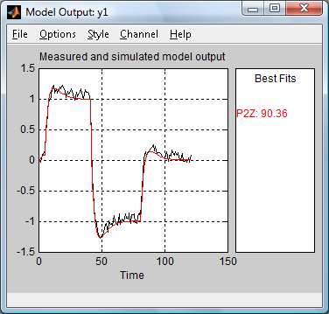
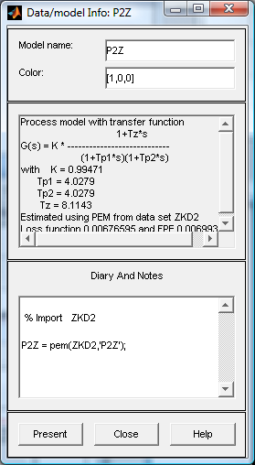
Fig. 2.2 – 18 Data Board with two data sets ZKU2, ZKD2, Working data ZKD2,
models P2,P2Zand P2Z red, which processed by known parameters Tp1,Tp2.
Fig. 2.2 – 19a Data model Info: P2Z.
Fig. 2.2 – 19b Measure and model
output P2Z (red)

Model of control

Open-loop control

Fig. 2.3-17: Model of an open-loop control system

The Laplace transform of output is equal

$Y(s)=F(s)⋅R_{W}(s)\text{.}W(s)+D(s)$, (2.3 - 1)
where are ….$F(s)=\frac{b_{m}s^{m}+\text{.}\text{.}\text{.}b_{1}s+b_{0}}{s^{n}+a_{n−1}s^{n−1}+\text{.}\text{.}\text{.}+a_{1}s+a_{0}}$.
$R_{W}(s)$… Transfer function of a feed forward controller,
$W(s)$ … Laplace transform of set point/desired value.
$D(s)$ … Laplace transform of the disturbance.

It is obvious from (2.3-1) that the disturbance cannot be compensated.

Closed-loop control

Using the general transfer function (2-1) and (2-3) the block diagram of the feedback control can be shown in the Fig. 2.3-2.
y = y(t)…Controlled variablee=w-y…Error/Correctin g variable
d = y(t)…Disturbanceu … Manipulatinged variable
w = w(t)…Set point/desired input variable

F_{D}(s)
F_{U}(s)
R(s)
Fig.gure 2.3-28: Block diagram of a general closed-loop feedback model control system

Simplified closed loop disturbance transfer function

$F_{\text{YD}}(s)=\frac{Y_{d}(s)}{D(s)}=\frac{F_{D}(s)}{1+R(s)F_{U}(s)}$ (2.3 - 2)

Simplified set point transfer function

$F_{\text{YW}}(s)=\frac{Y_{W}(s)}{W(s)}=\frac{R(s)F_{U}(s)}{1+R(s)F_{U}(s)}$ (2.3 - 3)

The general closed-loop transfer function model can be applied to any specific system by substituting the transfer function models for the loop elements.

PI controller

- P controller/ proportional mode: proportional only controller
The output from a P controller is proportional to the error and is equal

$u_{P}(t)=P⋅e(t),$ (2.4 - 1)

where are $P$… proportional gain, $e(t)=w(t)−y(t)$… error.

Transfer function of P controller is $R_{P}(s)=\frac{U_{P}(s)}{E(s)}=P\text{.}$ (2.4 - 2)

The proportional mode is simple, provides an adjustment of the manipulating variable, does not provide zero offset although it reduces the error, speeds the dynamic response, and can cause instability if tuned improperly.

- PI controller: proportional-integral controller
2) PI controller: proportional-integral controller
A PI controller has two terms (and two tuning parameters), one proportional to the error and the other proportional to the integral of the error. The PI controller output is equal

$u_{\text{PI}}(t)=P⋅e(t)+I⋅\int_{0}^{t}{e(τ)dτ}=K_{R}\left[e(t)+\frac{1}{T_{I}}⋅\int_{0}^{t}{e(τ)dτ}\right]$, (2.4 – 3)

where are $P$… proportional gain, $I$… integral gain, $K_{R}$… all controller gain,
$T_{I}$… integral time, $e(t)=w(t)−y(t)$… error.

The PI controller transfer function is equal

$R_{\text{PI}}(s)=\frac{U_{\text{PI}}(s)}{E(s)}=P+\frac{I}{s}=\frac{\text{Ps}+I}{s}=K_{R}\frac{T_{I}s+1}{T_{I}s}\text{.}$ (2.4 - 4)

Integral mode: $u_{I}(t)=\frac{K_{R}}{T_{I}}⋅\int_{0}^{t}{e(τ)dτ+e(0), }$ (2.4 - 5)

where is $e(0)\text{.}\text{.}\text{.}$ initial condition.

Control parameter optimization

The proportional-integral-derivative PID controller has three adjustable tuning constants that must be set. After parameter setting we must check the maximum value of manipulated variable with the possibility of the real system!

The tuning constants must be derived using the same algorithm (controller structure) that is applied in the control system.

Hand tuning
We consider that
- there is a real closed loop system with a PID controller or a model closed-loop system.
- The model must be able to model the maximal movement constraints in the form of saturation limit (See fig. 2.4-).
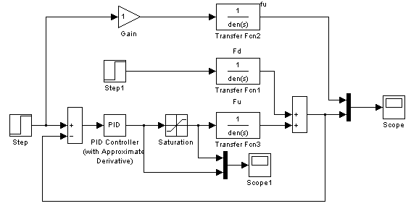

Fig. 2.4-1Closed-loop feedback model with saturation of the actuator $\text{Gain}=({a_{0}}/K)⋅w$.

Hand tuning procedure

- Set gains P, I, D to zero
- Increase gradually the proportional gain P until the transient responses of closed-loop system is fast enough (speeds the dynamic response).
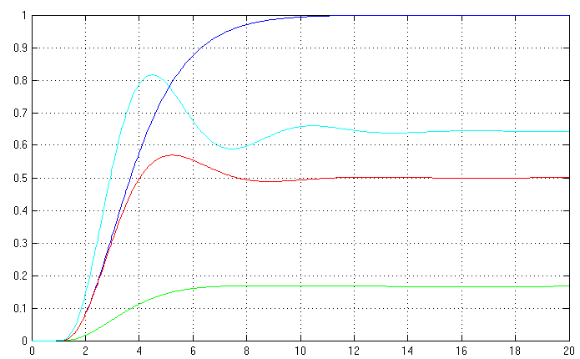
P₁=0.2
P₂=1.0
P₂=1.8
Plant step response without feedback

- Chose the appropriate proportional gain and begin to increase gradually the integral gain. The focus must be the steady error and its behavior.
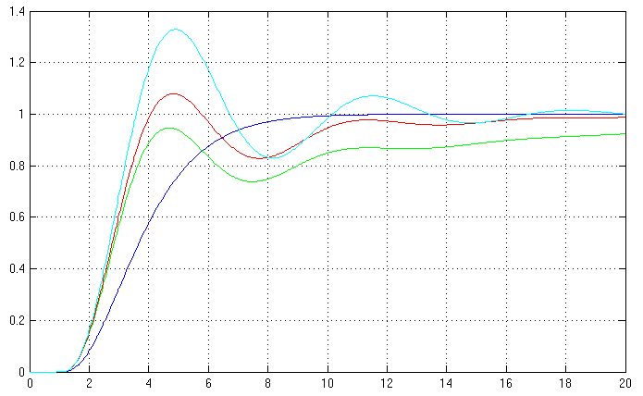
I₁=0,2
I₃=0,8
I₂=0,4
P=1.8
Plant step response without feedback

- At the end you can increase the derivative gain to damp oscillations of the closed-loop system.
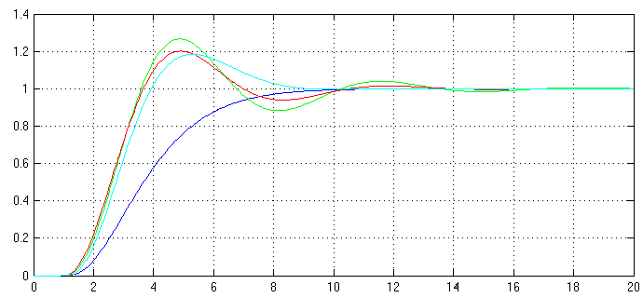
D₁=0.2
D₃=0.8
D₂=0.5
Plant step response without feedback

P=1,8;I=0,8;

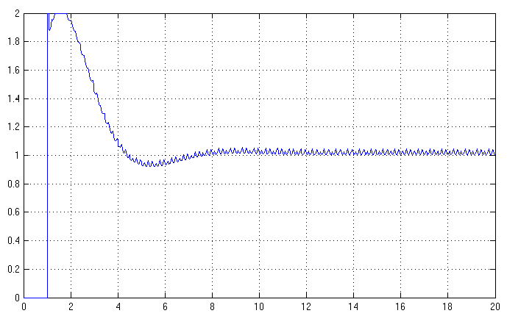

Root-Locus Designed method

For the Root-Locus Design Method is the program packet MATLAB / SIMULINK “SISO Design Tool” used that is called “sisotool”. This Tool is a graphical-user interface (GUI) that allows you to design compensators. The SISO Design Tool is made up of the following:
- The SISO Design Task Node in the Control and Estimation Tools Manager, a user interface (UI) that facilitates the design of compensators for single-input, single-output feedback loops through a series of interactive panes.
- The Graphical Tuning Window - a graphical user interface (GUI) for displaying and manipulating the Bode, root locus, and Nichols plots for the controller currently being designed. This window is titled SISO Design for Design Name.
- The Graphical Tuning Window by default displays the root locus and Bode diagrams for your imported systems. The two are dynamically linked; for example, if you change the gain in the root locus, it immediately affects the Bode diagrams as well.
- The SISO Design Task-associated LTI Viewer (For instructions on how to operate the LTI Viewer, see LTI Viewer)
- A tool that automatically generates compensators using PID, internal model control (IMC), or linear-quadratic-Gaussian (LQG) methods.
- A response optimization tool that automatically tunes the system to satisfy design requirements (available if you have Simulink Response Optimization installed).

Structure of controller by using the Root-Locus Design Method for tuning
- In the synthesis, the pole and zeros of a transfer function R(s) of the controller define the structure of the controller.

$R(s)=\frac{U(s)}{E(s)}=P+\frac{I}{s}+\text{Ds}=\frac{D⋅s^{2}+P⋅s+I}{s}$ (2.5 -1)

$R(s)=D\frac{(s−s_{\text{BR}1})(s−s_{\text{BR}2})}{s}=\text{Gain}\frac{\left(1+βs+(γs)^{2}\right)}{s}\text{.}$ (2.5 - 2)

$$I=\text{Gain}; P=\text{Gain}⋅β; D=\text{Gain}⋅γ^{2}$$

- To create a PID controller, a second zero point must be connected.
- If it is necessary to control an oscillating plant, both the zero points of the controller are to be situated in the vicinity of the complex poles of the function of transfer of the plant.

The synthesis will be demonstrated on the example 1.
Function of transfer of the plant F_{U}(s) is: $F_{U}(s)=\frac{1}{s^{2}+2s+1}\text{.}$
Example 1
The controller setting is found for:
  - I controller , %P <20%,
  - PI controller %P <20% and T_{s} < 6 sec.
Solution: a) For required occasional overshoot %P , ξ=0,6 is chosen.
Transfer function of $R_{0}(s)=\frac{1}{s}$ , i.e. the controller pole lies at $s_{R}=0$. Where the curve of the geometric locus of roots intersects the straight line of the damping, the value Gain will create the required occasional overshoot ξ=0,6.
The desired overall gain of the controller (see figure 2.4-1,2): Gain=0,323
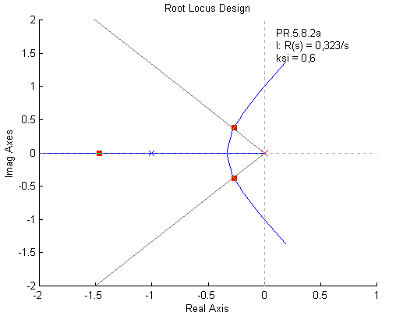
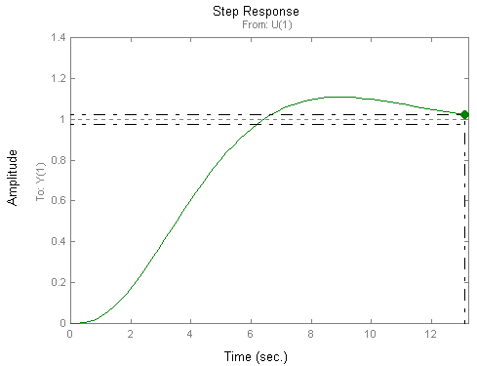
Fig. 2.4-2 Root loci of the closed loop

Fig. 2.4-3 Step response w(t)=1

Solution b) For the PI controller, the oscillation time is T_{s} <6sec. PI controller: $R_{0}(s)=\frac{r_{0}s+r_{1}}{s}=\frac{\text{Gain}⋅(s−s_{\text{RB}})}{s}$. Zero point s_{BR} of the transfer function R₀(s) has been set to$s_{\text{RB}}=−0,\text{73}$. The desired overall gain of the controller Gain lies in the point of intersection of the straight line for ξ=0,6 and of the straight line for Ts=6sec with the curve of the geometric locus of the roots, see figure 2.4-3a,b. The amplification is : Gain=1,17
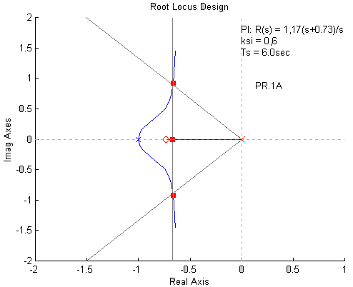
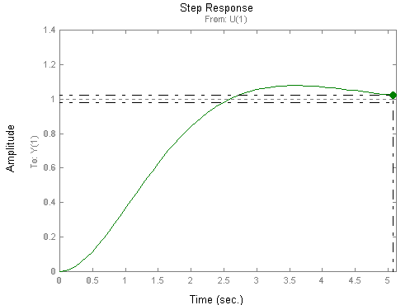
Fig, 2.4-3a Curve of geometric locus of roots of PI controller

Fig. 2.4-3b Step response w(t)=1

The PI controller has been adjusted as follows:$R(s)=\text{Gain}\frac{s−s_{\text{BR}}}{s}=1,\text{17}\frac{s+0,\text{73}}{s}=1,\text{17}+\frac{0,\text{85}}{s}$.

Set-up of the experiment

There is used an experimental set up training device SITRAN DR 20 that is shown in the Figure 3-1. The essential part of the experimental set-up contains the control device SIPART DR 20 (controller) and the controlled plant – temperature control of a soldering gun.

Fig. 3-1: Training device SITRAN DR 20

SIPART
DR20
Controlled
plant

SITRAN DR 20

The measuring and evaluation instruments are digital displays and a PC including input/output card (see Figure 3-2). The units will be connected by means of measuring lines and switches respectively. The software for data requisition and saving is LabVIEW, and the software for data computing is MATLAB.

Monitor
Network
Printer
Jump_Generator.vi
TRFK_LIBEREC.vi
CH1 CH3
Bedo
SAK 14
Card
Keyboard
PC
Fig. 3-2: Measuring and control on the experiment with a PC

The functions of the PC during this experiment are the following:
- data requisition and saving
- generating of step functions
- data computing (analyse, modelling, verification, evaluation)

Controlled plant

The simplified structure of the controlled system is shown in the block diagram Fig. 3-3. The input and output signals are the voltages Uy(t) and Ux(t). The input signal Uy is amplified by means of a power amplifier (non-linear) because it supplies the heater - the soldering gun with voltage. A sheet metal connects the soldering gun with a temperature sensor (PT100).

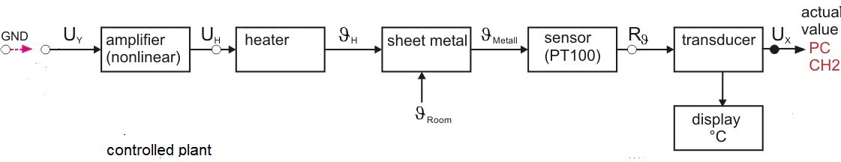
Fig. 3-3: Simplified structure diagram of controlled plant

A transducer transforms the output signal of the temperature sensor (the resistor Rϑ(t)) into the output signal of the controlled system (the voltages Ux). The disturbance is caused by the changing of the room temperature ϑ_{Room}=ϑ_{Room}(t). The simplified structure of the feedback control with instrumentation is shown in Figure 3-4. The voltages Uy(t) (input signal) can be
generated by the block Jump_Generator.vi or by the controller SIPART DR20 by proper connection of inputs with the signal U_{W} or U_{Y} by the red cable.

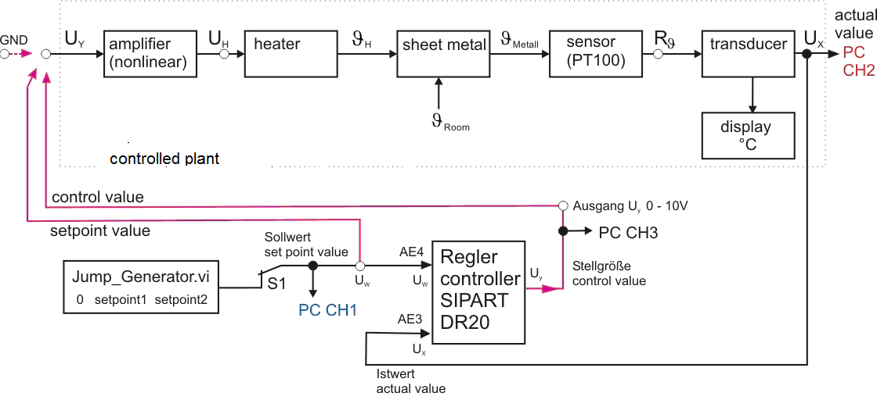

Fig. 3-4: Simplified instrumentation and control diagram of temperature control

Controller SIPART DR 20
This industrial control device is based on a microprocessor. By means of programming of this device it is possible, to create a controller of different structures. The front of SIPART DR 20 is shown in Fig. 3-5.

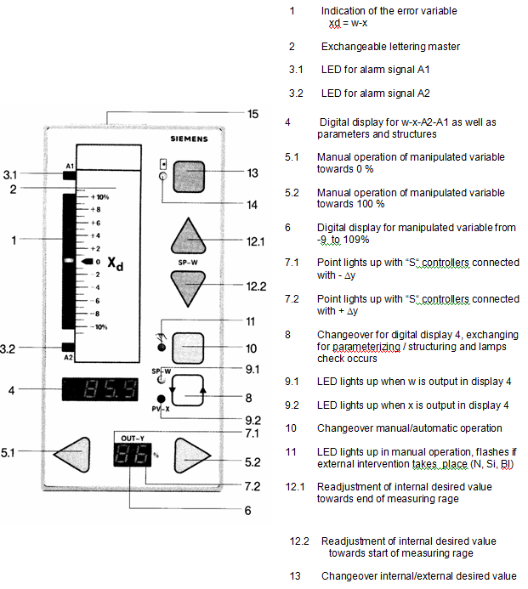
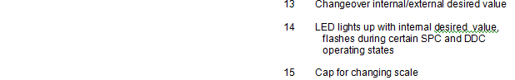
Fig. 3-5: Front view of SIPART DR 20 controller (lit. [1] p.10)

Data acquisition and control

Labview-Program „Jump_Generator.vi“ (Fig. 3-6)
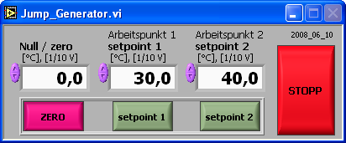
The program generates different setpoints.
Fig.3-6: Panel Jump_Generator.vi

Data Acquisition and Saving:
The measured data on the inputs CH1 to CH3 of the Bedo SAK 14 card are read in the PC with the program „TRFK_Liberec.vi“. The input voltage is within the parameters of –10 V and + 10 V. This desktop is shown in Figure 3-7.
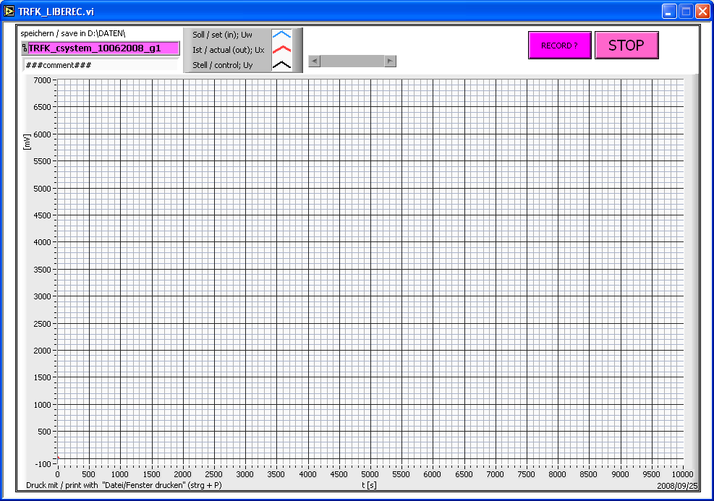
Fig.3-7: Desktop TRFK_Liberec.vi

Operating the equipment and software used in the experiment

Controller SIPART DR20

The location of the various buttons and displays is shown in Fig. 3-5. The digital display 4 shows the reference input variable w and the controlled variable x, respectively, in the unit of measurement [10⁻¹V]. The digital display 6 shows the reference-correcting variable y in the unit of measurement [10⁻¹V].
The SIPART DR 20 has 3 operating levels: process operating, parameterisation and structuring. The operation of the device in process operation is, to a large extent, self- explanatory.
In the parameterisation level the individual parameters for adaptation of the device to the system data are called up and set in on-line operation, i.e. the controller remains in the set mode.
In the structuring level a large number of prepared functions for controlling industrial systems are filed in the program memory. Using adjustable switches, the diverse structures of the controller are composed. Table 1 shows the essential structuring switches with their adjustable values.

Structuring  Switches | Adjustable values | Remarks
1 | 4 | Slave controller without  internal/external switchover
8 | 1 | Allocation of input x1
10 | 1 | Allocation of input x2
25 | -2; (0; 1) | Display range of the display 1 (2.5%;  10%; 20 %)
26 | 0 | Sense of the controller on the  controlled system (Kp>0)  Referred to Xd = w-x
27 | 0 | D element input : Xd
28 | 0  1 | PI (D) – controller  P (D) - controller
36 | 1 | Components supplied with the optional  module GW

Table 1: The essential structuring switches with their adjustable values

For security reasons, the changeover from process operation to parameterization or structuring takes place in several steps. These steps must be carried out within 20 seconds, otherwise there is an automatic return to process operation.The operation of the controller takes place in the following steps [lit, 1, p.: 17].

Preparation for changeover to parameterization and structuring: Press key 8 until the „PS“ appears on the two-digit display. Release key 8. The display „PS“ changes to steady light.

Parameterization

Changeover to parameterization level:
When “PS” lights up, press key 12.1 several times until the letters “PAr” appear in the four-digit display 4; “Str” and then “PAr” again appear if “PAr“ was bypassed by mistake. Press key 5.1 or 5.2 once; the last parameter selected appears, the name in display 6 and the appertaining value in display 4. Display1 still shows the negative deviation for the observation of the process.

Selecting the parameters:
The parameter list (Table 2) is paged forwards and backwards using the 5.1 and 5.2 keys.

The essential characters of the parameterization with the adjustable values are shown in Table 2.

Setting the parameters:
The parameter which is currently selected can be set using the keys 12.1 and 12.2.

Switching back to process operation:
During setting the device can be switched back to process operation at any time using key 8.

Character | Adjustable value | Parameter
Vv | 1 | Derivative-action gain
Cp | ? [-] | Proportional gain
Yo | 0 | Working point
Tn | ? [s] | Reset time
Tv | ? [s] | Derivative-action time
TF | off | Filter time constant for xd
tS | off | Setpoint ramp
ty | 60 | Valve positioning time/ Period y+
t - | 60 | Period y-
LA | 0 | Start of scale value 0 %
L1  .  .  .  L7 | 0  .  .  .  0 | Vertex  .  .  .  Vertex
LE | 100 | Full-scale value 100
SA | -5 | Setpoint limitation start
SE | 105 | Setpoint limitation end
SH | 0.0 | Safety point
A2 | -199.9 | Limit value, minimum
A1 | 999.9 | Limit value, maximum
A | 0.0 | Response threshold of xd
YA | -5 | Manipulated variable limitation, start of ya
YE | 105.0 | Manipulated variable limitation, end of ya
yS | 0.0 | Safety manipulated variable
c1 | 0.0 | Constant 1 (zero)
c2 | 0.0 | Constant 2 (factor)
Table 2: The parameterization with the adjustable values

Structuring

Changeover to the structuring level:
When „PS“ lights up, press key 12.1 several times until the letters „Str“ appear after „PAr“ in the four-digit display 4. Press key 5.1 or 5.2 once: the last structuring switch-selected appears, the number in display 6 and the appertaining switch position in display 4. The controller blocks its output. Display 1 now displays a striped pattern.

Selecting structuring switches:
The structuring switch list (Table 1) is paged forwards or backwards using keys 5.1 and 5.2

Setting the structuring switches:
The structuring switch which is currently active can be set using the keys 5.1 and 5.2.

Switching back to process operation or parameterisation:
During setting, the device can be switched back to process operation at any time by pressing key 8 twice. The controller is then always in manual mode, i.e. the binary input BE is only effective when key 10 is pressed (once). After key 8 has been pressed once while in manual mode, “PS” and “PAr" are displayed, so that afterwards changeover can be made to parameterisation (see above).

Controller output functions of controllers are:

The characteristic functions for the transfer behaviour of the controller are adjusted by the characteristics of Tables 1 and 2.

P-Controller
y = Cp * e e : error variable
y : manipulating variable

PI-Controller
y = Cp * ( e + $\frac{1}{\text{Tn}}\int_{0}^{t}{e}$* dt ) / 1 /

Cp, Tn : see table 2

Data acquisition and control

Labview-Program „Jump_Generator.vi“ (Fig. 3-6)
You can put in the values in the corresponding field and jump step between the different values by clicking on the buttons „Zero“, „setpoint1“ or „setpoint2“.

The measured data on the inputs CH1 to CH3 of the Bedo SAK 14 card are read in the PC with the program „TRFK_Liberec.vi“. The input voltage is within the parameters of –10 V and + 10 V.

This desktop is shown in Figure 3-7.
The buttons under the menu bar are self-explanatory. Place the cursor over the button to read a description field.

Measured and shown are the charts of the setpoint Uw (blue), the actual value Ux (red) and the control value Uy (black). You can adjust the scaling of the chart by entering of the new final values on the co-ordinate axis.

In the violet field “speichern / save in D:\Daten\” you enter the filename of the data which will be measured and saved after the start of recording.

The form of the file name for this experiment is: TRFK_u_v_w

Legend:
u (character of analysed part)
analysis of controlled system : u = csystem
analysis of controlled control loop: u = cloop

v (character of date) : day month year (for instance : 050709)

w (character of group) : g number of group (for instance :g2)

Start of measurement: click on the button “Run“
$→$ the violet field “STOP“ and “RECORD ?“ can be seen
$→$ you can see the charts of the measured data

Start of recording: click on the button “RECORD ?“
$→$ the field “RECORD ?” changes to a yellow field “Recording!“

End of measurement: click on the button “STOP“

Data computing
The handling of MATLAB is the content of the curriculum and is not described here [lit 2, 3].

Conducting the experiment

Conducting of measuring and recording on the SITRAN DR 20

The input steps to the controlled plant can be changed with the “Jump_Generator.vi” (see
Fig.3-6).

The step response, the input signal of the controlled system and the set-point signal can be recorded by the software “TRFK_LIBEREC.vi” that is shown in the Fig.3-7.

The graphical representation of the step response and the step function are printed by means of the software “grafTRFK”.

Instruction to the identification measurement

The static characteristic shows us if linearization is possible by approximation of the non linear dynamic by a transfer function. We shall find a linear part of the static characteristic where the working point can be placed. You are using the measured static characteristic in the Fig. 5-1 because the dynamic of this experiment is very slowly and the measurements would take a long time. The static characteristic depends on the room temperature $ϑ_{\text{Room}}$,so that the measurement of the static characteristic was carried out for two room temperatures: $ϑ_{\text{Room}}={\text{23}}^{0} \text{and} {\text{28}}^{0}C$. The temperature $ϑ(∞)$ was measured on the output as the voltage $U_{X}$ by the scale$1V={\text{10}}^{0}C$.

t
U_{Y}
[V]
2
4

[V]
Working point:
Fig. 5-3: Identification measure

t
U_{Y}
[V]
2
4

[V]
Working point:
Fig. 5-3: Identification measure

$ϑ_{\text{Room}}={\text{23}}^{0} \text{and} {\text{28}}^{0}C$$ϑ(∞)$$U_{X}$$1V={\text{10}}^{0}C$An identification measurement is shown in Fig. 5-3.

The identification measurement procedure:

- Determine the working point $(u_{0},x_{0})=(U_{\text{wp}},ϑ_{\text{wp}}(∞))$on the static characteristic and voltage $U_{\text{ID}}$.
- Connect the input of the plant U_{y} with GND (red cable), to prevent the plant from heating up (see Fig. 5-4).

S1
Red wire (rotes) Kabel)
Uw
PC_CH3
PC_CH1
Ux
Uy
Uw
Ux
Θ_{Room}
Uyc
PC_CH2
Controller
SIPART
DR 20
Jump Generator
GND
Extended
Controlled
Plant

Fig. 5-4: Block diagram for preventing from heating

- Cool down the plant to room temperature.
- Put in the “setpoints” in „Jump_Generator.vi“ and run the program.
- Put in the filename (and comment) in „TRFK_Liberec.vi”.
- The “setpoint” can be monitored in the SIPART Display 4 (if activated by switch 8 -> LED 9.1 on).
- Connect the input of the plant U_{y} (red cable) with the “set point”- output U_{w} (Output after switch S1-see the Fig. 5-5 ).

GND
Uyc
PC_CH1
PC_CH3
Uw
PC_CH2
Ux
Red wire (rotes) Kabel)
Controller
SIPART
DR 20
Extended
Controlled
Plant
Jump Generator
Uy
Ux
Uw
Fig. 5-5: Cable connection for identification measurement

- Run the program „TRFK_Liberec.vi“ and activate recording by a click to “record”.
- The input voltage is made by the “Jump_Generator.vi”. Carry out:
  - Step from the “setpoint ZERO” to the “setpoint 1” (U_{WP} on the „Jump_Generator.vi“). The “setpoint 1” is the voltage of the working point U_{WP}. The steady output is the steady temperature in the working point $ϑ$_{WP}(∞)
  - Step from the “setpoint 1” (U_{WP} ) to the “setpoint 2” (U_{ID} ). The steady output Ux is the steady temperature $ϑ$_{ID}(∞)
  - Step from the “setpoint 2” to the “setpoint 1”
- Stop „TRFK_Liberec.vi“.
- Step to setpoint ZERO.
- Connect the input of the plant U_{y} with GND (red cable), to prevent the plant for heating up.

Modelling

Modelling of the controlled system

Using the MATLAB software to determine the mathematical model of the controlled system
from experimental data (with an identification parameter techniques).

  - Give reasons for the structure of the model.
  - Decide what structure of transfer function$F(s)$ shall be used.
  - Use identification input as a step from the working point $u_{0}$to the defined input $u_{1}$. For this input perform the identification measure and calculate the parameters of the transfer function$F(s)$. After parameterization the function is denoted as$F_{1}(s)$.
  - Use identification input as a step from the working point $u_{0}$to the defined input $u_{1}$ and back to the input$u_{0}$. For this input you shall perform the identification measure and calculate the parameters of the transfer function that is denoted as$F_{2}(s)$.
  - Check the outputs of the both transfer functions $F_{1}(s), F_{2}(s)$ and of the real plant if the inputs are the same identification steps! Explain the differences!
  - Verify the model. Describe the procedure used and your results

Theoretical analysis of the control loop:
- Analyse the real control loop, which is composed of the controlled system and a PI-controller. What are the limitations?
- Define the range of stability of the control loop as function of the parameters of the PI-controller.

Studies on the model of the control loop:
- Using the software package MATLAB to create a model of the control loop
- Determine the parameters of the PI controller using the model of the control loop for both transfer functions$F_{1}(s), F_{2}(s)$ according to the following methods:
- a) Hand tuning
b) Root locus method
- Check the behaviour of the control loop outputs with transfer functions $F_{1}(s), F_{2}(s)$
- Illustrate and check this modelling control results graphically.

Symbols used in the following text (DIN 19221):
e error signal
w set point, (reference input variable)
x controlled variable
y correcting /manipulated variable
z disturbance

Studies on the real feedback system (control loop)

- Create the real control loop on the experiment device.
- Adjust the parameters on the controller, one after another.
- The reference inputs (set points) are volts in this feedback system and are generated by the “Jump_Generator.vi”. In this experiment the relation between the temperature $ϑ$[°C] and the voltage U is

$ϑ$ = k$ϑ$ * $U_{ϑ}$ with k$ϑ$ = 10°C / V . ( 5-1)

The set point temperature$ϑ$ to the feedback system is given in volts $U_{ϑ}$. The volts must be calculated by the equation

$U_{ϑ}=\frac{ϑ}{{\text{k }}^{ϑ}}$ ( 5-2)
- We give as the set point first the steady temperature of the working point $ϑ$_{WP}(∞) and after the output temperature of the closed loop system will reach its steady state we give as the next set point the steady temperature of the sheet metal$ϑ_{\text{metal}}(∞)$.
- Check the disturbance rejection.
- Instruction for measurement
  - Cool down the plant to room temperature.
  - Put in the setpoints in „Jump_Generator.vi“ and run the program with
Setpoint ZERO
  - Put in the filename (and comment) in „TRFK_Liberec.vi.
  - Program the controller with the calculated parameters.
  - Activate “automatic operation” (SIPART switch 10) after switching back to
process operation
  - Close the control loop by connecting the input of the plant U_{y} (red cable)
with the controller output U_{y} (“U_{y} 0 – 10 V”, see the Fig.5-6 )
Uw
S1
PC_CH3
PC_CH1
Ux
Uw
Ucy
PC_CH2
Controller
SIPART
DR 20
Extended
Controlled
Plant
Jump Generator
Θ_{Room}
Red wire (rotes Kabel)
Fig. 5-6: Cable connection for feedback control

  - Run the program „TRFK_Liberec.vi“ and activate recording.

- Step from setpoint ZERO to setpoint 1 -$U_{ϑ\text{WP}}(∞)$ on „Jump_Generator.vi“).
- Step from setpoint 1 ($U_{ϑ\text{WP}}(∞)$) to setpoint 2 ($U_{ϑ\text{ID}}(∞)$)
- Disturb the plant by dunking the sheet metal in water briefly after steady state has been reached
- Step from setpoint 2 ($U_{ϑ\text{ID}}(∞)$) to setpoint 1 ($U_{ϑ\text{WP}}(∞)$)
- Disturb the plant by dunking the sheet metal in water briefly after steady state has been reached

  - Stop „TRFK_Liberec.vi“.
  - Step to set point ZERO.
  - Connect the input of the plant U_{y} with GND (red cable), to prevent the
plant from heating up

Analysis of the experiment

- Discuss and evaluate the behaviour of the feedback system that is working with PI controller, which parameters has been calculated by using transfer functions $F_{1}(s),F_{2}(s)$!
- Discuss and evaluate all step responses and disturbances!
- Compare the step responses of the real control loop to the model of the controlled system with the transfer functions $F_{1}(s),F_{2}(s)$as a plant model!
- What are your conclusions?

Literature

[ 1 ] SIEMENS : SIPART DR 20 S/K Operating Instructions
Ord. No.: C73000-M7464-C30-8

[ 2 ] The Student Edition of MATLAB. Version 4, User’s Guide. The Math Works, Inc. 1995, Prentice Hall, Englewood Cliffs. ISBN 0-13-184979-4

[ 3 ] Simulink Dynamic System Simulation for MATLAB. Using Simulink, Version 2, The Math Works, Inc. 1997

