Contents

1 Goal of the experiment: 2
1.1.1 Program and function in MATLAB 2
1.1.2 System identification tool “Ident” 2
1.1.2.1 System Identification Tool “Ident” 2
1.1.2.2 Data import 3
1.1.2.3 Process Model 3
1.1.2.4 Working Data and Validation Data 9

Goal of the experiment:

Program and function in MATLAB

System identification tool “Ident”

The identification toolbox “ident” enables to build mathematical models of dynamic systems based on measured data. The toolbox is good described and contains vast help. The aim of this chapter is to make our students familiar with the toolbox “Ident” and to focus on practical identification.

The procedure “Ident” involves three basic parts:
- The input-output data
- A set of candidate model (the model structure)
- A criterion to select a particular model in the set

The System Identification Toolbox “Ident” provides a graphical user interface (GUI).
Start the tool by typing
>>ident

in the MATLAB Command Window.
Window “Ident” is dominated by two tables: table for data and table models known as Data board and Model board (see Fig.2.2-2). A new data can be entering by importing them from the MATLAB workspace.

Data import
Imports are handled under the Import data menu as shown in the Fig. 2.2- 3. The GUI supports three kinds of data objects for parameter estimation: Time-domain input/output signal, Frequency-domain input/output signal and Frequency functions.
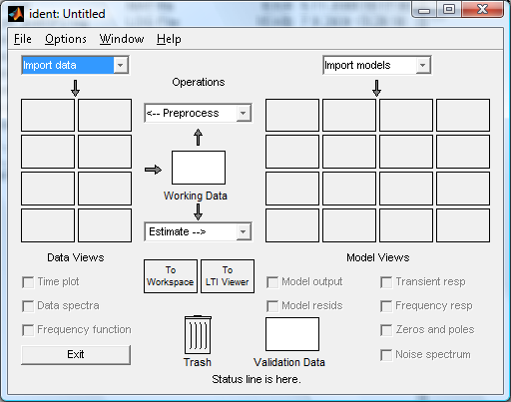
Fig. 2.2 – 2. The main ident Window
Data boardModel board

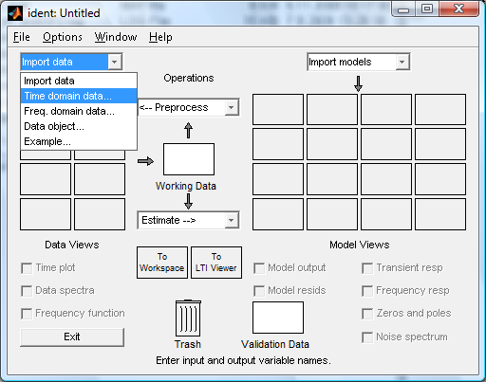
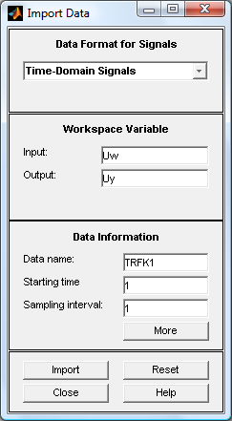
Fig. 2.2 – 3. Data import for Time-Domain input/output signals Window

The input and output are vectors that are equal

$\text{Uw}=u(t)−u_{0}, \text{Uy}=y(t)−y_{0}$, (2.2-1,2)

where $u(t),y(t)$ are vectors of measured input and output,
$u_{0},y_{0}$ are values of the working point.

You can choose the “Data name”, the “Starting time” and “Sampling interval”. Usually the parameters “Starting time” and “Sampling interval” are set to 1. After a click on “Import” the data are imported and you will see a Data icon (TRFK1) in the Data board (see Fig. 2.2 – 4). Choosing the checkbox “Time plot” you can plot the data (TRFK1: input Uw, output Ux) that are prepared for identification (see Fig. 2.2 – 4).

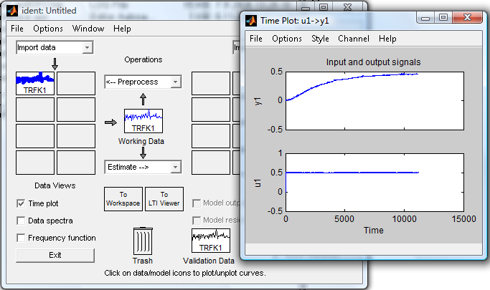
Fig. 2.2 – 4. Time plot of input/output signals

Process Model

Commands for creating estimation models based on the working data (TRFK1) you find after a click on “Estimation” menu (see Fig.2.2 – 5). You see you can choose Parametric models in form a Z-transfer function, Process model (Defined transfer function), Spectral model and Correlation models. We are interested in Process model.
By a click on the menu item “Process models…” the window “Process models” is opened (see the Fig. 2.2-6). The part of the window “Model Transfer Function” shows the structure of a continuous-time model (a transfer function) that is characterized by
K …static gain
T_{PK} … one or several time constants for k=1,2,3 or for under damped systems called T_{W} and ζ for time constant and damoing in the complex roots gcase
T_{Z} … A possible process zero
T_{D} … A possible time delay (dead time)
A possible enforced integrator.

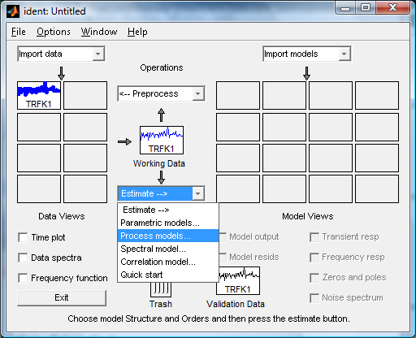
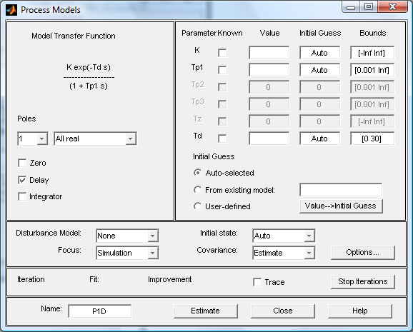
Fig. 2.2 – 5. Determination of model type
Fig. 2.2 – 6. Determination of transfer function structure
Field of transfer function structure setting

The transfer function structure with gain K is defined by number of real poles 0,1,2,3 or by choice of an underdamped system (complex poles). You can make a choice of a zero and time delay. When it is necessary you can add a pole equal zero as integrator.
Choosing a combination of above parameters a set of transfer functions can be defined.
Same of them are:

$G(s)=\frac{K}{T_{P1}s+1}e^{−\text{sTd}}$ $G(s)=\frac{K}{(T_{P1}s+1)(T_{P2}s+1)}e^{−\text{sTd}}$ $G(s)=\frac{K}{s}e^{−\text{sTd}}$

$G(s)=\frac{K}{s\left[(T_{W}s)^{2}+2{ξT}_{W}s+1\right]}$ $G(s)=\frac{K\text{.}(T_{Z}s+1)}{s(T_{P1}s+1)(T_{P2}s+1)}e^{−\text{sTd}}$

After a click on “Estimate” on the process window the estimated parameter values are shown (see Fig.2.2-7). On the main windows “Ident” the model icon is shown (see Fig.2.2-7).

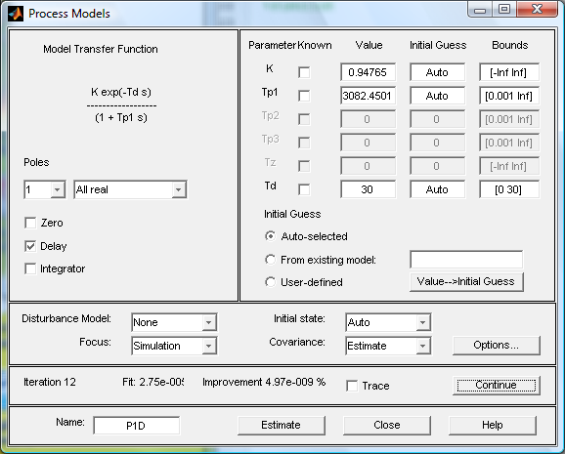

Fig. 2.2 – 7 Estimated parameters K,Tp1 and time delay Td

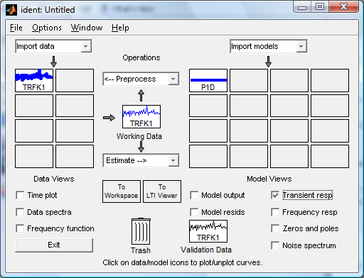
Fig. 2.2 – 8 The main window with model icon P1D

Click check point “Transient resp” (see Fig. 2.2-8) plots the transient response, Fig. 2.2-9a).
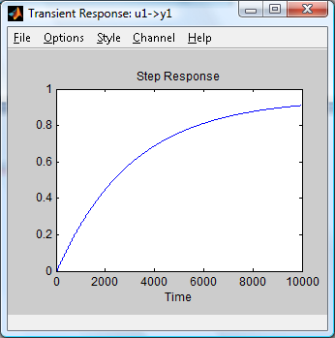
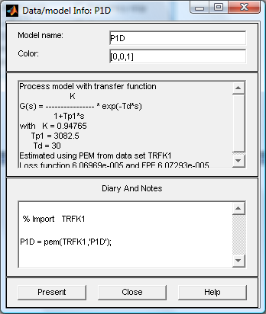

Fig. 2.2 – 9a Transient response
of the model P1D

Fig. 2.2 – 9b Data model Info: P1D.

By a click on model icon P1D is opening windoe “Data/model Info” shown in Fig.2.2-9b.
For the same data set (TRFK1) we can make parameter estimation for another transfer function structure. As an illustration example we choose the structure

$$G(s)=\frac{K\text{.}(T_{Z}s+1)}{s(T_{P1}s+1)(T_{P2}s+1)(T_{P3}s+1)}$$

On the Fig.2.2-10 you can see the determination of the model structure in the window “Process model” part “Model Transfer Function”. You can see in the field Parameter the estimated parameters. The main window “Ident” in the Fig. 2.2-11 you can see the model icon P3IZ.
The transient function is shown on the Fig.2.2-12a and the Data model Info P3IZ is sown on the fig.2.2-12b.

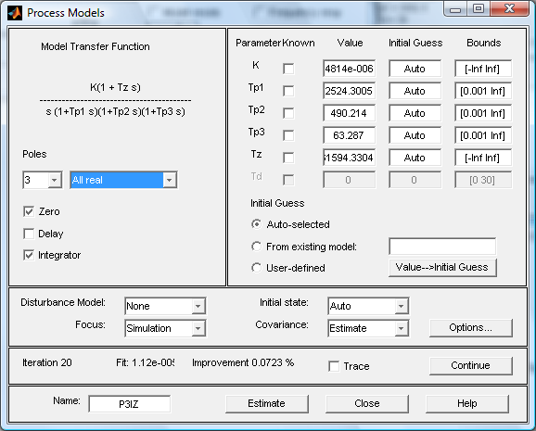
Fig. 2.2 – 10 Estimated parameters K,Tp1,Tp2,Tp3,Tz

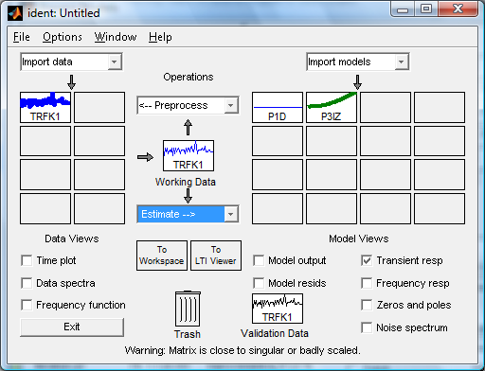
Fig. 2.2 – 11 The main window with model icons P1D, P3IZ

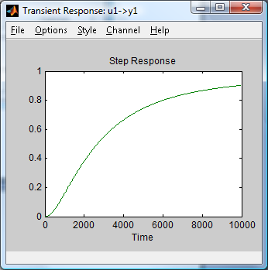
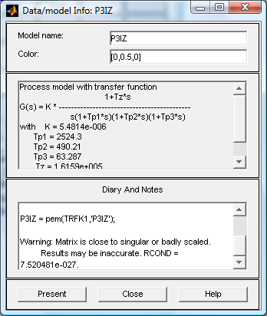
Fig. 2.2 – 12a Transient response of
the model P3IZ
Fig. 2.2 – 12b Data model Info: P1D.

Working Data and Validation Data
When we have been working with a data set and now it is necessary to create a new data set we use the function Import data. So we can have prepared in the Data Board some data sets. A data set can be processed by the tool “Ident” only than, if the data set is placed to the
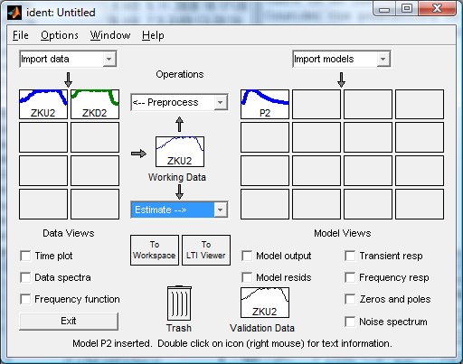
Fig. 2.2 – 13 Data Board with two data sets ZKU2,ZKD2.

placeholder (position) Working Data. So you have to drag and drop data icon from the Data Board into the position “Working Data”. You see in the Fig. 2.2-13 that in the placeholder “Working Data” is the data icon ZKU2 so the tool “Ident” is processing this data set.
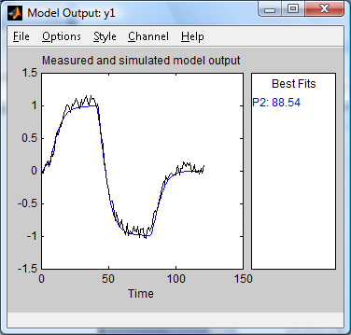
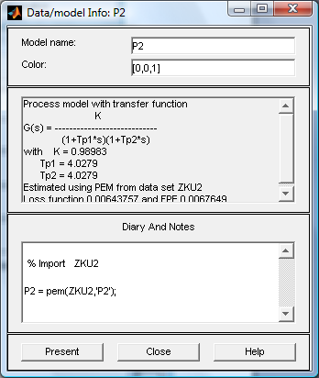

Fig. 2.2 – 14b Transient response of
the model P2

Fig. 2.2 – 14a Data model Info: P2.

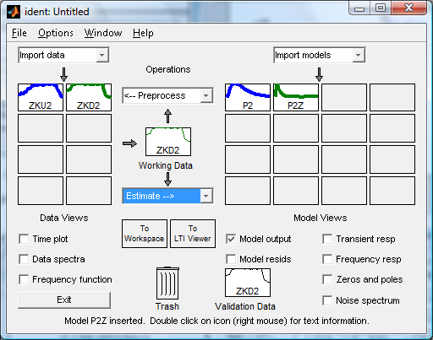
Fig. 2.2 – 15 Data Board with two data sets ZKU2,ZKD2, Working data ZKD2, two models P2,P2Z

We can estimate a model P2 (transfer function) , see results in the Fig. 2.2-14a,b. The result of drag and drop of the data set ZKD2 from the Data Board to the Working data placeholder is shown in the Fig. 2.2-15. The results of the model P2Z is shown in the Fig. 2.2 -16a,b. models P2,P2Z
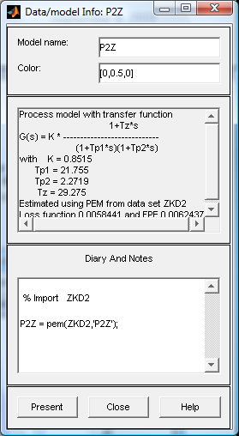
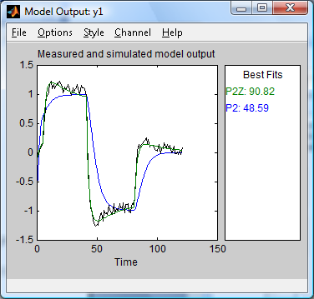

Fig. 2.2 – 16b Transient response of
the model P2Z, P2

Fig. 2.2 – 16a Data model Info: P2Z.

Using knowledge of some parameters of transfer function in the identification

In the praxis there exist situations that same of parameters of the transfer function are known. To illustrate the case we show a plant model with disturbance. By disturbance modeling of a system by an approximation of a linear model the system output can be described
$Y(s)=\frac{B(s)}{A(s)}U(s)+\frac{C(s)}{A(s)}D(s)=F_{U}(s)U(s)+F_{D}(s)D(s)$. (2.2-2)

You see that the transfer functions $F_{U}(s),F_{D}(s)$ have the same nominator$A(s)$. The polynomial $A(s)$ can be calculated by the estimation of the transfer function$F_{U}(s)$. By parameter estimation of the transfer function $F_{D}(s)$ must the polynomial $A(s)$ be the same as in the transfer function$F_{U}(s)$, so it necessary to calculate only the polynomial $C(s)$.
Using the identification tool “Ident” it is possible, the known values of some parameters write direct in the table in the field “Value” see Fig.2.2-17. You must not forget to check the parameters as known in the checkbox “Known”. The results of estimated parameters K,T_{Z} are shown in the Fig. 2.2-17 too.

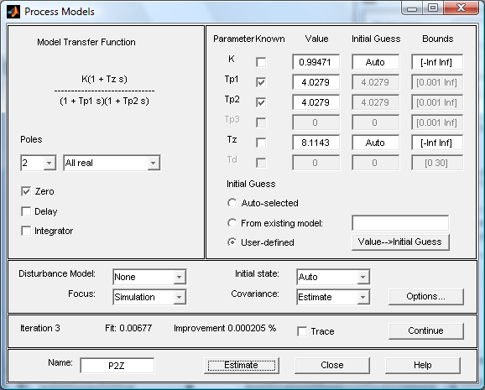
Fig. 2.2 – 17 Estimated parameters K, Tz, parameters Tp1,Tp2 are known

Data Board with two data sets ZKU2, ZKD2, Working data ZKD2, models P2,P2Zand P2Z red are shown in the Fig. 2.2-18. The window “Data/model Info” P2Z , which is processed with known parameters Tp1,Tp2 is shown in the Fig. 2.2-19a. The plot of the measure and model output P2Z is shown in the Fig. 2.2-19b.
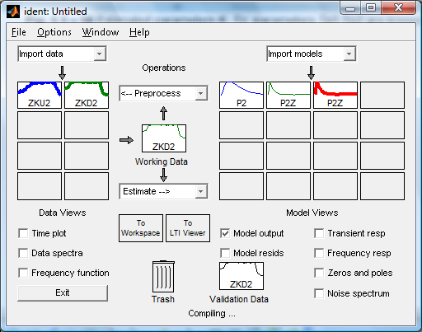
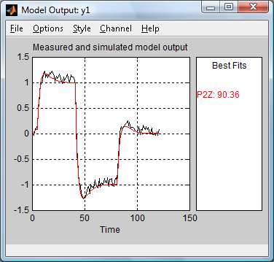
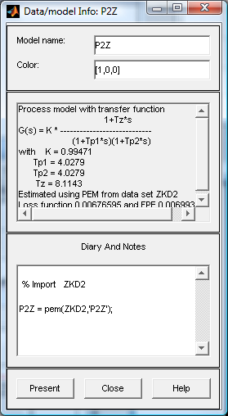
Fig. 2.2 – 18 Data Board with two data sets ZKU2, ZKD2, Working data ZKD2,
models P2,P2Zand P2Z red, which processed by known parameters Tp1,Tp2.
Fig. 2.2 – 19a Data model Info: P2Z.
Fig. 2.2 – 19b Measure and model
output P2Z (red)

